ADVANCED OPTIMIZATION IN E-COMMERCE LOGISTICS: COMBINING MATHEURISTICS WITH RANDOM FORESTS FOR HUB LOCATION EFFICIENCY
(HubOptima)
A project report submitted in partial fulfilment of the requirements for the award of the degree of
BACHELOR OF TECHNOLOGY
in
COMPUTER SCIENCE AND ENGINEERING (DATA SCIENCE)
Submitted by
CH.ARCHANA | 23K91A6745
A.MEENAKSHI | 23K91A6705
B.ARUN | 23K91A6734
A.SAMPATH | 23K91A6712
Batch A4 (CSE - Data Science, Section A)
Under the esteemed guidance of
[GUIDE NAME]
[DESIGNATION]
[COLLEGE LOGO]
DEPARTMENT OF COMPUTER SCIENCE AND ENGINEERING (DATA SCIENCE)
[COLLEGE NAME]
[COLLEGE ADDRESS / AFFILIATING UNIVERSITY]
[ACADEMIC YEAR]

[COLLEGE LOGO]
[COLLEGE NAME]
DEPARTMENT OF COMPUTER SCIENCE AND ENGINEERING (DATA SCIENCE)
CERTIFICATE
This is to certify that the project report entitled "Advanced Optimization in E-Commerce Logistics: Combining Matheuristics With Random Forests for Hub Location Efficiency (HubOptima)" is a bonafide record of the work carried out by CH.ARCHANA (23K91A6745), A.MEENAKSHI (23K91A6705), B.ARUN (23K91A6734), A.SAMPATH (23K91A6712), in partial fulfilment of the requirements for the award of the degree of Bachelor of Technology in Computer Science and Engineering (Data Science), during the academic year [ACADEMIC YEAR], under my supervision.

Project Guide  [GUIDE NAME]  [DESIGNATION] | Head of the Department  [HOD NAME]  Department of Computer Science and Engineering (Data Science) | External Examiner  [NAME AND SIGNATURE]
DECLARATION
We hereby declare that the project report entitled "Advanced Optimization in E-Commerce Logistics: Combining Matheuristics With Random Forests for Hub Location Efficiency (HubOptima)", submitted to the Department of Computer Science and Engineering (Data Science), [COLLEGE NAME], in partial fulfilment of the requirements for the award of the degree of Bachelor of Technology in Computer Science and Engineering (Data Science), is a record of original work carried out by us under the guidance of [GUIDE NAME], [DESIGNATION]. The results embodied in this report have not been submitted to any other university or institution for the award of any degree or diploma.

CH.ARCHANA | 23K91A6745
A.MEENAKSHI | 23K91A6705
B.ARUN | 23K91A6734
A.SAMPATH | 23K91A6712
Place: [PLACE]
Date: [DATE]
ACKNOWLEDGEMENT
We express our sincere gratitude to our project guide, [GUIDE NAME], [DESIGNATION], for valuable guidance, encouragement and constructive suggestions throughout this project.
We thank [HOD NAME], Head of the Department of Computer Science and Engineering (Data Science), for providing the facilities and support needed to complete this work, and [PRINCIPAL NAME], Principal, [COLLEGE NAME], for the encouragement given to us.
We thank the project coordinators and all faculty and staff members of the department for their help, and our families and friends for their constant support.
We also acknowledge the authors of the base paper, Kassem Danach, Abbas Rammal, Imad Moukadem, Hassan Harb and Abbass Nasser, and the authors and maintainers of the open-source software on which HubOptima is built, in particular scikit-learn, pandas, NumPy, PuLP and the CBC solver, FastAPI and React.

CH.ARCHANA
A.MEENAKSHI
B.ARUN
A.SAMPATH
ABSTRACT
E-commerce delivery networks route parcels through hubs, so the places where hubs are opened strongly affect cost and delivery time. Hub location is a hard combinatorial problem, classical models assume a fixed demand, and demand in practice fluctuates between regions and seasons. The base paper by Danach et al. (IEEE Access, 2025) proposes to forecast demand with a Random Forest and to feed the forecast into a matheuristic that chooses the hubs, and reports improvements on proprietary data.
This project implements that predict-then-optimise framework end to end as HubOptima. Order histories of 90 demand regions over 36 months (a synthetic dataset, because no real data was available) are cleaned and turned into 19 lag, rolling, calendar and region features; a Random Forest forecasts next-month demand; a capacitated single-allocation hub-location model is built from the forecast; and a matheuristic (greedy construction, a local search whose moves are screened by a cheap estimate and priced by exact assignment MIPs, and a kernel search) solves it. Plans are scored on the demand that actually occurred. A FastAPI service with 14 endpoints and a React web application expose forecasting, planning, method comparison, scalability benchmarking and month-by-month re-optimisation.
On six held-out months the Random Forest reaches a MAPE of 7.67% (R-squared 0.9766) against 17.6-19.7% for naive forecasters. For October 2025 the proposed plan costs INR 62.2 M per month with 92.3% simulated fulfilment; greedy, k-means, the largest-markets rule and planning without a forecast cost 11.5%, 3.6%, 16.1% and 8.1% more. The matheuristic matches the exact MIP at 90 and 180 nodes and is 3.67% above the exact incumbent at 270 nodes, where the exact MIP did not finish. Re-planning every month gives 98.3% against 83.7% simulated fulfilment for a static plan. The evidence is synthetic, the forecast under-called the October peak by 13.2% and left three of six hubs overloaded, and the base paper's real-data results are not reproduced.
Keywords: hub location problem, matheuristic, Random Forest, demand forecasting, e-commerce logistics, mixed-integer programming.
TABLE OF CONTENTS
CHAPTER 1 INTRODUCTION 1
1.1 Domain and Background 1
1.2 Motivation 1
1.3 Problem Statement 2
1.4 Need for the System 2
1.5 Objectives 3
1.6 Scope 3
1.7 Contributions 4
1.8 Novelty Against the Base Paper 5
1.9 Limitations and Assumptions 5
1.10 Organisation of the Report 6
CHAPTER 2 LITERATURE SURVEY 8
2.1 Overview of the Survey 8
2.2 Analysis of the Base Paper 8
2.3 Related Work by Theme 10
2.4 Datasets and Algorithms Used in the Literature 11
2.5 Strengths and Limitations of the Surveyed Work 12
2.6 Research Gap 12
CHAPTER 3 FEASIBILITY STUDY 13
3.1 Technical Feasibility 13
3.2 Economic Feasibility 13
3.3 Operational Feasibility 14
3.4 Schedule Feasibility 14
3.5 Advantages and Constraints 14
CHAPTER 4 SYSTEM REQUIREMENTS AND ANALYSIS 16
4.1 Existing System and its Limitations 16
4.2 Proposed System and its Advantages 16
4.3 Functional Requirements 17
4.4 Non-Functional Requirements 17
4.5 Hardware Requirements 18
4.6 Software Requirements 18
4.7 User Roles and Constraints 18
CHAPTER 5 SYSTEM DESIGN 20
5.1 System Architecture 20
5.2 High-Level Workflow 21
5.3 Data-Flow Diagrams 22
5.4 UML Diagrams 24
5.5 Data Model and Storage Design 26
5.6 Module Breakdown 28
5.7 User Interface Design 28
CHAPTER 6 METHODOLOGY AND SOFTWARE IMPLEMENTATION 30
6.1 Overall Methodology 30
6.2 Dataset 30
6.3 Data Preprocessing and Feature Engineering 31
6.4 Algorithm Choice and Justification 33
6.5 Mathematical Formulation 34
6.6 Core Algorithm Flowchart 35
6.7 Model Architecture and Training Configuration 36
6.8 Application Architecture 36
6.9 Key Code Walkthroughs 37
6.10 Implementation Decisions and Reasoning 38
6.11 API Design 39
6.12 Security and Error Handling 40
6.13 Installation and Execution 41
CHAPTER 7 SYSTEM TESTING 42
7.1 Testing Strategy 42
7.2 Unit and Module Tests 42
7.3 API Integration Tests 43
7.4 Functional Testing 43
7.5 Security Testing 44
7.6 Validation and Edge Cases 44
7.7 Performance Testing 45
7.8 User Acceptance Testing 45
7.9 Limits of the Testing Done 46
CHAPTER 8 RESULTS AND OUTPUT SCREENS 47
8.1 Demand Forecast Results 47
8.2 The Proposed Plan for October 2025 49
8.3 Comparison with Traditional Methods 50
8.4 Rolling Re-Optimisation 53
8.5 Scalability 54
8.6 Output Screens 54
8.7 Sample Inputs and Outputs 61
8.8 Comparison with the Base Paper 62
8.9 Success and Failure Analysis 63
8.10 Limitations of the Results 64
8.11 Objectives Against Outcomes 64
CHAPTER 9 CONCLUSION 65
9.1 Summary of the Work 65
9.2 Objectives Achieved 65
9.3 Key Findings 65
9.4 Practical Applications 66
9.5 Known Limitations 66
CHAPTER 10 FUTURE SCOPE 68
10.1 Improvements 68
10.2 Additional Features 68
10.3 Scalability and Deployment 68
10.4 Further Research 69
REFERENCES 70
APPENDIX A IMPORTANT CODE 72
A.1 Hub-location model: instance and exact MIP 72
A.2 Matheuristic 72
A.3 Forecasting 74
A.4 Evaluation 75
A.5 API endpoint for planning 76
APPENDIX B INSTALLATION AND USER GUIDE 77
B.1 Prerequisites 77
B.2 One-click start (Windows) 77
B.3 Using the application 77
B.4 Command line 77
B.5 Tests 78
B.6 Troubleshooting 78
APPENDIX C ADDITIONAL SCREENS 79

LIST OF FIGURES
Fig. 5.1: System architecture of HubOptima 20
Fig. 5.2: High-level workflow 21
Fig. 5.3: Data-flow diagram, level 0 (context) 22
Fig. 5.4: Data-flow diagram, level 1 22
Fig. 5.5: Data-flow diagram, level 2: solving the hub-location problem 23
Fig. 5.6: UML class diagram 24
Fig. 5.7: Use-case diagram 25
Fig. 5.8: Sequence diagram of the main flow: planning hubs 26
Fig. 5.9: Entity-relationship diagram of the file-based data model 27
Fig. 6.1: Monthly network demand of the synthetic dataset, with the six test months shaded 31
Fig. 6.2: Flowchart of the core algorithm: the matheuristic 35
Fig. 8.1: Held-out accuracy of the three forecasters 47
Fig. 8.2: Top 10 Random Forest feature importances 48
Fig. 8.3: Per-region forecast and actual orders, Dec 2025 48
Fig. 8.4: Distribution of per-region error, Dec 2025 48
Fig. 8.5: Network forecast against realised demand, July to December 2025 49
Fig. 8.6: Hub utilisation of the proposed plan on realised demand 50
Fig. 8.7: Operating cost by method 51
Fig. 8.8: Simulated fulfilment by method 51
Fig. 8.9: Cost components by method 52
Fig. 8.10: Fulfilment of the adaptive and the static plan by month 53
Fig. 8.11: Solve time of the exact MIP and the matheuristic 54
Fig. 8.12: Dashboard 55
Fig. 8.13: Forecast page 55
Fig. 8.14: Regions page 56
Fig. 8.15: Plan hubs: parameters 56
Fig. 8.16: Plan hubs: result KPIs 57
Fig. 8.17: Plan hubs: network map and cost split 57
Fig. 8.18: Plan hubs: search log and allocation 58
Fig. 8.19: Plan hubs: next month on the forecast 58
Fig. 8.20: Plan hubs: exact MIP 59
Fig. 8.21: Compare methods (full) 59
Fig. 8.22: Scalability benchmark 60
Fig. 8.23: Re-optimise page 60
Fig. 8.24: Re-optimise page (full) 61
Fig. 9.1: Operating cost by method (October 2025) 66
Fig. C.1: Landing page 79
Fig. C.2: Landing page: the pipeline 80
Fig. C.3: Forecast page (full) 80
Fig. C.4: Plan hubs: complete result 81
Fig. C.5: Compare methods 81
Fig. C.6: Scalability benchmark (full) 82
Fig. C.7: Dashboard in dark mode 82
Fig. C.8: Not-found page 83

LIST OF TABLES
Table 1.1: Base paper and this project compared 5
Table 1.2: Organisation of the report 6
Table 2.1: Results reported by the base paper 9
Table 2.2: Datasets, algorithms and measures in the surveyed work 11
Table 2.3: Strengths and limitations of the surveyed work 12
Table 2.4: Research gaps and responses 12
Table 3.1: Technical feasibility: needs and evidence 13
Table 3.2: Project milestones from the repository history 14
Table 3.3: Advantages and constraints 14
Table 4.1: Functional requirements 17
Table 4.2: Non-functional requirements 17
Table 4.3: Hardware requirements 18
Table 4.4: Software requirements 18
Table 5.1: Files that form the data model 27
Table 5.2: Modules, sizes and responsibilities 28
Table 5.3: Pages of the web application 29
Table 6.1: Methodology stages 30
Table 6.2: Dataset facts 31
Table 6.3: The 19 features of the forecaster 32
Listing: hublocator/forecast.py - build_features 32
Table 6.4: Baseline methods 33
Table 6.5: Random Forest configuration 36
Listing: hublocator/model.py - Instance.__post_init__ 37
Listing: hublocator/matheuristic.py - screen and price 37
Listing: hublocator/model.py - evaluate_solution (core) 38
Table 6.6: Implementation decisions 38
Table 6.7: The 14 API endpoints 39
Listing: request body of POST /api/optimize 39
Listing: response of POST /api/optimize (trimmed) 39
Table 6.8: Error handling 40
Listing: installation and commands 41
Table 7.1: Testing layers 42
Table 7.2: Assertions of tests.py 42
Table 7.3: The 18 smoke checks and what they observed 43
Table 7.4: Functional scenarios 43
Table 7.5: Edge cases 44
Table 7.6: Latency of read endpoints 45
Table 7.7: Latency of the planning endpoint 45
Table 8.1: Forecast accuracy on the held-out months 47
Table 8.2: Network-level forecast error by test month 49
Table 8.3: Hubs of the proposed plan, Oct 2025 (scored on realised demand) 49
Table 8.4: KPIs of the proposed plan 50
Table 8.5: Methods compared on October 2025 (p = 6) 51
Table 8.6: Adaptive and static plans, July to December 2025 53
Table 8.7: Exact MIP against matheuristic by network size 54
Listing: sample input 61
Listing: sample output (trimmed) 61
Listing: GET /api/forecast: first two regions 62
Table 8.8: Base paper and this project, side by side 63
Table 8.9: Success cases 63
Table 8.10: Failure and weak cases 63
Table 8.11: Objectives and outcomes 64
Table 9.1: Objectives achieved 65
Listing: hublocator/model.py - Instance and objective 72
Listing: hublocator/matheuristic.py - bound, price, construct 72
Listing: hublocator/matheuristic.py - construction and local search 73
Listing: hublocator/matheuristic.py - kernel search and result 74
Listing: hublocator/forecast.py - train_forecaster 74
Listing: hublocator/model.py - evaluate_solution 75
Listing: backend/main.py - /api/optimize 76
Table B.1: User guide 77
Listing: commands 77
Listing: test commands 78
Table B.2: Troubleshooting 78

LIST OF ABBREVIATIONS
Abbreviation | Expansion
API | Application Programming Interface
CBC | COIN-OR Branch and Cut (open-source MIP solver)
CLI | Command-Line Interface
CORS | Cross-Origin Resource Sharing
CSV | Comma-Separated Values
DFD | Data-Flow Diagram
ER | Entity-Relationship
FR | Functional Requirement
HLP | Hub Location Problem
HTTP | Hypertext Transfer Protocol
INR | Indian Rupee
JSON | JavaScript Object Notation
KPI | Key Performance Indicator
MAE | Mean Absolute Error
MAPE | Mean Absolute Percentage Error
MIP | Mixed-Integer Program
MILP | Mixed-Integer Linear Program
ML | Machine Learning
NFR | Non-Functional Requirement
PuLP | Python linear-programming modelling library
R2 | Coefficient of determination
REST | Representational State Transfer
RF | Random Forest
RMSE | Root Mean Squared Error
SLA | Service-Level Agreement (delivery-time target)
SVG | Scalable Vector Graphics
UI | User Interface
UML | Unified Modeling Language
VNS | Variable Neighbourhood Search

CHAPTER 1
INTRODUCTION

1.1 Domain and Background
Electronic commerce has changed what customers expect from a delivery network. Orders are placed at any hour, from any town, and are expected to arrive within a promised window. Behind that promise sits a physical network of warehouses, sorting centres and transport links. The nodes at which parcels are consolidated, sorted and re-dispatched are called hubs, and deciding where to open them is the classical Hub Location Problem (HLP) of operations research [6], [7].
A hub-and-spoke design lets a carrier combine many small flows into fewer, larger shipments, which lowers the cost per parcel. The price is that every parcel travels to a hub before reaching its destination, so a badly placed hub adds distance, time and cost. Hub placement is therefore a trade-off between fixed cost (each hub must be built, staffed and run every month), transport cost (distance travelled by the parcels) and service quality (how long deliveries take and how many orders the hub can actually process).
Two properties make the problem hard in practice. First, it is combinatorial: with 90 candidate sites there are billions of ways to choose six hubs, and every region must also be allocated to exactly one of them. Exact mixed-integer programming (MIP) solves small instances well but its running time grows quickly with the number of demand points. Second, the input is not fixed: e-commerce demand grows, peaks in festival months and shifts between regions, so a plan computed once on last year's average can be wrong by the time it is used.

1.1.1 Predict, then optimise
The base paper [1] proposes to join two well-known tools: a machine-learning forecaster that predicts regional demand from historical orders, and a matheuristic, a heuristic search that calls exact mathematical-programming solvers on small sub-problems, that chooses the hubs for the forecast demand. The forecast replaces the fixed-demand assumption; the matheuristic replaces the slow exact solver. This project implements that predict-then-optimise loop end to end and measures it.

1.2 Motivation
Three observations motivated the work. First, the cost of a poor hub decision is paid every month, so even single-digit percentage differences matter: on the October 2025 test the cheapest traditional heuristic costs INR 2.2 M more per month than the proposed plan (3.6% more) and the managerial 'largest markets' rule costs INR 10.0 M more (16.1% more), in the model's own units.
Second, the demand a plan is built for is rarely the demand that arrives. In the October 2025 festival peak the network received 2,383,534 orders against a forecast of 2,067,718; a plan that ignores forecasting and uses the historical average serves only 66.0% of the realised orders in the same test.
Third, the people who plan networks need to see the effect of their choices. A command-line research script is hard to hand to a logistics planner, so the project wraps the pipeline in a web application that shows forecasts, plans on a map, comparisons and the month-by-month behaviour of the network.

1.3 Problem Statement
Given a history of monthly orders for a set of demand regions, a set of candidate hub sites with fixed costs and capacities, and parameters for transport cost, delivery time and service level, choose which hubs to open and which hub serves each region so that total monthly cost is minimised, every region is served by exactly one hub, no hub exceeds its capacity, and the plan remains good as demand changes from month to month.
- Poor hub placement increases transportation cost and delays deliveries.
- Traditional hub location models assume fixed demand and ignore fluctuations.
- Exact optimisation is too slow for large, changing logistics networks.
- Forecasting and optimisation are usually done separately, which weakens hub decisions.
Need. A framework that feeds machine-learning demand forecasts directly into an efficient optimisation model, so hub choices adapt to changing demand, together with an honest measurement of what that adaptation buys.

1.4 Need for the System
- Adaptation. Plans must be re-computed as each new month of data arrives; doing this by hand is not realistic.
- Speed. A planner exploring 'what if we open one more hub?' needs an answer in seconds, not in the minutes an exact solver may need on a larger network.
- Evidence. The value of forecasting and of the matheuristic should be measured against the methods used today: exact MIP, greedy rules, clustering and managerial judgement.
- Accessibility. The same pipeline should be usable from a browser, with parameters, maps and tables, by someone who does not read Python.

1.5 Objectives
1. Collect and preprocess historical e-commerce logistics data.
2. Predict regional demand using a Random Forest model.
3. Formulate hub location as an optimisation problem with cost, time and capacity constraints.
4. Solve the problem efficiently with a matheuristic approach.
5. Re-optimise hub configurations as demand changes.
6. Compare performance with traditional hub location methods.
The status of each objective against the measured results is given in the Results chapter.

1.6 Scope

1.6.1 In scope
- A synthetic but realistic monthly demand history for 90 regions (30 Indian cities and 60 satellite districts) over 36 months, with growth, festival peaks, promotions and noise, and the preprocessing that a real file of the same schema would need.
- A Random Forest demand forecaster with lag, rolling, seasonal, promotion and region features, evaluated on a time-based hold-out of six months against two naive forecasters.
- A capacitated single-allocation hub location model with fixed hub cost, transport cost, a delivery-time penalty, hub capacity, a limit of p hubs and an optional hard service-level constraint.
- A matheuristic (greedy/k-medoids construction, MIP-priced local search, kernel search) and the exact MIP as the traditional reference.
- Four baseline methods: greedy heuristic, k-means clustering, a 'largest markets' rule and a planning-on-historical-average method with no forecast.
- A rolling-horizon simulation over six months and a scalability benchmark with 90, 180 and 270 demand points.
- A FastAPI service with 14 endpoints, a React web application with seven screens, and a command-line interface.

1.6.2 Out of scope
- Real company data. No real order history was available; all figures are produced on the synthetic data and must not be read as field measurements.
- Vehicle routing, multi-echelon networks, hub-to-hub flows and economies of scale between hubs (the model is single-allocation: each region is served by exactly one hub).
- Robust or stochastic optimisation and the 'network robustness' indicator reported by the base paper.
- Multiple capacity levels for a hub, capacity expansion over time and hub-disruption scenarios.
- Real-time data feeds, user accounts, authentication and multi-user deployment.
- Forecasting models other than the Random Forest (deep learning, gradient boosting) and hyper-parameter search.

1.7 Contributions
1. An end-to-end, reproducible implementation of predict-then-optimise (data preparation, Random Forest forecast, capacitated hub MIP, matheuristic, KPI evaluation) in about 2,000 lines of Python, with a fixed random seed and saved models and results.
2. A matheuristic with a screening bound. Swap, drop and add moves are first screened with a cheap greedy cost bound and only the promising ones are priced by an exact assignment MIP; a kernel search then polishes the result. It matched the exact optimum on the 90- and 180-node instances (gap 0.00% and -0.05%) and ran in 3.1 s and 8.3 s against 12.7 s and 42.9 s for the exact MIP.
3. A no-look-ahead evaluation protocol. For a past month the forecaster sees only earlier data, plans are made on the forecast and scored on the demand that actually occurred, so capacity overload caused by forecast error is visible (3 of 6 hubs overloaded in the October 2025 peak). Six methods are compared on the same instance: relative to the proposed plan, the greedy plan costs 11.5% more, k-means 3.6% more, the largest-markets rule 16.1% more and planning without a forecast 8.1% more.
4. Rolling re-optimisation. Re-forecasting and re-planning every month gave 98.3% average simulated fulfilment against 83.7% for a static plan, at 4.9% lower average operating cost, with one hub change in six months.
5. A usable product. A FastAPI layer (14 endpoints, background jobs) and a React application (landing page, dashboard, forecast, plan, compare, re-optimise, regions) that run the same code as the command line; 4 test functions and 18 API smoke checks pass.

1.8 Novelty Against the Base Paper
The base paper [1] describes the framework and reports service-level results on a proprietary dataset. It does not publish code, the dataset or the parameters of its matheuristic. The table lists what this project adds or does differently. None of it is a claim of better performance than the base paper: the datasets are different and the paper's figures cannot be reproduced.
Table 1.1: Base paper and this project compared
Aspect | Base paper [1] | This project
Data | Real logistics data of a global transport company (two years, thousands of customer locations); not public | Synthetic data, 90 regions x 36 months, generated by a seeded script and shipped with the code
Forecast model | Random Forest, with hyper-parameter tuning and cross-validation stated; the improvement over statistical methods is left as 'X %' | Random Forest with fixed parameters, time-based hold-out, compared with two naive forecasters; all numbers reported
Matheuristic | MILP for an initial solution, then Variable Neighbourhood Search (VNS) | Greedy/k-medoids construction, swap/drop/add local search priced by exact assignment MIPs after a greedy-bound screen, kernel search; no VNS
Model | Multiple capacity levels, unmet-demand penalty, scenario-based robust objective | Single capacity level, soft or hard SLA, time penalty; no robust objective
Evaluation | Delivery-time compliance 92.3%, fulfilment 97.6%, robustness 0.87; networks of 50-500 nodes | Cost, delivery time, simulated fulfilment and SLA reliability on realised demand; 90-270 nodes; no robustness measure
Adaptation | Re-optimisation described; temporal effects modelled by time-dependent constraints | Rolling-horizon simulation over six months with a static plan as the control
Delivery | Paper only | Open code, tests, 14-endpoint API and a web application

1.9 Limitations and Assumptions

1.9.1 Assumptions
- Demand in a region is the monthly number of orders; one order is one parcel of the same size.
- Road distance is 1.25 times the great-circle (haversine) distance; trucks average 45 km/h; a hub needs 6 hours of handling.
- Each region is served by exactly one hub (single allocation); every region can host a hub.
- A hub's capacity is 1.25 times the average planned demand per hub; fixed hub cost is INR 2.5 million per month scaled by city tier (1.35, 1.0, 0.75).
- Costs are model parameters (INR 0.04 per order-km, INR 1.5 per order-hour). They are plausible but not calibrated to any real carrier.

1.9.2 Limitations
- Synthetic data. The demand process was generated by the project, so the Random Forest learns a process the authors wrote down. The forecast accuracy (MAPE 7.67%) is therefore not evidence of accuracy on real data.
- Forecast error is not handled by the optimiser. The plan trusts the forecast. In the October 2025 peak the forecast was 13.2% low and three of six hubs ran above capacity (fulfilment 92.3%).
- Little gain from the matheuristic at 90 nodes. The matheuristic and the exact MIP found the same plan and solved in comparable times; the speed advantage appears from 180 nodes, and at 270 nodes the matheuristic was 3.67% above the exact incumbent.
- No robustness analysis. The base paper's robustness indicator was not implemented or measured.
- Single hold-out. There is one six-month hold-out split; no cross-validation or hyper-parameter search was run.
- No user study. The web application was exercised by scripted walkthroughs only; no real planner has evaluated it.
- Local deployment. There is no database, authentication or multi-user support; results are files on disk that background jobs overwrite.

1.10 Organisation of the Report
Table 1.2: Organisation of the report
Chapter | Content
1 Introduction | Domain, motivation, problem, objectives, scope, contributions, limitations
2 Literature Survey | The base paper, related work by theme, datasets and algorithms, research gap
3 Feasibility Study | Technical, economic, operational and schedule feasibility
4 System Requirements and Analysis | Existing and proposed system, requirements, hardware and software
5 System Design | Architecture, workflow, data-flow diagrams, UML, data model, modules, user interface
6 Methodology and Software Implementation | Data, features, forecaster, optimisation model, matheuristic, application, API, security, installation
7 System Testing | Strategy, tests that were run, edge cases, performance and the limits of the testing
8 Results and Output Screens | Measured results, output screens, comparison with the base paper, objectives against outcomes
9 Conclusion | Summary, findings, applications, known limitations
10 Future Scope | Improvements, features, deployment and research directions

CHAPTER 2
LITERATURE SURVEY

2.1 Overview of the Survey
The literature relevant to this project falls into five groups: the foundations of hub location, heuristic and metaheuristic search for hub and facility location, exact and decomposition methods, optimisation under demand uncertainty, and the use of machine learning to forecast the demand that drives the location decision. Matheuristics, the methodological family of the base paper, sit between the exact and the heuristic groups.
The batch's literature-survey list names five works: the base paper [1] and four recent related studies [2]-[5]. Their bibliographic details were confirmed from the publishers' pages; their methods are summarised below from their abstracts and from the base paper's own description. This chapter does not claim to have read more than that. Classical references [6]-[10] are those the base paper itself cites for hub location, and references [11]-[20] are the methodological sources of the tools used in this project.

2.2 Analysis of the Base Paper
Reference. K. Danach, A. Rammal, I. Moukadem, H. Harb and A. Nasser, 'Advanced optimization in e-commerce logistics: Combining matheuristics with random forests for hub location efficiency,' IEEE Access, vol. 13, pp. 55915-55926, 2025 [1]. The paper was received on 3 February 2025 and accepted on 9 March 2025, and is open access.

2.2.1 Problem and model
The paper studies the HLP for e-commerce distribution networks with centralised hubs, dynamic demand, capacity constraints, service-level requirements, cost minimisation and risk. The formulation minimises the fixed cost of opened hubs, the variable transport cost and a penalty on unmet demand; flows y_ij are continuous, hubs x_i and capacity levels z_ik are binary, capacity constraints bind the flow into each hub, demand constraints require every demand point to be served, and valid inequalities tighten the model (activation, single-allocation, demand-splitting limits).

2.2.2 Solution approach
The paper combines a Random Forest and a matheuristic. A relaxed MILP provides an initial solution; Variable Neighbourhood Search improves it; a Random Forest trained on historical demand forecasts the future demand at each location; the forecasts are fed back so the hub locations and capacities are re-optimised; finally the solution is validated on test scenarios (peak demand, sudden spikes, route disruptions). The paper also says the Random Forest assists in tuning matheuristic parameters and in scenario analysis.

2.2.3 Data and experiments
The experiments use a proprietary dataset of a global transport company with thousands of customer locations, several candidate hub sites, two years of demand history, transport costs and hub capacities. Scalability was tested on networks of 50 to 500 nodes.

2.2.4 Reported results
Table 2.1: Results reported by the base paper
Indicator | Value reported in [1]
Delivery-time compliance | 92.3% on average (+7.8% over traditional methods in the abstract)
Fulfilment rate | 97.6% on average (+9.4% in the abstract)
Network robustness | 0.87 (+16% in the abstract)
Operating-cost reduction | 15-20% against benchmarks
Scalability | networks up to 300 nodes within reasonable time; near-optimal for up to 500 nodes

2.2.5 Strengths
- The idea of replacing the fixed-demand assumption by an explicit forecast is simple and practical.
- It states the limits of the study plainly (sector-specific data, offline evaluation, scalability not extensively tested).
- It points to clear extensions: other learners, real-time IoT data, explainable AI, sustainability objectives.

2.2.6 Gaps that this project addresses
- The dataset, code and matheuristic parameters are not available, so the results cannot be reproduced; this project ships code, a seeded dataset and saved results.
- The sentence on the Random Forest's gain reads 'improves the predictive accuracy by X %'; this project measures the gain against two naive forecasters on a time-based hold-out.
- The paper does not show how forecast error affects the plan; this project scores each plan on realised demand and reports the overloaded hubs.
- No application is provided; this project adds a usable web interface.

2.3 Related Work by Theme

2.3.1 Foundations of hub location
O'Kelly introduced the location of interacting hub facilities [6]. Campbell, Ernst and Krishnamoorthy surveyed hub location problems, separating median, centre and fixed-cost variants and single from multiple allocation [7]. Ernst and Krishnamoorthy developed efficient algorithms for the uncapacitated single-allocation p-hub median problem [8]. These works define the single-allocation structure on which this project's model is based, with the addition of capacities and a delivery-time term.

2.3.2 Heuristics and metaheuristics
Zheng, Xu and Chen locate logistics hubs for drones with a diversity-based hybrid particle swarm optimiser that combines a Gaussian random walk, a bubble-net strategy and an Archimedes spiral; the abstract reports a 42.58% improvement in scheme efficiency over other intelligent algorithms [2]. Dehghan Chenary, Ferdowsi and Hartl treat a bi-objective mobile hub location problem with congestion by combining Pareto-based clustering with a metaheuristic and test it on the Australian Post dataset against MOPSO and NSGA-II [4]. Danach, Gelareh and Neamatian Monemi combine Lagrangian relaxation with a hyper-heuristic for a capacitated single-allocation location-routing problem [9]. All of these search the solution space by heuristic moves; none uses a demand forecast.

2.3.3 Exact methods and decomposition
Yang, Zheng, Wang and Hu study a liner-shipping p-hub centre problem with a maximal-detour restriction; they give three MILP models and an improved Benders decomposition with inspection, heuristic and multi-cut strategies [3]. The result illustrates how far exact methods can be pushed by decomposition, and why the exact MIP remains the reference against which heuristics are judged.

2.3.4 Uncertainty
Zhang, Wang and Gao formulate a two-stage adaptive robust hub location problem: capacitated hubs are located in the first stage against the worst case over a budgeted uncertainty set, and routing is decided in the second stage after demand is revealed. A column-and-constraint-generation method built on Benders decomposition solves large instances and gives better out-of-sample performance than a two-stage stochastic model [5]. Here the uncertainty set is assumed; the base paper and this project instead learn the demand from data.

2.3.5 Forecasting and machine learning
The base paper's own survey discusses LSTM-based demand prediction for couriers, recurrent networks with metaheuristic tuning for e-commerce sales, a transformer for passenger flow between transport hubs, and federated graph neural networks for facility location [1]. The Random Forest of Breiman [11] was chosen in [1] for its robustness, interpretability and low sensitivity to tuning; Hyndman and Athanasopoulos [19] provide the forecasting-evaluation conventions (time-ordered splits, naive benchmarks) used in this project.

2.3.6 Matheuristics
Maniezzo, Boschetti and Stuetzle define matheuristics as the interoperation of metaheuristics and mathematical programming [12]. Kernel search, in which a restricted MIP is solved over a small set of promising variables, was introduced by Angelelli, Mansini and Speranza [17], and Variable Neighbourhood Search by Hansen and Mladenovic [16]. This project's solver uses the kernel-search idea and a MIP-priced local search; VNS, named in the base paper, is not implemented.

2.4 Datasets and Algorithms Used in the Literature
Table 2.2: Datasets, algorithms and measures in the surveyed work
Work | Dataset | Algorithm family | Evaluation measure
[1] | Proprietary logistics data, 2 years | Random Forest + MILP + VNS | Delivery-time compliance, fulfilment, robustness, cost
[2] | Drone-delivery scenario for villages | Diversity-based hybrid PSO | Scheme efficiency vs other algorithms
[3] | Liner-shipping networks | MILP + improved Benders decomposition | Solve time, detour constraints
[4] | Australian Post dataset | Pareto clustering + metaheuristic | Pareto set quality vs MOPSO, NSGA-II
[5] | Not stated in the abstract | Column-and-constraint generation + Benders | Out-of-sample performance vs stochastic model
This project | Synthetic, 90 regions x 36 months | Random Forest + matheuristic (greedy, local search, kernel) + exact MIP baseline | MAPE/R2; cost, delivery time, simulated fulfilment, SLA reliability; solve time

2.5 Strengths and Limitations of the Surveyed Work
Table 2.3: Strengths and limitations of the surveyed work
Work | Strength | Limitation for this project's purpose
Danach et al., 2025 [1] (base paper) | Delivery-time compliance 92.3%, fulfilment 97.6%, robustness 0.87; +7.8% / +9.4% / +16% over traditional methods | Data not public; sector-specific; scalability not extensively tested; the RF gain over statistics is left as 'X %'
Zheng et al., 2024 [2] | Abstract reports a 42.58% improvement in scheme efficiency over other intelligent algorithms | Metaheuristic only; no demand forecasting; no optimality bound
Yang et al., 2023 [3] | Models detour limits explicitly; decomposition strategies speed up the exact solve | Fixed demand; liner-shipping specific
Dehghan Chenary et al., 2024 [4] | Better Pareto sets than MOPSO and NSGA-II (as reported in the abstract) | Metaheuristic; demand treated as given
Zhang et al., 2025 [5] | More reliable out-of-sample solutions than a two-stage stochastic model (as reported in the abstract) | Uncertainty set is assumed, not learned from data
Danach et al., 2019 [9] | Described in [1] as a Lagrangian-relaxation and hyper-heuristic approach for large instances | No demand forecasting
Ernst and Krishnamoorthy, 1996 [8] | Efficient algorithms for the uncapacitated problem (title) | Uncapacitated; fixed demand

2.6 Research Gap
Classical hub location models use fixed demand and cannot adapt to fluctuating e-commerce orders; combining machine-learning demand forecasting with optimisation is still limited in practice. From the survey, four specific gaps follow, and each corresponds to a part of this project.
Table 2.4: Research gaps and responses
Gap in the literature | How this project responds
Hub location studies assume known or assumed demand [2]-[5], [8], [9] | Demand is forecast from history by a Random Forest and fed into the model
The base paper's data, code and matheuristic parameters are unavailable [1] | Open code, a seeded dataset, saved models and results, tests
Effects of forecast error on the plan are not shown | Plans are made on the forecast and scored on realised demand; overloaded hubs are reported
No evidence on how much re-planning is worth | A rolling-horizon simulation against a static plan over six months
Exact versus matheuristic behaviour is described but not measured on growing instances | Scalability benchmark at 90, 180 and 270 nodes with an exact-MIP time limit

CHAPTER 3
FEASIBILITY STUDY

3.1 Technical Feasibility
The technology needed by the project is mature and free. Demand forecasting uses scikit-learn's RandomForestRegressor [13]; the optimisation models are written with PuLP [14] and solved by the CBC branch-and-cut solver [15] that PuLP bundles, so no commercial solver licence is needed; the API uses FastAPI and uvicorn, and the user interface uses React and Vite.
The feasibility of the computation was checked by measurement on a desktop machine (Intel Core i5-12500 (6 cores, 12 threads), 15.7 GB RAM, Windows 11 Pro, Python 3.11.9, Node.js v24.19.0). Training the Random Forest on 2,430 rows takes under one second; a 90-region plan takes about 3 to 12 seconds end to end depending on the method and the parameters; the 270-node scalability instance (73,170 binary variables) is solved by the matheuristic in about 31 seconds, while the exact MIP did not finish within 67 seconds. The measured results are in Chapter 8.
Table 3.1: Technical feasibility: needs and evidence
Requirement | Technology | Evidence it works
Demand forecasting | scikit-learn 1.4.2 Random Forest | MAPE 7.67% on 540 held-out region-months
Mixed-integer optimisation | PuLP 3.3.2 + CBC | Exact plan for 90 regions in 8-15 s; optimal status reported
Heuristic search | Python + NumPy 1.26.4 | Matheuristic solves the same instance in 4.9 s (solver time)
API | FastAPI 0.110.0 + uvicorn 0.29.0 | 18 smoke checks pass
User interface | React 18.3.1 + Vite 5.4.11 | 7 routes captured with real data

3.2 Economic Feasibility
Every software component is open source (scikit-learn, pandas and NumPy under BSD licences, PuLP and React under MIT, CBC under the Eclipse Public License), so the project has no licence cost. It runs on a standard desktop; no GPU, server or cloud service is needed. The development cost is the students' time.
The economic case for the method is a modelled one. In the model's own units, the proposed plan for October 2025 costs INR 62.2 M per month; the greedy plan would cost INR 69.3 M, k-means INR 64.4 M, the largest-markets rule INR 72.2 M and planning on the historical average INR 67.2 M. The differences, INR 2.3 M to INR 10.0 M per month, are produced by cost parameters that are plausible but not taken from a real carrier, so they show the direction and relative size of the benefit and not a forecast of real savings.

3.3 Operational Feasibility
- Users. A logistics planner uses a browser; the interface asks only for a month, the number of hubs and a few cost parameters, all with defaults.
- Installation. One command installs the Python packages (pip install -r backend/requirements.txt), one script (run.bat) starts both servers and opens the browser.
- Data. Replacing data/regions.csv and data/demand_history.csv with real files of the same schema is enough to run the pipeline on real data; preprocessing already removes duplicates and fills gaps.
- Maintenance. The code is split into six small modules (data, forecast, model, matheuristic, baselines, rolling) with a shared configuration file.
- Limits. There is no sign-in, so the application must run on a trusted machine; this is acceptable for a desktop planning tool but not for shared hosting.

3.4 Schedule Feasibility
The project was carried out between September and October 2026. The dates below are the dates recorded in the repository history and on the artefacts, not a retrospective plan.
Table 3.2: Project milestones from the repository history
Date (2026) | Milestone | Evidence
21 Sep | Project folder, base-paper record and the first code drop | repository history
22 Sep | Synthetic dataset generated (90 regions x 36 months) | data/*.csv file dates
26 Sep | Random Forest trained, forecast metrics saved | models/forecast_metrics.json (trained_at)
14 Oct | Comparison, rolling and scalability results regenerated; React/FastAPI application completed | results/*.json; frontend commit
15 Oct | Tests re-run, screenshots, diagrams, charts and the submission documents produced | docs/, scripts/, this report

3.5 Advantages and Constraints
Table 3.3: Advantages and constraints
Advantages | Constraints
Free, open-source stack; no licence cost | Synthetic data; no real-world calibration
Runs offline on one desktop; plans in seconds | No robustness analysis; plan trusts the forecast
Same code from command line, API and browser | Single user; no authentication or database
Reproducible: fixed seed, saved models and results | Matheuristic slightly worse than exact at 270 nodes (+3.67%)
Exact MIP available as a baseline in the same tool | Exact MIP needs minutes beyond about 180 nodes

CHAPTER 4
SYSTEM REQUIREMENTS AND ANALYSIS

4.1 Existing System and its Limitations
In practice, hub networks are planned in one of four ways. Managers choose hubs by judgement, usually at the largest markets; analysts solve an exact model such as a mixed-integer program once for a fixed demand; teams run greedy or clustering heuristics that are fast but give no quality guarantee; and the demand forecast, if one exists, is produced by a different team and is not connected to the location model.
- Exact models become computationally expensive for large logistics networks (the 270-node instance of this project was not solved by CBC within 67 s).
- Fixed-demand assumptions do not reflect fluctuating e-commerce orders (a plan on the historical average served 66.0% of October 2025 orders).
- Hub configurations are not updated when demand or operating conditions change (a static plan averaged 83.7% against 98.3% for re-planning).
- Separating forecasting from optimisation leads to sub-optimal hub decisions.
- Pure heuristics do not guarantee solution quality (the greedy plan cost 11.5% more than the proposed plan on the same instance).

4.2 Proposed System and its Advantages
HubOptima connects the four steps into one pipeline: it cleans and loads the order history, trains a Random Forest, forecasts next month's demand per region, builds a capacitated hub-location model from the forecast, solves it with a matheuristic (or the exact MIP on request), scores the plan on realised demand and repeats the cycle each month. A web application exposes every step.
- Forecast and optimisation are one pipeline, so the plan always uses the latest forecast.
- The matheuristic reaches the exact optimum on the 90- and 180-node instances and keeps solving where the exact MIP stalls.
- Re-optimisation each month follows demand: one hub was moved in the six simulated months (Kolkata-W to Kolkata for the October peak).
- Plans are evaluated on the demand that actually occurred, which exposes overloaded hubs instead of hiding them.
- Baselines are built in, so any plan can be compared with the methods used today.

4.3 Functional Requirements
Table 4.1: Functional requirements
ID | Requirement | Where it is met
FR1 | Load and preprocess regions and order history; show a dataset summary | data.py: load_dataset, dataset_summary; GET /api/summary, /api/regions; Dashboard and Regions pages
FR2 | Train and evaluate a Random Forest against naive forecasters; allow retraining | forecast.py; POST /api/train; Forecast page
FR3 | Forecast the next month and back-test a past month using only earlier data | forecast_next_period, forecast_for_period; GET /api/forecast
FR4 | Plan hubs for a chosen month with p, capacity, costs, SLA (soft or hard), method and time limit | POST /api/optimize; Plan hubs page
FR5 | Solve with the matheuristic or the exact MIP | matheuristic.py, model.py: solve_exact
FR6 | Report cost, delivery time, fulfilment, SLA reliability, utilisation and the allocation per region | model.py: evaluate_solution; Plan hubs page
FR7 | Compare the proposed method with the traditional methods on the same month | baselines.py: run_comparison; POST /api/compare/run; Compare page
FR8 | Benchmark scalability of exact MIP against the matheuristic | rolling.py: scalability_benchmark; Compare page, Scalability tab
FR9 | Simulate month-by-month re-optimisation against a static plan | rolling.py: rolling_reoptimisation; POST /api/rolling/run; Re-optimise page
FR10 | Run long jobs in the background and report their status | backend/main.py: start_job, GET /api/jobs; usePoll in the frontend
FR11 | Provide the same functions from a command line | run.py: data, forecast, optimize, compare, rolling, benchmark, serve, all

4.4 Non-Functional Requirements
Table 4.2: Non-functional requirements
ID | Requirement | How it is addressed
NFR1 Performance | Plan for 90 regions in seconds; forecast in under a second | Median 12.2 s (matheuristic) and 15.3 s (exact) end to end; forecast 264 ms
NFR2 Reproducibility | Same data and seed give the same results | random_state 42; saved model and result files; seeded dataset
NFR3 Usability | Defaults for every parameter; validation messages; light and dark themes | Plan form validated in the browser and by the API; theme remembered per browser
NFR4 Reliability | Reject bad input; explain infeasible plans | pydantic limits (p 1-20, SLA > 0, time limit 2-300 s); 'No feasible solution' message
NFR5 Portability | Run on a Windows desktop without admin tools | Python 3.10+ and Node 18+; run.bat; CBC bundled with PuLP
NFR6 Maintainability | Small modules and shared configuration | Six core modules of 120-205 lines; config.py
NFR7 Security | Limit exposure of the API | CORS limited to the web port; no secrets stored; no sign-in (stated limitation)

4.5 Hardware Requirements
Table 4.3: Hardware requirements
Item | Minimum | Used for the measurements
Processor | Any 64-bit dual-core CPU | Intel Core i5-12500, 6 cores / 12 threads
Memory | 4 GB | 15.7 GB
Disk | 1 GB free (38.5 MB model file plus the npm packages) | SSD
GPU | Not needed | Not used
Display | 1280 x 720 | 1440 x 900 for screenshots

4.6 Software Requirements
Table 4.4: Software requirements
Software | Version used | Purpose
Python | 3.11.9 (3.10 or later) | Core package, API, scripts
pandas / NumPy | 2.2.1 / 1.26.4 | Data handling
scikit-learn / joblib | 1.4.2 / 1.3.2 | Random Forest, k-means, model persistence
PuLP + CBC | 3.3.2 | Mixed-integer optimisation
Flask | 3.1.0 | Original classic web interface (port 5000)
FastAPI / uvicorn | 0.110.0 / 0.29.0 | JSON API (port 8104)
Node.js / npm | v24.19.0 (18 or later) | Frontend tooling
React / Vite / recharts | 18.3.1 / 5.4.11 / 2.13.3 | Web application (port 5104)
Browser | Chrome (any current browser) | Using and capturing the application

4.7 User Roles and Constraints
HubOptima has a single user role, the logistics planner, who may view every page and run every action; a second kind of user, the developer or analyst, uses the command line. There is no sign-in and no administrator role, because the application is intended to run on the planner's own machine.
- Only one background job per kind (comparison/scalability, rolling horizon, training) runs at a time; a second request returns HTTP 409.
- Comparison, rolling and training runs overwrite the saved files in models/ and results/.
- A planning month must be the next month or one of the history months after the first three (the forecaster needs lags).
- The exact MIP time limit is capped at 300 s; a plan with a hard SLA may be infeasible and is then reported as such.

CHAPTER 5
SYSTEM DESIGN

5.1 System Architecture
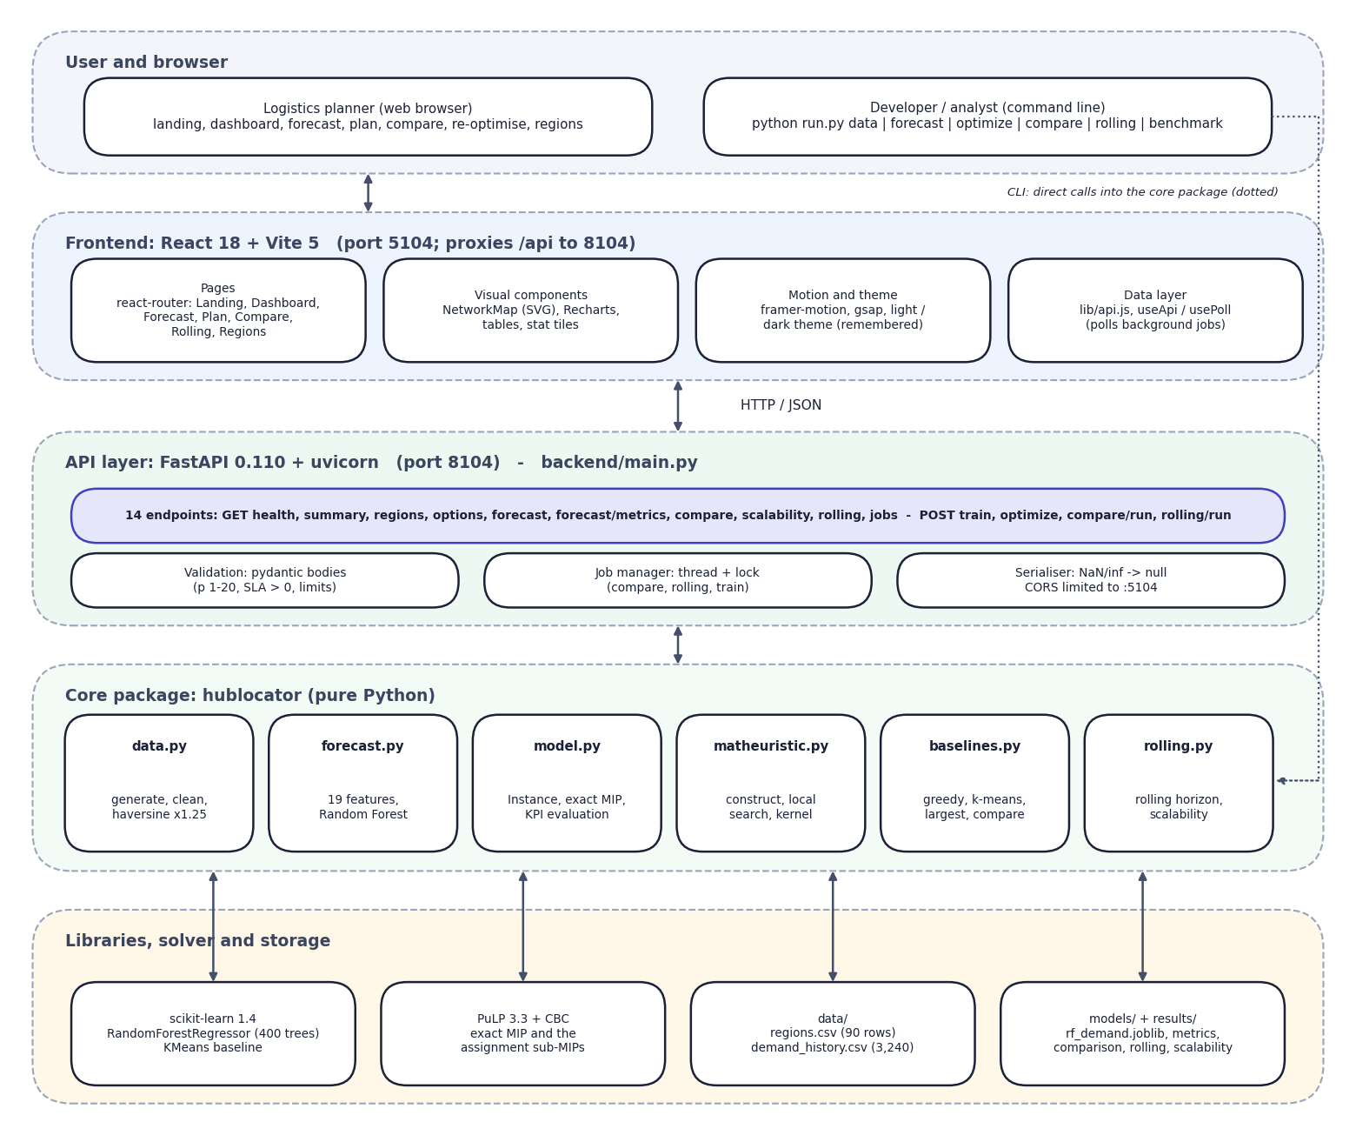
Fig. 5.1: System architecture of HubOptima
The architecture has five layers. The user works in a browser, or a developer uses the command line. The frontend is a React application served by Vite on port 5104; it holds the seven pages, the SVG network map, the charts, the theme and the small data layer (api.js, useApi, usePoll) that polls background jobs.
The API layer is a FastAPI service on port 8104 with 14 endpoints. It validates request bodies with pydantic, runs long jobs in a thread guarded by a lock, and converts numpy values to JSON (NaN and infinity become null). The core package hublocator contains all of the science: data preparation, the Random Forest, the hub model and exact solver, the matheuristic, the baselines and the rolling-horizon simulation. No forecasting or optimisation logic lives in the API layer.
The bottom layer holds the libraries (scikit-learn, PuLP with CBC) and the files that act as storage: two CSV files in data/, the trained model and metrics in models/ and the result files in results/. The command line calls the core package directly, which is why the dotted line bypasses the web tiers.
Design principles. (1) One implementation of the science: the command line, the classic Flask interface and the FastAPI service import the same package. (2) Files as storage: the artefacts a planner would want to inspect or replace (the CSV inputs, the model, the JSON results) stay readable files. (3) Thin API: it validates, runs jobs and serialises; it never decides anything about hubs. (4) Honest evaluation: the evaluation function takes the realised demand separately from the planning demand, so capacity overload is visible.

5.2 High-Level Workflow
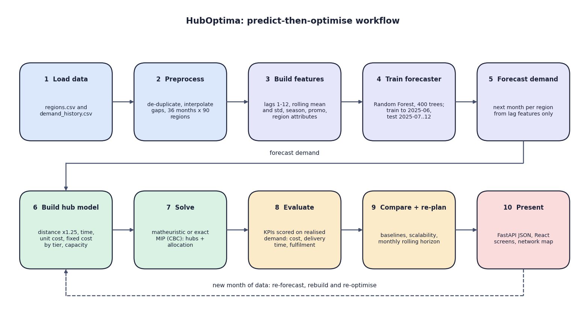
Fig. 5.2: High-level workflow
The ten steps are the predict-then-optimise loop. Steps 1 to 5 prepare the data and produce a demand forecast; steps 6 and 7 turn the forecast into a hub-location model and solve it; step 8 scores the plan on the demand that actually occurred; step 9 compares methods and re-plans month by month; step 10 presents the outcome. The dashed arrow shows the cycle: when a new month of data arrives the forecast is recomputed, the model is rebuilt and the network is re-optimised.

5.3 Data-Flow Diagrams
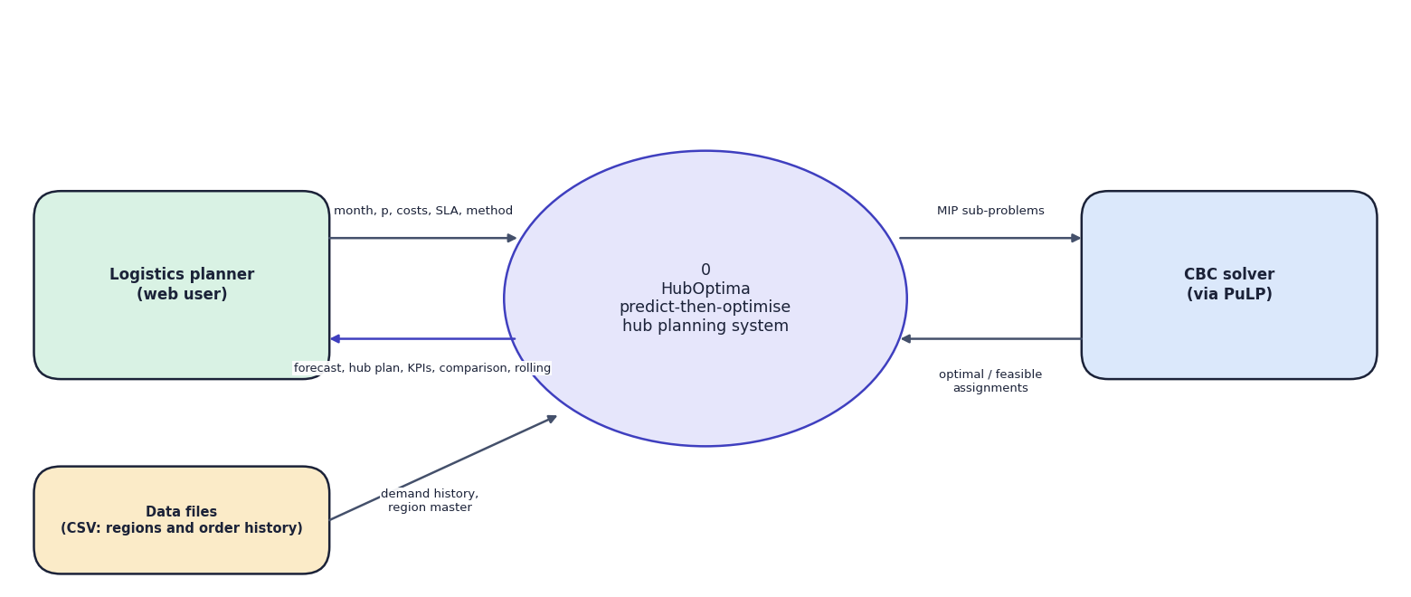
Fig. 5.3: Data-flow diagram, level 0 (context)
The context diagram shows HubOptima as one process with three external entities. The logistics planner supplies the planning month, the number of hubs, cost and service parameters and the method, and receives forecasts, hub plans, KPIs, comparisons and rolling results. The data files supply the region master and the order history. The CBC solver receives mixed-integer sub-problems and returns optimal or feasible assignments.
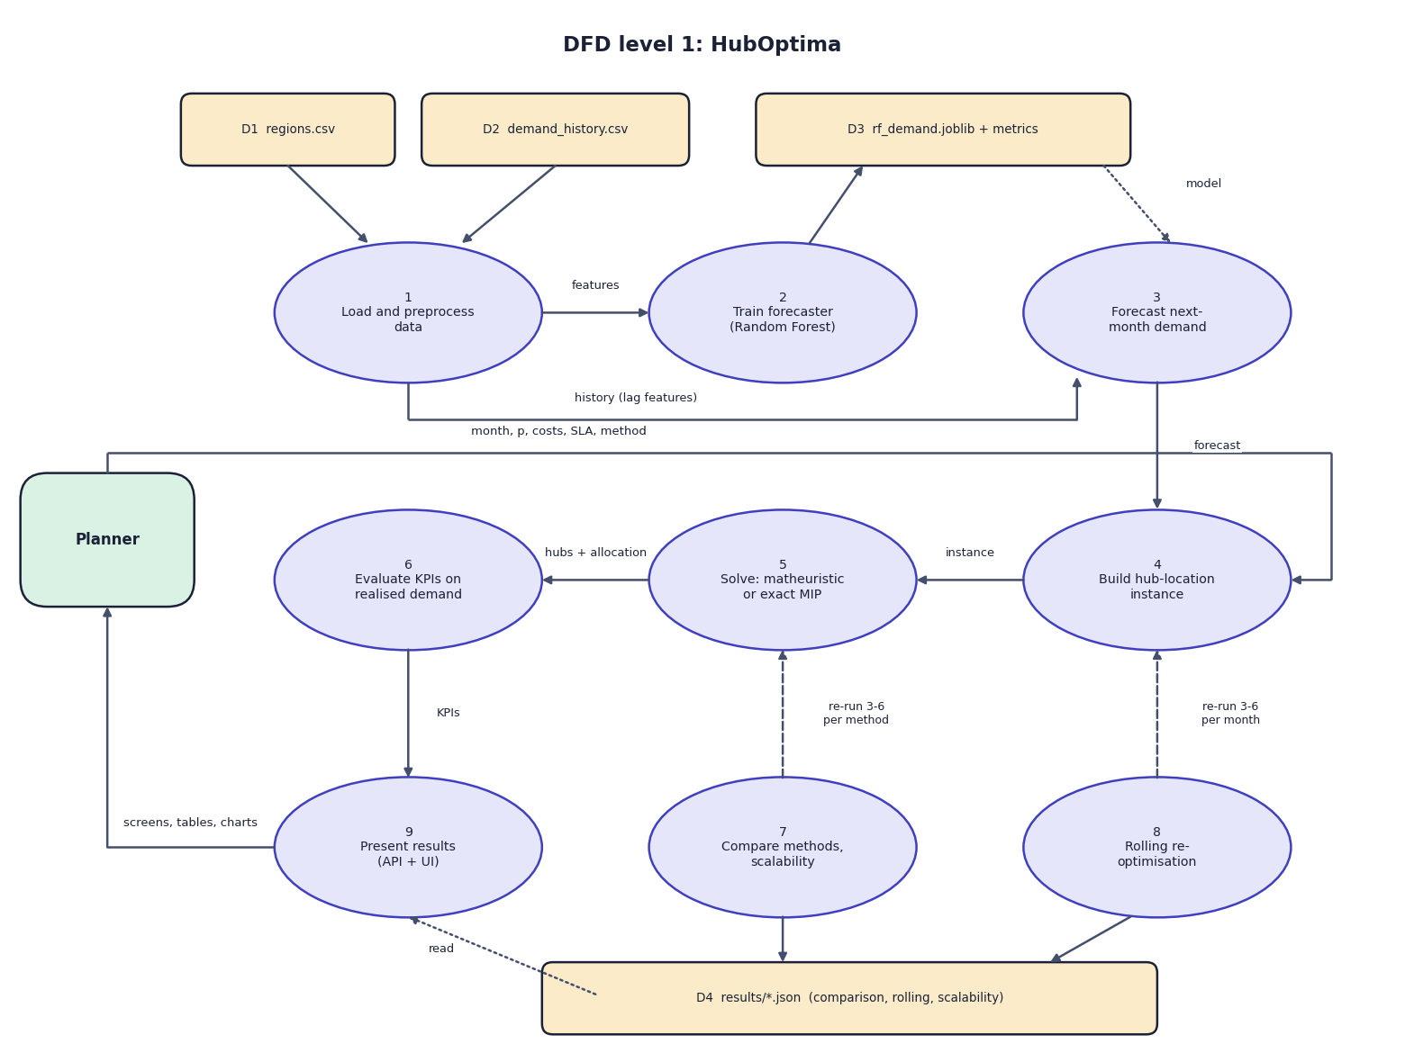
Fig. 5.4: Data-flow diagram, level 1
Level 1 splits the system into nine processes and four data stores. Process 1 reads regions.csv and demand_history.csv (D1, D2), cleans them and passes features to process 2, which trains the Random Forest and writes the model and its metrics (D3). Process 3 forecasts next month's demand from the model and the history. Process 4 builds the hub-location instance from the forecast and the planner's parameters; process 5 solves it; process 6 evaluates the KPIs on realised demand. Processes 7 (comparison and scalability) and 8 (rolling horizon) re-run processes 3 to 6 for each method or month and store their results in D4. Process 9 presents everything to the planner.
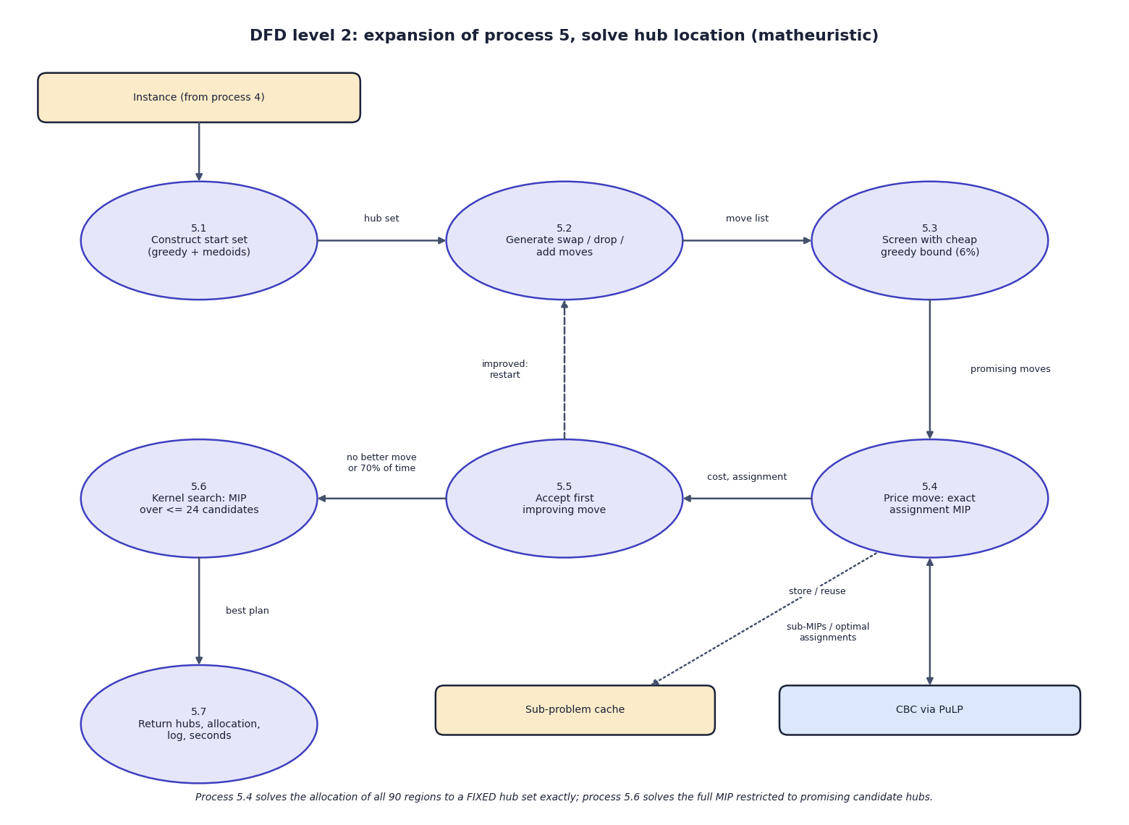
Fig. 5.5: Data-flow diagram, level 2: solving the hub-location problem
Level 2 opens process 5. The start set is constructed greedily (5.1), moves are generated (5.2) and screened with a cheap greedy cost bound (5.3), the promising ones are priced by an exact assignment MIP solved by CBC (5.4), and the first improving move is accepted (5.5) and triggers a restart. When no move helps, or 70% of the time limit is used, a kernel search solves the full MIP restricted to about 24 promising hubs (5.6) and the best plan is returned (5.7). A cache of priced hub sets avoids solving the same sub-problem twice.

5.4 UML Diagrams
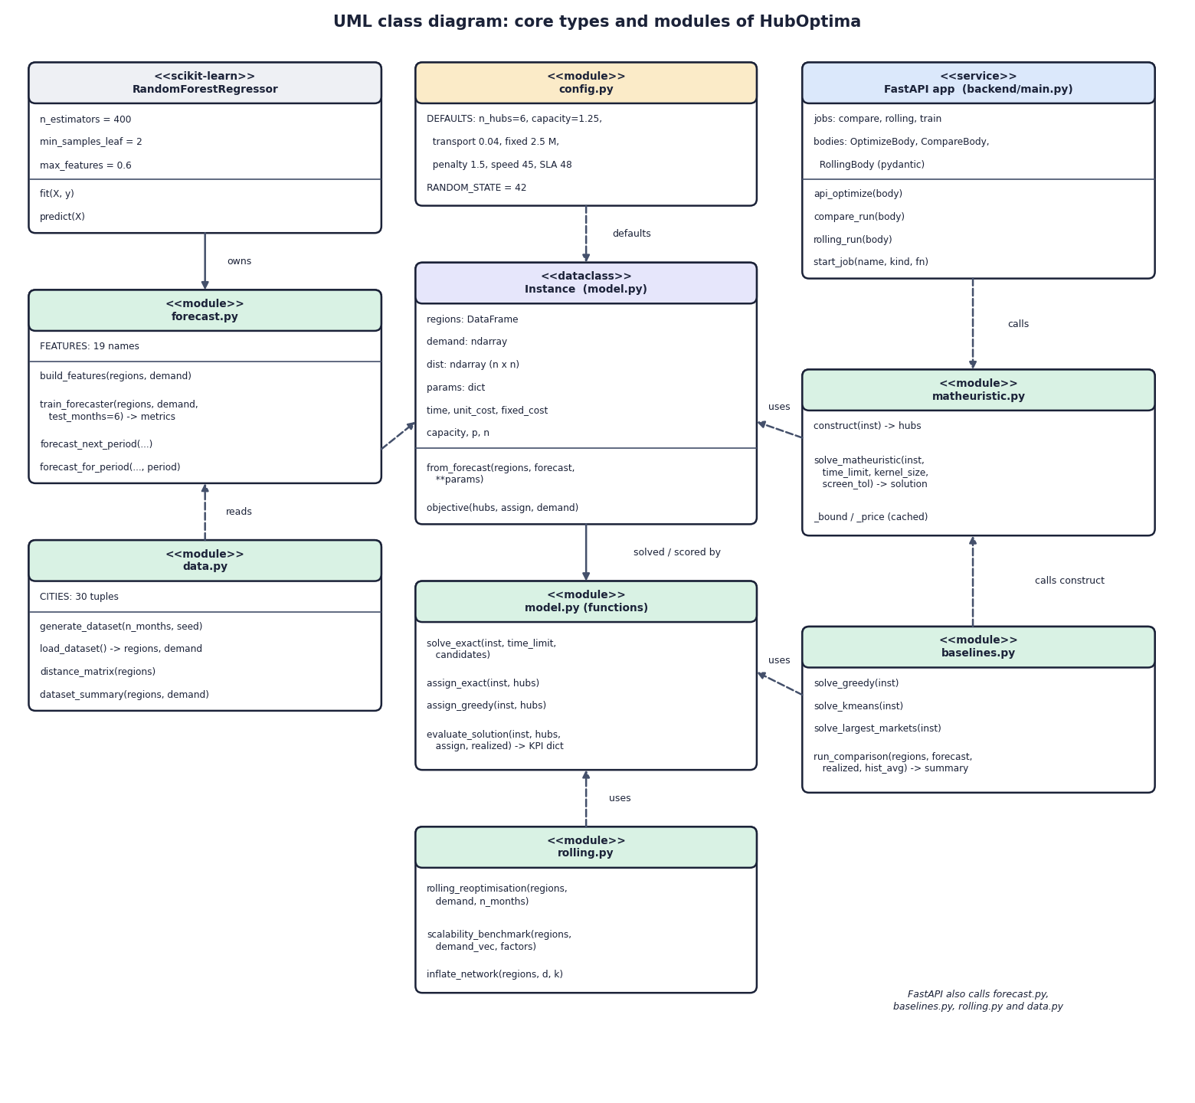
Fig. 5.6: UML class diagram
The core is the Instance dataclass, which holds the regions, the demand vector, the distance matrix and the parameters and derives the delivery time, the unit cost, the fixed cost per hub and the capacity. The functional modules model.py, matheuristic.py, baselines.py and rolling.py all take an Instance. forecast.py owns the RandomForestRegressor and data.py supplies the data. config.py holds the defaults. The FastAPI application only calls these modules; it defines the three request bodies and the job table.
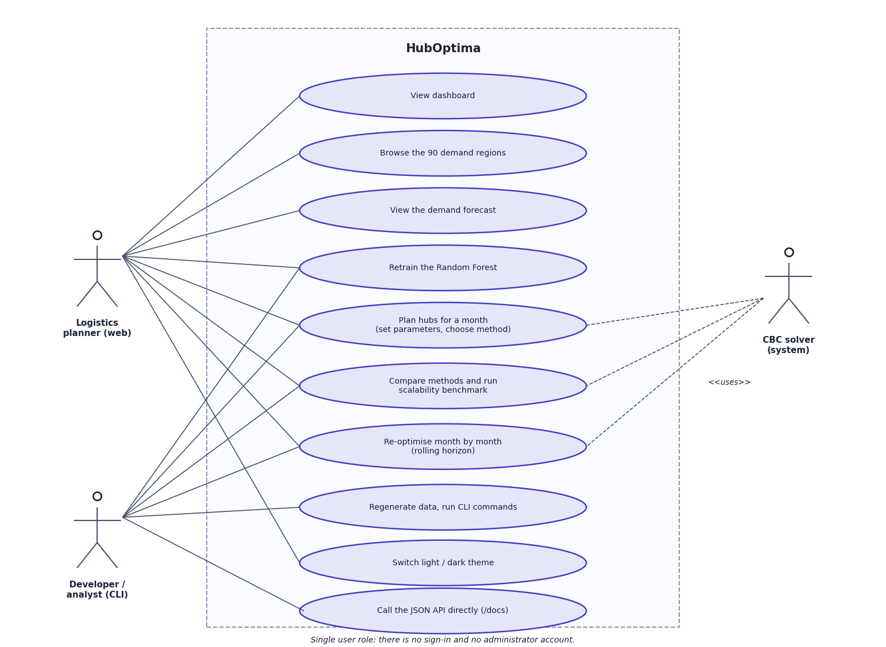
Fig. 5.7: Use-case diagram
The logistics planner browses the dashboard and regions, views and retrains the forecast, plans hubs, compares methods, runs the scalability benchmark, re-optimises over time and switches the theme. The developer or analyst uses the command line for the same functions and for regenerating the data, and may call the JSON API directly. The CBC solver is a system actor used by planning, comparison and re-optimisation.
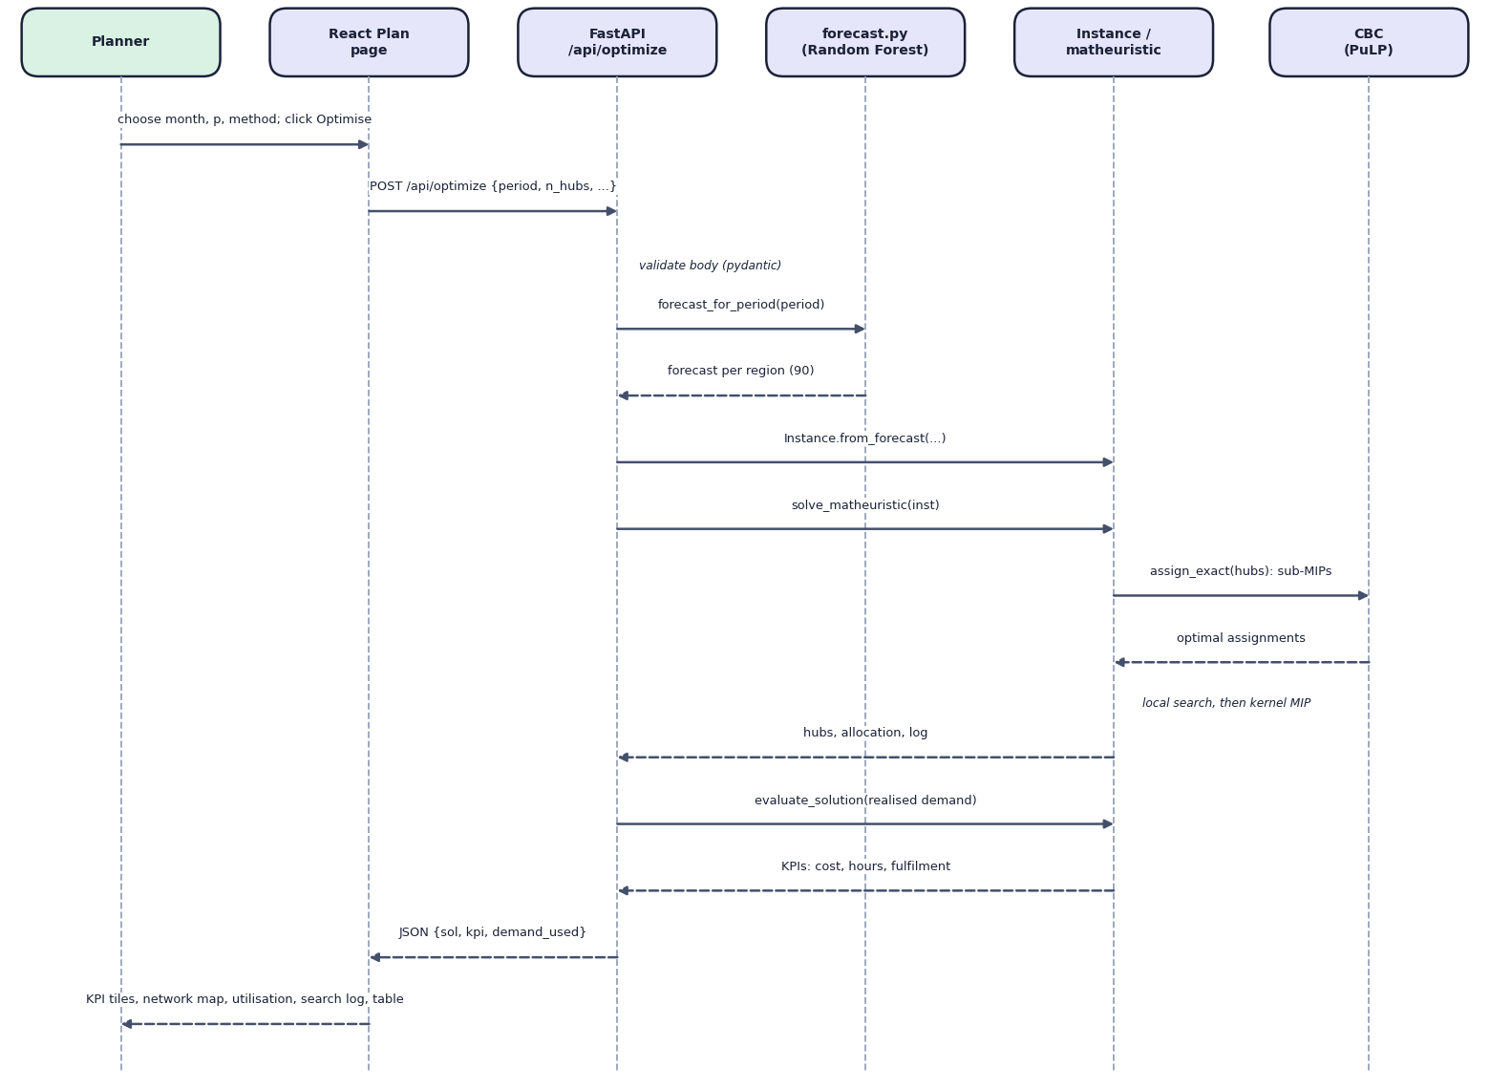
Fig. 5.8: Sequence diagram of the main flow: planning hubs
The planner chooses a month, the number of hubs and a method and clicks Optimise. The React page posts the body to /api/optimize. FastAPI validates it, obtains the forecast for that month using only earlier data, builds the Instance, and runs the matheuristic, which calls CBC for the assignment sub-problems. The result is scored on the realised demand by evaluate_solution and returned as JSON, which the page turns into KPI tiles, the network map, hub utilisation, the search log and the allocation table.

5.5 Data Model and Storage Design
The system keeps its data in files. This was a deliberate choice: the order history of a regional network (3,240 rows here) is small, the artefacts are easier to inspect and replace as files, and no server process or credentials are needed. The consequence is that there are no transactions and no multi-user access; background jobs overwrite result files.
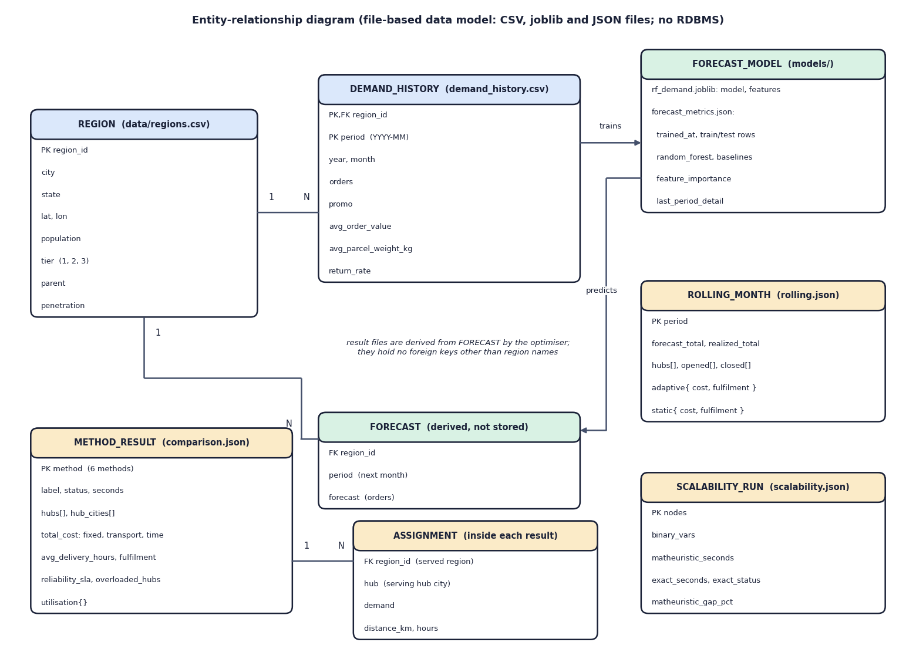
Fig. 5.9: Entity-relationship diagram of the file-based data model
HubOptima does not use a database. Its data are two CSV files, a joblib model with a JSON metrics file, and JSON result files. The diagram shows them as entities so that the relationships are explicit. A region has many monthly demand-history rows (primary key region and period). The forecast model is trained from the demand history and predicts a forecast per region, which is derived and not stored. The result files (method results with their region-to-hub assignments, rolling-horizon months and scalability runs) are produced by the optimiser from forecasts and hold region names rather than foreign keys.
Table 5.1: Files that form the data model
File | Fields | Rows / size | Written by
data/regions.csv | region_id, city, state, lat, lon, population (millions), tier (1-3), parent, penetration | 90 rows | python run.py data
data/demand_history.csv | region_id, period (YYYY-MM), year, month, orders, promo, avg_order_value, avg_parcel_weight_kg, return_rate | 3,240 rows (90 x 36) | python run.py data
models/rf_demand.joblib | the fitted RandomForestRegressor and its 19 feature names | 38.5 MB | train_forecaster
models/forecast_metrics.json | trained_at, train/test rows and periods, metrics of three forecasters, feature importance, December 2025 per-region detail | about 12 KB | train_forecaster
results/comparison.json | parameters, forecast and realised totals, and for each of six methods the hubs, costs, KPIs, utilisation and the 90-row allocation | about 118 KB | run_comparison
results/rolling.json | per month: forecast and realised totals, hubs, opened and closed hubs, adaptive and static KPIs; averages | about 6 KB | rolling_reoptimisation
results/scalability.json | per instance size: binary variables, matheuristic and exact time and objective, gap, exact status | about 1 KB | scalability_benchmark

Integrity rules in code. load_dataset drops duplicate (region, period) rows, coerces orders to numbers, sorts by region and period, interpolates gaps inside each region and drops rows that remain empty. tier and penetration receive defaults if absent, and year and month are derived from period if missing. These guards are not exercised by the generated data, which has no gaps, but they make a real file usable.

5.6 Module Breakdown
Table 5.2: Modules, sizes and responsibilities
Module | Lines | Responsibility | Main functions
config.py | 31 | Paths, random state, default model parameters | DEFAULTS, RANDOM_STATE
data.py | 177 | Dataset generation, loading, preprocessing, distances, summary | generate_dataset, load_dataset, distance_matrix, dataset_summary, haversine_km
forecast.py | 145 | Features, Random Forest training and evaluation, forecasting | build_features, train_forecaster, forecast_next_period, forecast_for_period
model.py | 203 | Instance, exact MIP, assignment sub-MIP, greedy assignment, KPI evaluation | Instance, solve_exact, assign_exact, assign_greedy, evaluate_solution
matheuristic.py | 167 | Construction, MIP-priced local search, kernel search | construct, solve_matheuristic, _bound, _price
baselines.py | 121 | Traditional methods and the comparison runner | solve_greedy, solve_kmeans, solve_largest_markets, run_comparison
rolling.py | 140 | Rolling-horizon simulation and the scalability benchmark | rolling_reoptimisation, inflate_network, scalability_benchmark
webapp.py | 349 | Original Flask interface and JSON API (port 5000) | create_app and five routes
backend/main.py | 272 | FastAPI layer for the React application (port 8104) | 14 endpoints, start_job, clean
run.py / tests.py | 135 / 72 | Command-line entry point and smoke tests | cmd_data ... cmd_serve; test_data ... test_webapp
frontend/src | 4,235 | React application: 7 pages, UI kit, charts, SVG map, theme | pages/*.jsx, components/ui, lib/api.js, useApi.js

5.7 User Interface Design
The web application is a single-page React application with a persistent sidebar (Dashboard, Forecast, Plan hubs, Compare methods, Re-optimise, Regions), a top bar showing the API and solver status, and a light and a dark theme. The theme follows the operating-system setting until the user chooses and is then remembered in the browser. The visual style, called 'Soft Pastel Calm' in the project documents, uses soft colours, rounded cards and short animations; animations respect the reduced-motion setting of the operating system (the SVG map uses useReducedMotion).
Table 5.3: Pages of the web application
Route | Page | What the user can do
/ | Landing | Read the pipeline in five steps and the headline results; open the app
/app | Dashboard | See the dataset size, forecaster accuracy and the monthly volume chart
/app/forecast | Forecast | Compare the Random Forest with the naive forecasters, see feature importance, search the next-month forecast per region, view the December back-test, retrain
/app/plan | Plan hubs | Set the month and parameters, choose matheuristic or exact, run, and read KPIs, the network map, utilisation, cost split, search log and allocation table
/app/compare | Compare methods | Run the six-method comparison for a month or the scalability benchmark in the background; see tables and charts
/app/rolling | Re-optimise | Run the rolling horizon for 2-12 months; see fulfilment and cost by month and the hub changes
/app/regions | Regions | Search and filter the 90 regions; see where demand sits on a map

5.7.1 Interaction details
- Validation before sending. The planning form checks every numeric field against the same ranges as the API (for example p between 1 and 20) and shows the message under the field.
- Progress and errors. While a plan is computed the page shows the four pipeline steps (forecast demand, build the model, solve, score) and the elapsed time; an infeasible plan produces an explanation rather than an empty page; a network error says that the API on port 8104 could not be reached.
- Background jobs. Comparison, scalability and rolling runs return immediately and the page polls /api/jobs every two seconds until the job finishes.
- Shared state. The Plan page keeps the last plan and form while the user visits other pages.
- Internet. The only external request is the Google Fonts stylesheet declared in index.html; without a connection the browser falls back to system fonts and the application works unchanged.

CHAPTER 6
METHODOLOGY AND SOFTWARE IMPLEMENTATION

6.1 Overall Methodology
The methodology follows the predict-then-optimise framework of the base paper [1] in eight stages. Each stage is a function of the hublocator package and a node of the data-flow diagrams in Chapter 5.
Table 6.1: Methodology stages
Stage | What happens | Module
1 Data | A seeded generator produces 90 regions and 36 months of orders; loading de-duplicates and fills gaps | data.py
2 Features | Lags 1, 2, 3, 6 and 12, rolling mean and standard deviation, trend, season, promotion and region attributes (19 features) | forecast.py
3 Forecaster | A Random Forest of 400 trees is trained on 2023-04 to 2025-06 and tested on 2025-07 to 2025-12 | forecast.py
4 Forecast | Next-month demand per region from the lag features; for a past month only earlier data is used | forecast.py
5 Model | Distances, delivery times, unit costs, fixed costs by tier and hub capacity form an Instance | model.py
6 Solve | Matheuristic (greedy construction, MIP-priced local search, kernel search) or the exact MIP | matheuristic.py, model.py
7 Evaluate | KPIs of the plan are computed on the realised demand: cost, delivery time, fulfilment, reliability, utilisation | model.py
8 Compare and adapt | Baselines, a scalability benchmark and a month-by-month rolling horizon | baselines.py, rolling.py

Plan, then judge. A plan is built from a forecast and judged on the realised demand. Capacity is sized from the planned demand, so if the realised demand is higher some hubs are overloaded and fulfilment falls below 100%. This separation is the heart of the evaluation and is how the effect of forecast error on the hub decision is made visible.

6.2 Dataset
No public region-level order dataset is referenced by the project and no company data was available, so the dataset is synthetic. It is produced by generate_dataset(seed=42) in hublocator/data.py and shipped in data/. All results in this report are produced on it and must be read with that in mind: the forecaster learns a demand process that the authors themselves wrote down.
Table 6.2: Dataset facts
Property | Value
Source | Generated by the project (seed 42); city coordinates and populations are approximate public values; no third-party licence applies
Regions | 90 = 30 Indian cities (tier 1: 8, tier 2: 14, tier 3: 8) plus 60 satellite districts 45-160 km away (3 per tier-1 city, 2 per tier-2, 1 per tier-3); 68 regions are tier 3 in total
History | 36 months, 2023-01 to 2025-12; 3,240 region-month rows
Total orders | 48,295,881; per region-month from 218 to 321,460
Network volume | 1,002,122 orders in 2023-01; peak 2,383,534 in 2025-10; 1,593,341 in 2025-12
Demand process | population x tier-specific penetration / 12, monthly growth 1.0-2.2%, festival multipliers (Oct 1.35, Nov 1.25, Jan 1.08, Aug 1.10), 0.93 in Feb and Jun, a promotion flag (18% random, always in Oct and Nov) with a 14% lift, and Gaussian noise with 6% standard deviation
Columns | demand_history: region_id, period, year, month, orders, promo, avg_order_value, avg_parcel_weight_kg, return_rate. regions: region_id, city, state, lat, lon, population, tier, parent, penetration
Split | Time-based: train 2023-04 to 2025-06 (2,430 rows), test 2025-07 to 2025-12 (540 rows). No random split, no cross-validation

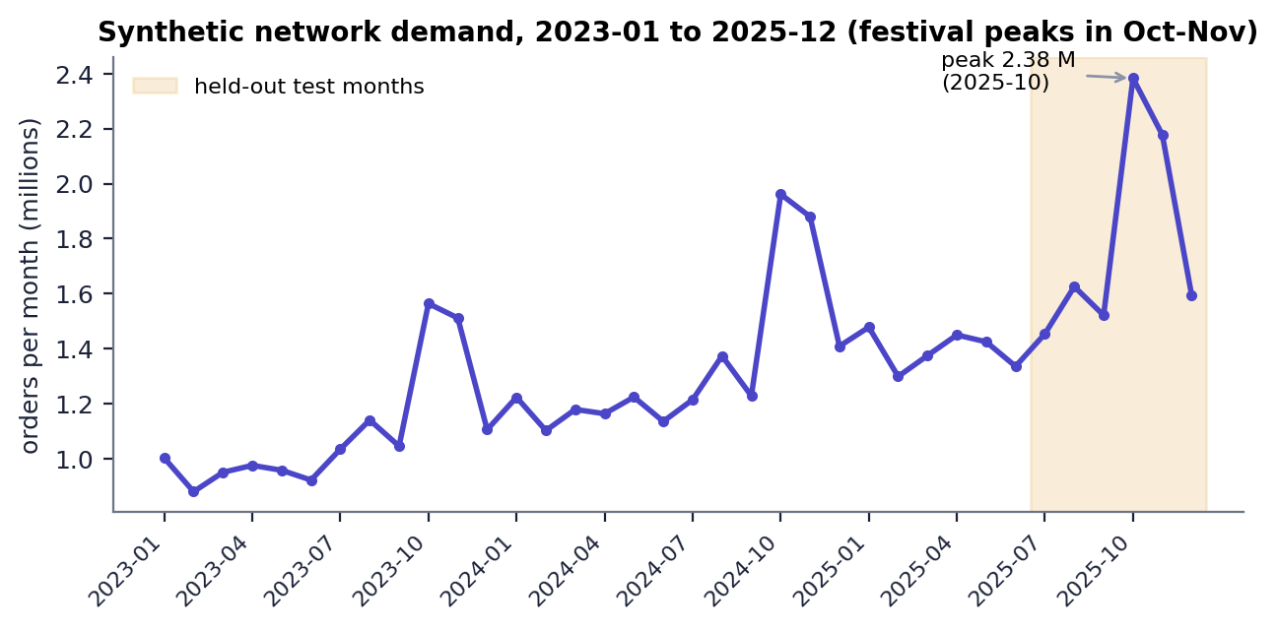
Fig. 6.1: Monthly network demand of the synthetic dataset, with the six test months shaded
The tier counts above count cities by their tier in the CITIES table; satellite districts are all tier 3, which is why 68 of the 90 regions are tier 3. Festival peaks in October and November and the upward trend are visible; the October 2025 peak (2.38 million orders) is higher than any earlier month, which matters for forecasting (see Chapter 8).

6.3 Data Preprocessing and Feature Engineering
Preprocessing is done by load_dataset and build_features. Because the generated data is complete, most guards are inactive; they exist so a real file of the same schema can be used.
1. Convert period to text and drop duplicate (region, period) rows.
2. Convert orders to numbers (non-numeric values become missing), sort by region and period.
3. Interpolate missing orders inside each region (both directions), then drop rows that are still empty and cast orders to integers.
4. Derive year and month from period if absent; give tier and penetration defaults if absent.
5. Merge the region attributes (population, tier, penetration) into the demand rows.
6. Per region, create lag features of orders at 1, 2, 3, 6 and 12 months; where the 12-month lag is not available it is filled with the 6-month rolling mean.
7. Create the rolling mean over 3 and 6 months and the rolling standard deviation over 3 months, all computed on values shifted by one month so that the current month never leaks into its own features.
8. Create trend_3 (lag 1 minus lag 3), quarter, festival (October, November, January, August) and the promotion flags for the month and the previous month.
9. Drop rows without the 3-month lag or rolling mean (the first months of each region).
Table 6.3: The 19 features of the forecaster
Group | Features
Lags | lag_1, lag_2, lag_3, lag_6, lag_12
Rolling | roll_mean_3, roll_mean_6, roll_std_3, trend_3
Calendar | month, quarter, festival
Promotion | promo, promo_prev
Region | population, tier, penetration
Market | avg_order_value, return_rate

The excerpt below is the lag and rolling-window part of build_features; the shift(1) before every rolling window is what keeps the features free of look-ahead.
Listing: hublocator/forecast.py - build_features
def build_features(regions: pd.DataFrame, demand: pd.DataFrame) -> pd.DataFrame:
df = demand.merge(regions[["region_id", "population", "tier", "penetration"]], on="region_id")
df = df.sort_values(["region_id", "period"]).copy()
g = df.groupby("region_id")["orders"]
for k in (1, 2, 3, 6, 12):
df[f"lag_{k}"] = g.shift(k)
df["roll_mean_3"] = g.transform(lambda s: s.shift(1).rolling(3).mean())
df["roll_mean_6"] = g.transform(lambda s: s.shift(1).rolling(6).mean())
df["roll_std_3"] = g.transform(lambda s: s.shift(1).rolling(3).std())
df["trend_3"] = df["lag_1"] - df["lag_3"]
df["quarter"] = (df["month"] - 1) // 3 + 1
df["festival"] = df["month"].isin(FESTIVAL_MONTHS).astype(int)
df["promo_prev"] = df.groupby("region_id")["promo"].shift(1)
df["lag_12"] = df["lag_12"].fillna(df["roll_mean_6"])
return df.dropna(subset=["lag_3", "roll_mean_3"]).copy()

6.4 Algorithm Choice and Justification

6.4.1 Random Forest for demand
A Random Forest [11] averages many decision trees, each grown on a bootstrap sample with a random subset of features at every split. It was chosen for the reasons given by the base paper [1] and for four practical ones: it handles the non-linear effects of season and promotion without feature scaling, it gives feature importances that a planner can read, it is robust to the noise in monthly demand, and it trains in under a second on 2,430 rows. Gradient boosting, neural networks and classical time-series models were not tried; the choice is therefore justified by the base paper and by the result against naive benchmarks, not by a tournament of models.

6.4.2 Capacitated hub-location MIP
The hub model is a mixed-integer program solved by CBC [15] through PuLP [14]. An exact MIP gives a quality reference: when it finishes, the plan is optimal for the model. It is also the building block of the heuristic.

6.4.3 Matheuristic
The full model has n + n^2 binary variables (8,190 for 90 regions, 73,170 for 270). Fixing the set of hubs, however, leaves only an assignment problem with n x |H| variables (540 for six hubs), which CBC solves quickly. The matheuristic therefore searches over hub sets and prices each set exactly [12]. Screening with a cheap estimate avoids most pricing calls, and a final kernel search [17] solves the full MIP over only about 24 candidate sites. Variable Neighbourhood Search [16], named in the base paper, was not implemented; the project's local search uses swap, drop and add neighbourhoods with first improvement.

6.4.4 Baselines
Table 6.4: Baseline methods
Method | How it chooses hubs | Why it is included
Greedy heuristic | Open the hub that most lowers the uncapacitated cost, repeat; allocate by capacity-aware nearest hub | Fast heuristic used in practice; no quality guarantee
k-means clustering [18] | Demand-weighted k-means on coordinates; hub = region nearest each centre | Standard clustering approach to hub placement
Largest-markets rule | Hubs at the p regions with the largest demand | Managerial judgement, no optimisation
Historical-average + matheuristic | Same solver but planned on the average of earlier months, with no forecast | Isolates the value of forecasting
Exact MIP | Full MIP with a time limit | Traditional exact method and optimality reference

6.5 Mathematical Formulation

6.5.1 Inputs derived from the data
Regions are indexed i, j = 1..n (n = 90); every region is a candidate hub site. With D_i the planned demand (forecast) of region i:
a = sin^2(dphi/2) + cos(phi_i) cos(phi_j) sin^2(dlambda/2)
dist_ij = 1.25 x 2R asin( sqrt(a) ), R = 6371 km (1)
t_ij = dist_ij / v + h (i != j), t_ii = h / 2 (2)
c_ij = r dist_ij + lambda t_ij (3)
f_j = F m(tier_j), m = 1.35, 1.0, 0.75 for tiers 1, 2, 3 (4)
C = kappa SUM_i D_i / p (5)
with v = 45 km/h, h = 6 h, r = INR 0.04 per order-km, lambda = INR 1.5 per order-hour, F = INR 2,500,000 per month, kappa = 1.25 and p = 6. The haversine formula [20] gives great-circle distance; the factor 1.25 turns it into an approximate road distance.

6.5.2 Optimisation model
Binary y_j = 1 if a hub is opened at j; binary x_ij = 1 if region i is served by hub j.
minimise SUM_j f_j y_j + SUM_i SUM_j c_ij D_i x_ij (6)
subject to SUM_j x_ij = 1 for every i (7)
x_ij <= y_j for all i, j (8)
SUM_i D_i x_ij <= C y_j for every j (9)
SUM_j y_j <= p (10)
x_ij = 0 whenever t_ij > SLA (optional hard service level) (11)
x_ij, y_j in {0, 1}
Equation (7) gives every region exactly one hub, (8) lets only open hubs serve, (9) is the hub capacity and (10) limits the number of hubs to p. The objective has three parts: a fixed hub cost, a transport cost proportional to distance and a delivery-time penalty. With a soft SLA (the default) late deliveries are only penalised through the time term and reported by the reliability KPI; with a hard SLA constraint (11) forbids them, which can make the problem infeasible. Compared with the base paper's model this one has a single capacity level, no unmet-demand variable and no robust objective.

6.5.3 Evaluation measures
A plan is a pair (H, a) of the hub set and the assignment a(i). Given the realised demand R_i, the load of hub j is L_j = SUM over i with a(i) = j of R_i, and the share a hub can serve is s_j = min(1, C / L_j). The KPIs are:
total cost = SUM_{j in H} f_j + SUM_i r dist_{i,a(i)} R_i + SUM_i lambda t_{i,a(i)} R_i (12)
average delivery time = SUM_i t_{i,a(i)} R_i / SUM_i R_i (13)
fulfilment = SUM_i s_{a(i)} R_i / SUM_i R_i (14)
SLA reliability = SUM_i 1[t_{i,a(i)} <= SLA] s_{a(i)} R_i / SUM_i R_i (15)
utilisation of hub j = L_j / C; overloaded hub: L_j > C (16)
Fulfilment and reliability are model quantities: a hub is assumed to process at most C orders, and the excess is counted as not fulfilled. They are not measured deliveries.

6.5.4 Forecast measures
On the test rows, MAE = mean |y - yhat|, RMSE = sqrt(mean (y - yhat)^2), MAPE = 100 x mean( |y - yhat| / max(y, 1) ) and R^2 = 1 - SS_res / SS_tot, following common practice [19].

6.6 Core Algorithm Flowchart
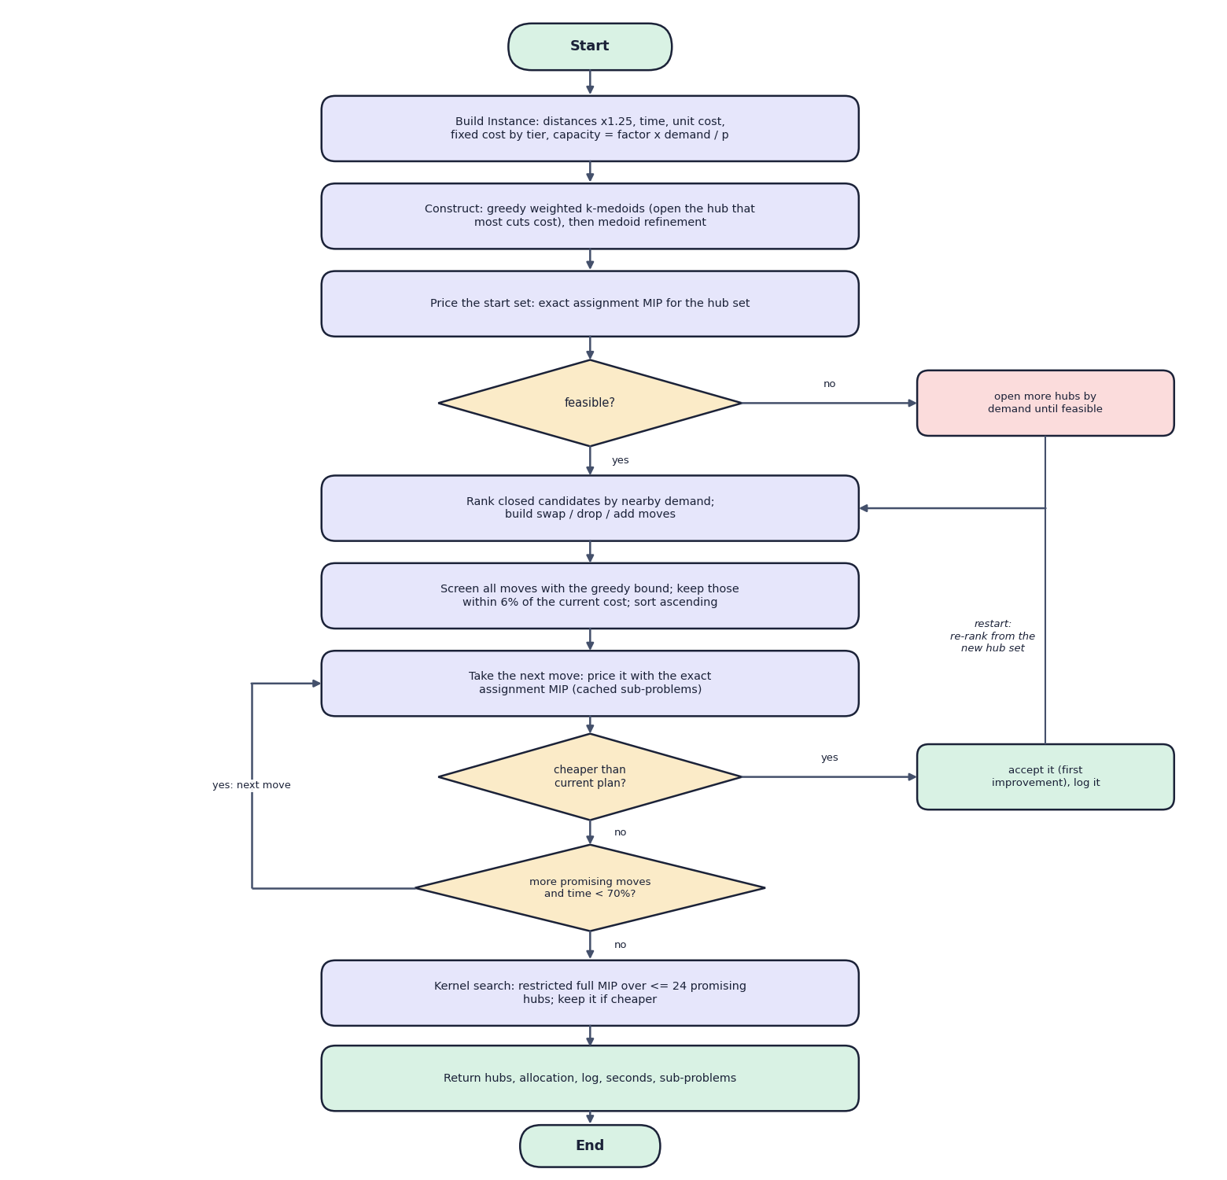
Fig. 6.2: Flowchart of the core algorithm: the matheuristic
The instance is built and a start set is constructed by a greedy weighted k-medoids rule followed by medoid refinement. It is priced by an exact assignment MIP; if it is infeasible, more hubs are opened by demand until it is feasible. The local search then ranks closed candidates, builds swap, drop and add moves, screens them with a greedy bound, and prices the best-screened move; a cheaper plan is accepted (first improvement) and the search restarts. When no promising move remains or 70% of the time is spent, the kernel search polishes the result and the best plan is returned.

6.7 Model Architecture and Training Configuration
Table 6.5: Random Forest configuration
Setting | Value
Model | scikit-learn RandomForestRegressor 1.4.2
Trees | 400 (n_estimators)
Depth / leaf | max_depth None; min_samples_leaf 2
Features per split | max_features 0.6 (60% of the 19 features)
Parallelism / seed | n_jobs -1; random_state 42
Target | orders of the region in the month (not log-transformed)
Training data | 2,430 rows, 2023-04 to 2025-06
Test data | 540 rows, 2025-07 to 2025-12 (never used for fitting)
Fit time | 0.8 s on an Intel Core i5-12500
Tuning | None: hyper-parameters were set once by the authors; no grid search and no cross-validation
Persistence | joblib file of the model and the feature list (38.5 MB); metrics in forecast_metrics.json

Optimiser configuration. Defaults come from config.DEFAULTS: p = 6, capacity factor 1.25, transport rate 0.04, fixed hub cost 2,500,000, time penalty 1.5, truck speed 45 km/h, handling 6 h, SLA 48 h (soft), time limit 20 s per MIP call. Matheuristic internals: kernel size 24, sub-problem limit 5 s, screening tolerance 6%, local search stops at 70% of the time limit. The scalability benchmark uses a 30 s matheuristic limit and a 40-45 s exact limit.

6.8 Application Architecture
The web application has three tiers. The React frontend (port 5104) never contains optimisation logic: it sends parameters to the API and draws what comes back. Vite proxies /api to the FastAPI service (port 8104), so the browser sees one origin. The FastAPI service loads the dataset and the model once at start-up and imports the functions of the hublocator package. Long computations (comparison, scalability benchmark, rolling horizon) run as background jobs in a thread, with a lock so that only one job of each kind runs at a time and with its status exposed at /api/jobs; training and planning run inside the request.
The classic interface of the original implementation (Flask, server-rendered, port 5000) is retained and runs the same functions, which keeps the numbers of the two interfaces identical.

6.9 Key Code Walkthroughs

6.9.1 Building the optimisation instance
The Instance constructor turns the regions, the demand vector and the parameters into the matrices used by every solver: delivery times, unit costs, tier-scaled fixed costs and the capacity of a hub.
Listing: hublocator/model.py - Instance.__post_init__
def __post_init__(self):
p = {**config.DEFAULTS, **self.params}
self.params = p
n = len(self.regions)
self.n = n
self.time = self.dist / p["truck_speed_kmph"] + p["hub_handling_hours"] # hours
np.fill_diagonal(self.time, p["hub_handling_hours"] * 0.5) # local delivery
self.unit_cost = p["transport_rate"] * self.dist + p["time_penalty"] * self.time
tier_mult = self.regions["tier"].map({1: 1.35, 2: 1.0, 3: 0.75}).fillna(1.0).to_numpy()
self.fixed_cost = p["fixed_cost_per_hub"] * tier_mult
total = float(self.demand.sum())
self.capacity = np.full(n, p["capacity_factor"] * total / p["n_hubs"])
self.p = int(p["n_hubs"])

6.9.2 Screening and pricing moves in the matheuristic
Every candidate move is first scored with the cheap greedy estimate; moves are sorted by it, the loop stops as soon as the estimate is more than 6% above the current objective, and the remaining moves are priced by the exact assignment MIP. The first strictly better plan is accepted and the search restarts.
Listing: hublocator/matheuristic.py - screen and price
scored = []
for kind, h, j in moves:
trial = [x for x in hubs if x != h] + ([j] if j is not None else [])
scored.append((_bound(inst, trial), kind, h, j, trial))
scored.sort(key=lambda t: t[0])
for b, kind, h, j, trial in scored:
if time.time() - t0 > time_limit * 0.7:
break
if b > obj * (1 + screen_tol):
break # greedy bound too poor to be worth a MIP
a, o = _price(inst, trial, cache, sub_time_limit)
if o < obj - 1e-6:
hubs, assign, obj, improved = trial, a, o, True
log.append({"phase": f"local-search {kind}", "hubs": sorted(hubs), "objective": o,
"t": round(time.time() - t0, 2)})
if verbose:
print(f" {kind:<5} -> {o:,.0f} hubs={[inst.regions.city[x] for x in hubs]}")
break # first improvement

6.9.3 Scoring a plan on realised demand
evaluate_solution is where forecast error becomes visible: capacity stays at the planned level while the load follows the realised demand, so an overloaded hub serves only the share that fits.
Listing: hublocator/model.py - evaluate_solution (core)
load = np.zeros(inst.n)
np.add.at(load, assign, d)
served = np.minimum(load, inst.capacity) # orders each hub can process
fulfil_by_hub = np.where(load > 0, served / np.maximum(load, 1e-9), 1.0)
fulfilment = float((fulfil_by_hub[assign] * d).sum() / total)

on_time = (t <= inst.params["sla_hours"]).astype(float)
reliability = float((on_time * fulfil_by_hub[assign] * d).sum() / total)

6.10 Implementation Decisions and Reasoning
Table 6.6: Implementation decisions
Decision | Reason | Consequence
Single allocation | Matches the classic p-hub median family [8] and keeps the assignment sub-problem small | No split flows; a distant region may be served by one far hub
Capacity = factor x planned demand / p | Ties capacity to the forecast so that forecast error shows as overload | Under-forecast leads to overloaded hubs; fulfilment below 100%
Soft SLA by default, hard SLA optional | A hard SLA can make a plan infeasible (the edge-case test uses 1 hub and a 5 h SLA); a soft SLA still penalises late delivery | Reliability is reported, not guaranteed
Price hub sets with an exact assignment MIP | Makes every accepted plan optimal for its hub set | About 14-18 sub-MIPs per search
Screen moves with a greedy estimate (6%) | Avoids pricing the large majority of moves | A good move whose estimate is poor can be missed
First-improvement with restart | Simple, and re-ranks candidates after each change | Search is not guaranteed to reach the global optimum
Kernel search of 24 candidates | Gives the exact solver a small enough model to finish | Result can be slightly worse than the full MIP (3.67% at 270 nodes)
Time-based split and no look-ahead | Mirrors real use: the future is not known | Only six test months
Model trained once; lags updated each month | Keeps re-optimisation fast (training takes under a second, so retraining is possible but was not done monthly) | The rolling horizon tests re-forecasting and re-planning, not re-training
Files instead of a database | Small data; artefacts easy to inspect and replace | No transactions or multi-user access
Thin API, shared package | One implementation for CLI, Flask and FastAPI | The numbers of all interfaces agree
Background jobs in threads | Comparison and rolling runs take 20 s to a few minutes | Single process; jobs are lost if the server stops

A caution about in-sample months. The Random Forest is trained on rows up to June 2025. For planning months before July 2025 the 'forecast' is therefore partly in-sample. All results reported in this document use the six test months (July to December 2025), for which the model saw no data.

6.11 API Design
Table 6.7: The 14 API endpoints
Method | Path | Purpose | Notes
GET | /api/health | status, version, solver, model present | used for the status chip and by run.bat
GET | /api/summary | dataset, forecaster, comparison and rolling digest | Dashboard
GET | /api/regions | the 90 regions with average orders | Regions page and the map
GET | /api/options | planning months, defaults, solver availability | fills the planning form
GET | /api/forecast | next-month forecast per region and model metrics | Forecast page
GET | /api/forecast/metrics | full metrics, importances, last-month detail | Forecast page
GET | /api/compare | saved comparison | Compare page
GET | /api/scalability | saved scalability runs | Compare page, Scalability tab
GET | /api/rolling | saved rolling-horizon results | Re-optimise page
GET | /api/jobs | state of background jobs | polled every 2 s while a job runs
POST | /api/train | retrain the forecaster (synchronous) | 409 if already running
POST | /api/optimize | plan hubs for a month | validated body; returns solution, KPIs, demand used
POST | /api/compare/run | start a comparison or scalability job | 409 if a job is running
POST | /api/rolling/run | start a rolling-horizon job (2-12 months) | 409 if a job is running

The request and response below were recorded from the running service (December 2025, four hubs, matheuristic). The response is trimmed for length; the full response also contains the 90-row allocation and the demand vector.
Listing: request body of POST /api/optimize
{
"period": "2025-12",
"n_hubs": 4,
"method": "matheuristic"
}

Listing: response of POST /api/optimize (trimmed)
{
"period": "2025-12",
"realized": true,
"sol": {
"status": "Matheuristic",
"hubs": [
1,
2,
5,
39
],
"objective": 54722309.15060887,
"seconds": 2.34,
"iterations": 1,
"subproblems_solved": 14,
"kernel_status": "Optimal"
},
"kpi": {
"n_hubs": 4,
"hub_cities": [
"Mumbai",
"Delhi",
"Kolkata",
"Bengaluru-N"
],
"total_cost": 50039855.0,
"fixed_cost": 12000000.0,
"transport_cost": 14358230.0,
"time_cost": 23681626.0,
"cost_per_order": 31.406,
"avg_delivery_hours": 9.91,
"max_delivery_hours": 27.07,
"avg_distance_km": 225.3,
"fulfilment_rate": 1.0,
"reliability_sla": 1.0,
"overloaded_hubs": 0,
"utilisation": {
"1": 0.892,
"2": 0.751,
"5": 0.431,
"39": 0.828
}
},
"kpi.assignment[0]": {
"region": "Hyderabad",
"region_id": "R001",
"hub": "Bengaluru-N",
"demand": 90287,
"distance_km": 546.7,
"hours": 18.1
},
"demand_used": "[90 values]"
}

The four original JSON contracts of the Flask interface (/api/forecast, /api/optimize, /api/compare, /api/rolling) keep their response shapes in the FastAPI layer, which the smoke test checks.

6.12 Security and Error Handling

6.12.1 Error handling
Table 6.8: Error handling
Situation | Behaviour | Checked by
Body out of range (for example n_hubs = 0) | HTTP 422 with the field and the reason (pydantic) | smoke test
Unknown planning month | HTTP 400 with 'Unknown planning month 1999-01.' | smoke test
A job of the same kind is already running | HTTP 409 with an explanation | code review
Infeasible plan (for example a hard SLA that cannot be met) | 200 with an error field: 'No feasible solution (try more hubs, a larger capacity factor or a soft SLA)' | smoke test (hard-SLA edge case)
Exception inside a solver or a job | Caught; the message is returned (planning) or stored in the job status (jobs) | code review
NaN or infinity in a result | Converted to null so that the JSON is valid | code review
API not reachable from the browser | The page says the backend on port 8104 could not be reached | browser walkthrough

The validation message recorded for n_hubs = 0 is: 'Input should be greater than or equal to 1' on field n_hubs.

6.12.2 Security
- CORS is limited to http://localhost:5104 and http://127.0.0.1:5104.
- No secrets are stored: the .env file contains only the two port numbers.
- Request bodies are validated with types and ranges, which bounds the work a request can ask for (for example time limit 2-300 s, p 1-20).
- There is no authentication, authorisation or rate limiting. Anyone who can reach port 8104 can retrain the model or start jobs that overwrite the result files. The application is therefore meant for a trusted local machine; this is recorded as a limitation, and no penetration test was carried out.

6.13 Installation and Execution
Requirements. Python 3.10 or later and Node.js 18 or later. On Windows, double-click run.bat in 8.ProjectCode; it reads the ports from .env, installs missing Python and npm packages, starts the API and waits for /api/health, starts the web server and opens http://localhost:5104.
Listing: installation and commands
pip install -r backend/requirements.txt
python -m uvicorn backend.main:app --host 127.0.0.1 --port 8104 # terminal 1
cd frontend && npm install && npm run dev # terminal 2 -> http://localhost:5104

python run.py forecast # train the Random Forest (about 1 s)
python run.py optimize --period 2025-10 --hubs 6
python run.py compare --period 2025-10
python run.py rolling --months 6
python run.py benchmark --factors 1 2 3
python tests.py # four smoke tests
python scripts/smoke_test.py # 18 API checks

A trained model and pre-computed results are included, so the application works immediately. Retraining, comparison, benchmark and rolling runs overwrite models/ and results/.

CHAPTER 7
SYSTEM TESTING

7.1 Testing Strategy
Testing had three layers: Python tests of the science and of the original web application (tests.py), an API smoke test of the FastAPI layer that the React application uses (scripts/smoke_test.py), and scripted browser walkthroughs of the finished application (Playwright driving Chrome) that also produced the screenshots. All of them were run on 15 October 2026 on the machine described below. The optimisation results themselves are the product of the experiments of Chapter 8, not of tests.
Table 7.1: Testing layers
Layer | Tool | What it checks | Result
Unit and module | tests.py (4 functions) | data schema and distances, forecast contract, optimisation constraints, Flask pages | 4 of 4 passed (32.7 s)
API integration | scripts/smoke_test.py (18 checks) | every endpoint, validation, edge cases, exact versus matheuristic | 18 of 18 passed (20.9 s)
Functional (browser) | scripts/capture_screens.py | 7 routes, 3 planning runs through the form, comparison, scalability and rolling screens, dark mode, not-found page | 22 screens captured with real data
Performance | Python timer over HTTP | latency of every read endpoint and the planning endpoint | see Section 'Performance Testing'
Acceptance | - | user acceptance by real planners | not done

Test machine. Intel Core i5-12500 (6 cores, 12 threads), 15.7 GB RAM, Windows 11 Pro, Python 3.11.9, Node.js v24.19.0.

7.2 Unit and Module Tests
Table 7.2: Assertions of tests.py
Test function | What it asserts
test_data | at least 30 regions and 24 months; required columns present; the distance matrix is square, has a zero diagonal and the first distance exceeds 100 km
test_forecast | a model exists (trained if missing); the next-month forecast covers every region and is positive; the forecast of October 2025 from earlier data is within 30% of the realised network total
test_optimisation | a 5-hub matheuristic plan opens at most 5 hubs and assigns every region to an open hub; planned fulfilment is at least 0.99 with no overloaded hub; the matheuristic objective is within 2% of the exact MIP; with a hard 30 h SLA every assignment is within 30 h
test_webapp | the five Flask pages return 200; POST /api/optimize returns a plan with at most 4 hubs on realised demand; /api/forecast returns a positive total

All four tests passed. Notably, the test of the matheuristic against the exact MIP requires agreement within 2%, which is consistent with the identical results found in the comparison experiment at 90 nodes.

7.3 API Integration Tests
The smoke test runs against the FastAPI application in-process (it can also be pointed at running servers with --url and --frontend). It stops at the first failing check; all 18 passed.
Table 7.3: The 18 smoke checks and what they observed
# | Check | Detail observed
1 | health | status ok, solver reported (CBC via PuLP)
2 | summary: dataset | 90 regions x 36 months
3 | summary: forecaster trained | model file present
4 | regions with coordinates | 90 rows with latitude and longitude
5 | options | next month first in the list, defaults present
6 | forecast (original contract) | 2026-01: 1,788,825 orders, 90 regions
7 | forecast metrics | MAPE present, city names attached
8 | compare (original contract) | proposed method present
9 | scalability | list returned
10 | rolling (original contract) | timeline present
11 | optimize: matheuristic on a past month | 4 hubs for Dec 2025, scored on realised demand
12 | optimize: allocation covers every region | 90 assignments
13 | optimize: next month on forecast | scored on the forecast, not realised demand
14 | optimize: exact MIP | status Optimal
15 | optimize: hard-SLA edge case | 1 hub, 5 h hard SLA: answered cleanly (plan, reliability 0.1957)
16 | optimize: validation rejects n_hubs = 0 | HTTP 422
17 | optimize: unknown month rejected | HTTP 400
18 | jobs status | compare and rolling jobs listed

7.4 Functional Testing
Table 7.4: Functional scenarios
Scenario | Steps | Expected | Observed
Browse every page | Open /, /app, /app/forecast, /app/regions, /app/compare, /app/rolling and an unknown route | Each loads with data from the API; unknown route shows the not-found page | As expected (screens 1-7, 15-22)
Plan a past month | Plan hubs: Oct 2025, p = 6, matheuristic, defaults | 6 hubs, scored on realised demand | Mumbai, Delhi, Kolkata, Hyderabad-W2, Bengaluru-SE, Ahmedabad-SE; INR 62.2 M; 92.3% fulfilment; 9.23 s
Plan the next month | Plan hubs: Jan 2026, p = 6 | Scored on the forecast, not realised demand | As expected; label 'scored on the forecast'
Compare with exact MIP | Plan hubs: Oct 2025, p = 6, exact MIP | Same cost if the matheuristic is optimal | Same hubs and cost; status Optimal; 9.29 s
View saved comparison | Compare methods page | Six methods with KPIs and charts | As expected; values equal results/comparison.json
View scalability | Compare methods > Scalability | Three instance sizes with times and status | As expected; 270 nodes shows 'Not Solved' for the exact MIP
View rolling horizon | Re-optimise page | Six months, adaptive vs static | As expected; 98.3% vs 83.7%
Dark theme | Open the app with a dark operating-system preference | Dark colours, readable charts | As expected (screen 21)

Long jobs (re-running the comparison, the benchmark or the rolling horizon) were not re-run during the walkthrough to avoid overwriting the saved results; their start, polling and completion path is covered by the optional --jobs flag of the smoke test, which was not used in this run.

7.5 Security Testing
Security testing was limited to input validation and configuration review. The API rejects out-of-range bodies with HTTP 422 and unknown months with HTTP 400, restricts CORS to the web port and stores no secrets. No authentication, authorisation, rate limiting or injection testing exists because the application has no users or database; no penetration test was performed. These are stated limitations, not passed tests.

7.6 Validation and Edge Cases
Table 7.5: Edge cases
Edge case | Input | Result
Zero hubs | n_hubs = 0 | HTTP 422: 'Input should be greater than or equal to 1' on field n_hubs
Unknown month | period = 1999-01 | HTTP 400: 'Unknown planning month 1999-01.'
Hard SLA that cannot be met | 1 hub, SLA 5 h, hard, Dec 2025 | Answered cleanly with a valid JSON plan (reliability 0.1957), no crash
Hard SLA 30 h | 8 hubs, SLA 30 h hard (tests.py) | Every assignment within 30 h
Exact MIP stopped by its time limit | 270-node scalability instance, time-limited exact MIP | Status 'Not Solved' is reported (wall time 67.14 s including model construction); the incumbent objective INR 53.43 M is reported
Capacity exceeded by realised demand | Oct 2025 peak, forecast 13.2% low | 3 of 6 hubs overloaded; fulfilment 92.3%; reported rather than hidden
Second background job | POST /api/compare/run while one runs | HTTP 409
Missing model file | models/rf_demand.joblib absent | The API trains the model at start-up (same behaviour as the command line)

7.7 Performance Testing
Timings were taken over HTTP on localhost with the servers running (Intel Core i5-12500 (6 cores, 12 threads), 15.7 GB RAM, Windows 11 Pro, Python 3.11.9, Node.js v24.19.0); n is the number of calls, the median and range are in the table. The planning calls include forecasting, instance construction, the solve and the evaluation, so they are slower than the solver-only times stored in the result files (for example 4.89 s for the matheuristic in the saved comparison).
Table 7.6: Latency of read endpoints
Endpoint | Median (ms) | Range (ms) | n
GET /api/health | 10 | 2-27 | 20
GET /api/summary | 30 | 4-37 | 20
GET /api/regions | 16 | 2-32 | 20
GET /api/forecast (next month, 90 regions) | 264 | 200-343 | 10
GET /api/forecast/metrics | 4 | 2-24 | 10
GET /api/compare | 11 | 8-35 | 10
GET /api/rolling | 3 | 2-14 | 10
GET /api/scalability | 2 | 1-30 | 10

Table 7.7: Latency of the planning endpoint
Planning call | Median | Range | n
POST /api/optimize, matheuristic, Oct 2025, p = 6 | 12.2 s | 9.2-13.4 s | 5
POST /api/optimize, exact MIP, Oct 2025, p = 6 | 15.3 s | 13.4-15.7 s | 3
POST /api/optimize, matheuristic, next month, p = 6 | 10.7 s | 9.6-13.2 s | 5
POST /api/optimize, matheuristic, Dec 2025, p = 4 | 3.4 s | 3.2-4.1 s | 5

- Read endpoints answer in 2-30 ms; the forecast endpoint takes 0.26 s because it builds features for 90 regions.
- Planning takes about 3 s for four hubs and 11-12 s for six hubs. At 90 nodes the exact MIP (15.3 s) is slower than the matheuristic (12.2 s) end to end but not dramatically; in the UI runs the solver-only times were 9.23 s and 9.29 s.
- Run-to-run variation of several seconds comes from CBC and from sharing the processor with the browser; the saved comparison measured 4.89 s (matheuristic) and 7.99 s (exact) for the same instance.

7.8 User Acceptance Testing
User acceptance testing was not performed. No real logistics planner has used the application. The walkthroughs above show that the screens work with real data; they do not show that the screens are understandable or useful to the intended users. A pilot with planners is the first item of future work.

7.9 Limits of the Testing Done
- No automated tests of the React frontend; it was checked by walkthroughs and a production build only.
- No concurrent-user or load test, no memory profile and only one machine; timings will differ elsewhere.
- No cross-validation or repeated seeds for the forecaster, and no statistical tests; the 18 smoke checks and 4 unit tests verify behaviour, not accuracy.
- The experiments of Chapter 8 are single runs on one synthetic dataset; run-to-run solve times vary by several seconds.
- Security was reviewed, not attacked.
- No user acceptance study.

CHAPTER 8
RESULTS AND OUTPUT SCREENS

8.1 Demand Forecast Results
The Random Forest was fitted on 2,430 region-months (2023-04 to 2025-06) and evaluated on the 540 region-months of July to December 2025, which it never saw. Two naive forecasters are scored on the same rows: the last month's value and the three-month moving average.
Table 8.1: Forecast accuracy on the held-out months
Forecaster | MAE (orders) | RMSE (orders) | MAPE (%) | R-squared
Random Forest (proposed) | 1,984.0 | 6,618.9 | 7.67 | 0.9766
Last month's value | 4,151.1 | 12,604.1 | 19.71 | 0.9152
3-month moving average | 3,785.5 | 11,882.0 | 17.56 | 0.9246

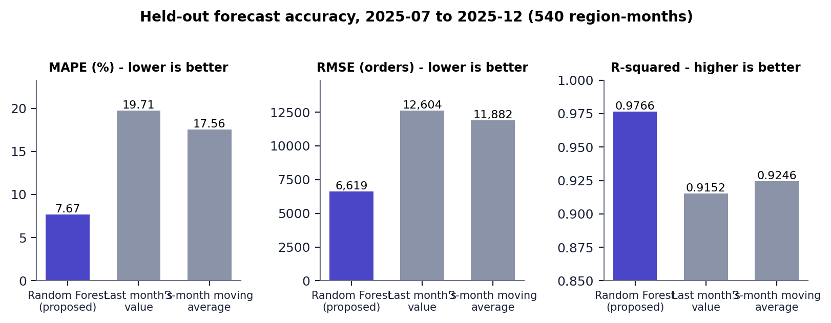
Fig. 8.1: Held-out accuracy of the three forecasters
The Random Forest roughly halves the error of both naive forecasters: MAE 1,984 against 4,151 and 3,786, MAPE 7.67% against 19.71% and 17.56%. These are results on a synthetic series whose generating process the model can learn; they should not be read as accuracy that would be achieved on real orders.

8.1.1 What the model relies on
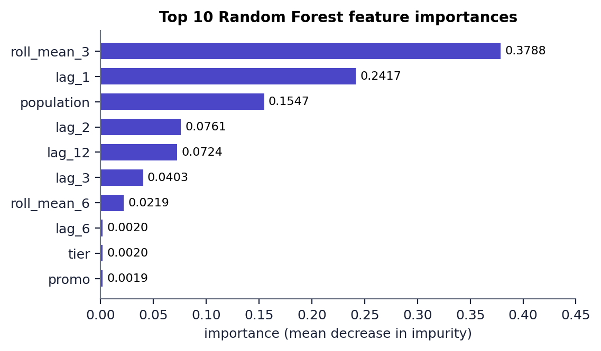
Fig. 8.2: Top 10 Random Forest feature importances
Three features carry almost all of the importance: the three-month rolling mean (0.379), the previous month's orders (0.242) and the region's population (0.155). The calendar features that encode the festival peak have very small importance (festival 0.0017, month 0.0011, promo 0.0019). This is consistent with the dataset: the level of a region is the main driver, and the trees appear to take most of the festival effect from recent lags rather than from the calendar.

8.1.2 Error by region and by month
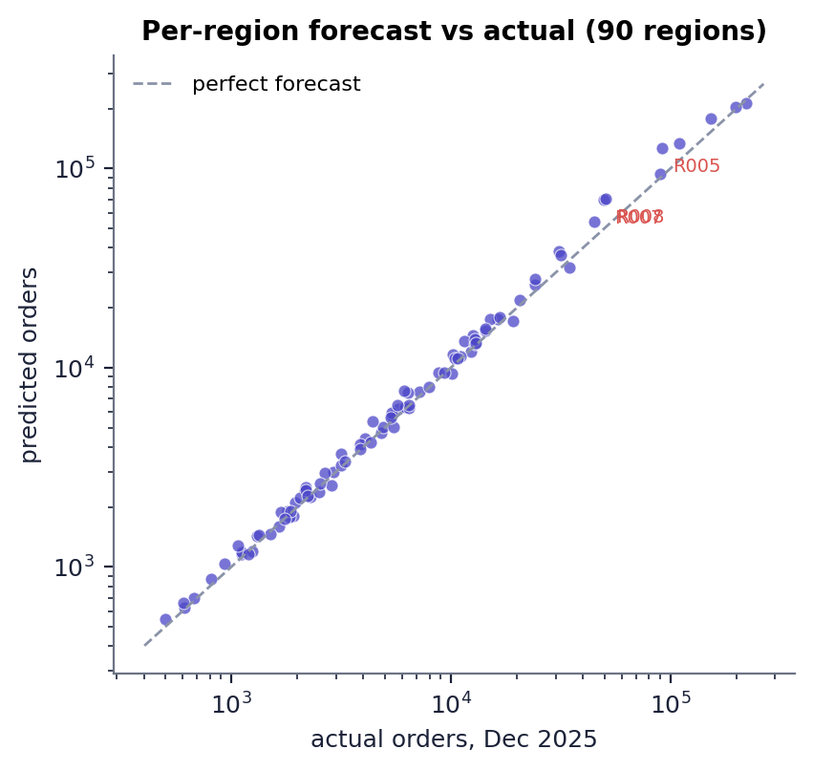  Fig. 8.3: Per-region forecast and actual orders, Dec 2025 | 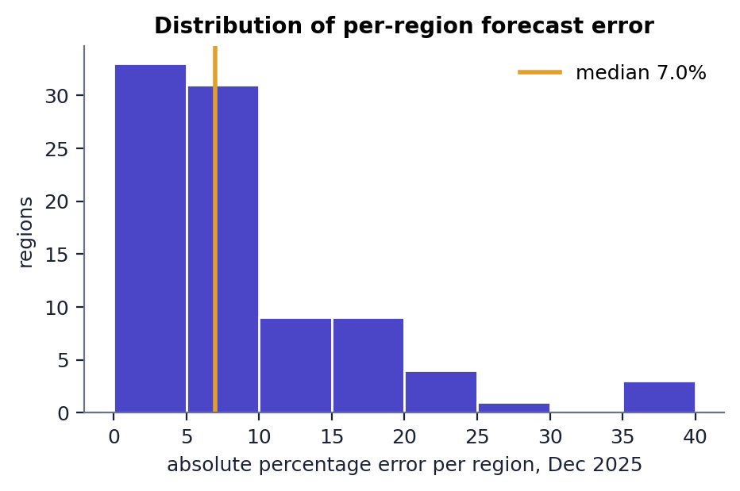  Fig. 8.4: Distribution of per-region error, Dec 2025

In December 2025 the median absolute error across the 90 regions is 7.0% and the mean 8.9%; 8 regions exceed 20%. The worst are Pune (39.9%), Ahmedabad (39.3%), Chennai (39.0%), all over-forecasts of large tier-1 cities.
Table 8.2: Network-level forecast error by test month
Month | Forecast total | Realised total | Network error (%)
2025-07 | 1,409,247 | 1,453,765 | 3.06
2025-08 | 1,569,092 | 1,625,632 | 3.48
2025-09 | 1,430,570 | 1,521,247 | 5.96
2025-10 | 2,071,229 | 2,383,534 | 13.10
2025-11 | 2,145,198 | 2,177,565 | 1.49
2025-12 | 1,756,241 | 1,593,341 | 10.22

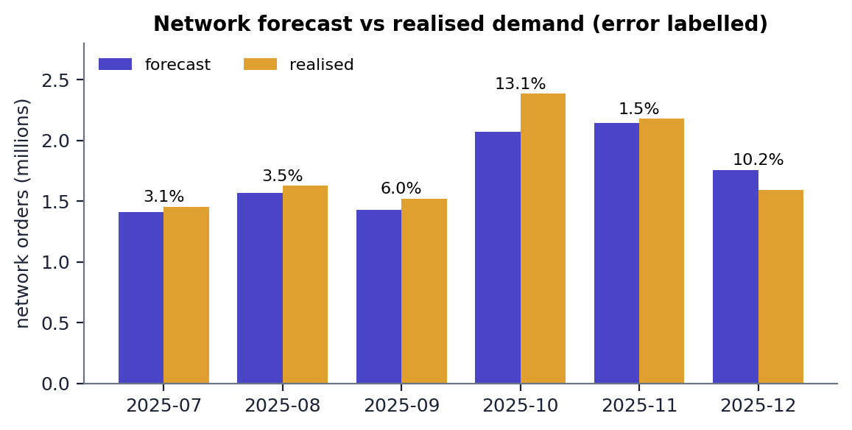
Fig. 8.5: Network forecast against realised demand, July to December 2025
Network errors are small in ordinary months (1.5-6.0%) and large at the festival peak (13.1% in October, an under-forecast) and in December (10.2%, an over-forecast after the peak). The October 2025 volume (2.38 million orders) is higher than any month the model was trained on (the previous maximum was 1.96 million in October 2024); a forest cannot predict beyond the range of the targets it has seen, so this is a likely cause of the under-forecast, although the project did not test it further.

8.2 The Proposed Plan for October 2025
The matheuristic, planned on the forecast of 2,067,718 orders and scored on the 2,383,534 orders that occurred, opens six hubs: three tier-1 cities (Mumbai, Delhi, Kolkata) and three satellite districts (Hyderabad-W2, Bengaluru-SE, Ahmedabad-SE).
Table 8.3: Hubs of the proposed plan, Oct 2025 (scored on realised demand)
Hub | Regions served | Realised demand | Utilisation | Longest delivery (h) | Mean distance (km)
Mumbai | 9 | 473,277 | 110% (over) | 10.0 | 133
Delhi | 12 | 524,850 | 122% (over) | 17.8 | 284
Kolkata | 16 | 346,521 | 80% | 27.2 | 424
Hyderabad-W2 | 18 | 253,915 | 59% | 25.4 | 453
Bengaluru-SE | 16 | 478,108 | 111% (over) | 16.2 | 264
Ahmedabad-SE | 19 | 306,863 | 71% | 37.7 | 582

Table 8.4: KPIs of the proposed plan
Measure | Value
Operating cost | INR 62,157,534 per month (INR 26.08 per order)
Fixed / transport / delivery-time penalty | INR 15,750,000 / 15,818,196 / 30,589,338
Average / maximum delivery time | 8.56 h / 37.71 h
Average distance | 165.9 km
Simulated fulfilment / SLA reliability (48 h) | 92.3% / 92.3%
Overloaded hubs | 3 of 6
Solver time (saved comparison) | 4.89 s (matheuristic), 7.99 s (exact MIP)

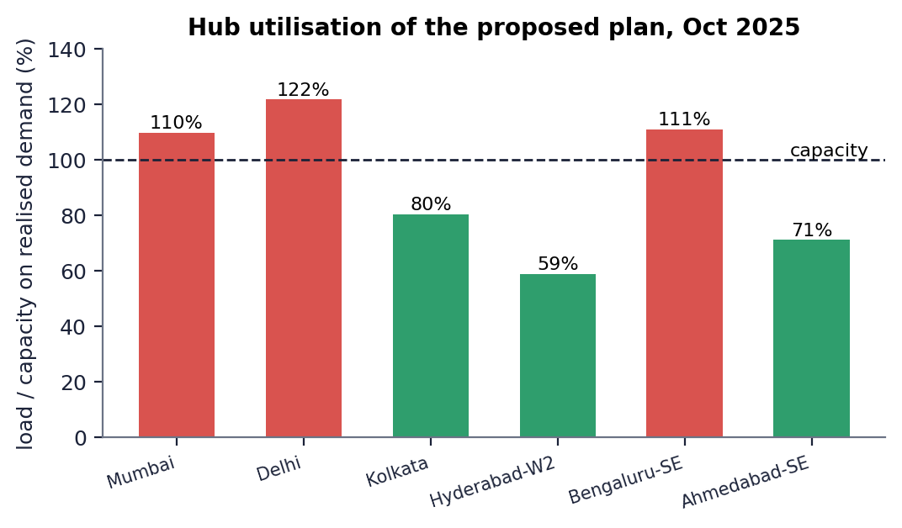
Fig. 8.6: Hub utilisation of the proposed plan on realised demand
Delhi (122%), Bengaluru-SE (111%) and Mumbai (110%) are above capacity. Capacity was sized from the forecast, which was 13.2% below the realised demand, so the three hubs that serve the biggest markets run over, and 7.7% of the realised orders are counted as unfulfilled. No hub is far under-used except Hyderabad-W2 (59%). The longest delivery (37.7 h to Dehradun-N through Ahmedabad-SE, 1,427 km) is within the 48 h SLA; with only six hubs, the north of the country is served from distant hubs.

8.3 Comparison with Traditional Methods
All methods plan the same month (October 2025) from the same forecast with p = 6 hubs and are scored on the realised demand. The exact MIP had a 30 s time limit.
Table 8.5: Methods compared on October 2025 (p = 6)
Method | Cost (INR M) | vs proposed | Avg delivery (h) | Fulfilment | Overloaded | Solve (s)
RF forecast + matheuristic (proposed) | 62.16 | reference | 8.56 | 92.3% | 3 | 4.89
RF forecast + exact MIP (CBC) | 62.16 | +0.00% | 8.56 | 92.3% | 3 | 7.99
RF forecast + greedy heuristic | 69.31 | +11.51% | 9.47 | 89.3% | 3 | 0.01
RF forecast + k-means clustering | 64.41 | +3.62% | 9.19 | 91.8% | 3 | 0.11
Largest-markets rule (no optimisation) | 72.15 | +16.08% | 8.96 | 91.1% | 3 | 0.00
Historical-average demand + matheuristic (no forecast) | 67.17 | +8.07% | 9.91 | 66.0% | 5 | 3.60

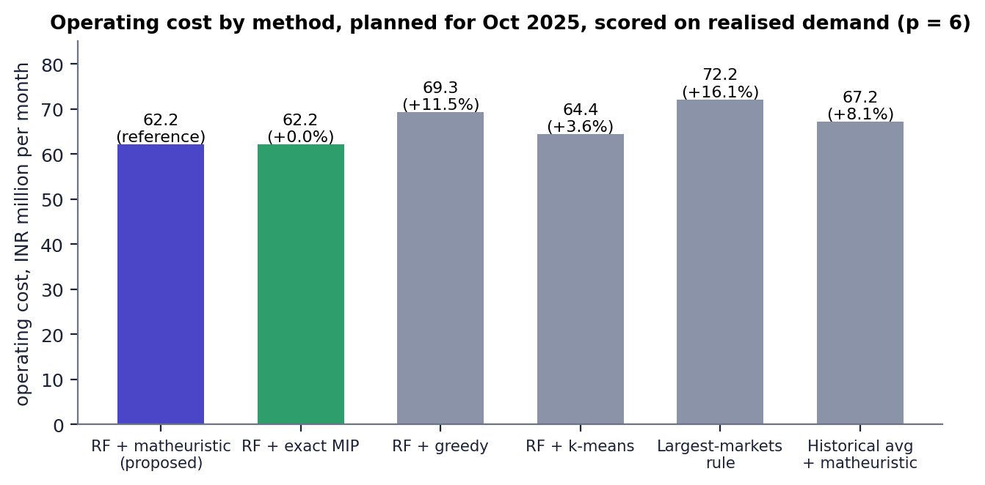
Fig. 8.7: Operating cost by method
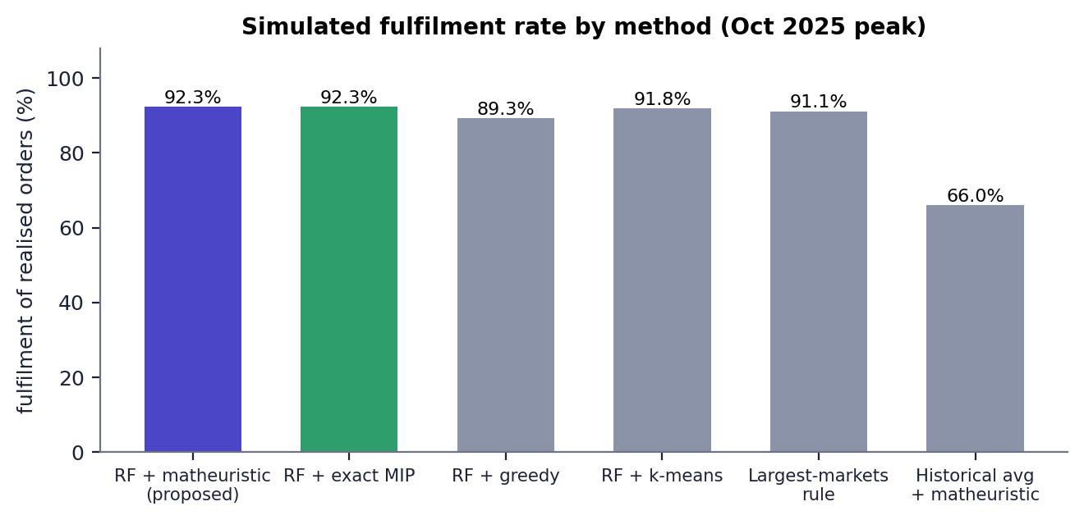
Fig. 8.8: Simulated fulfilment by method
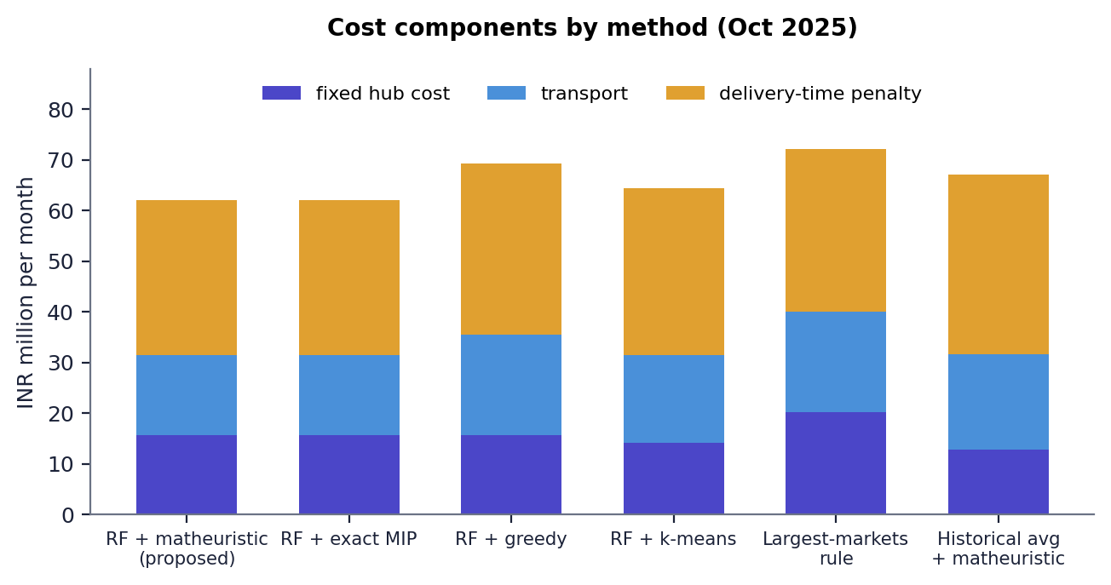
Fig. 8.9: Cost components by method

8.3.1 Reading the comparison
- The matheuristic equals the exact MIP. Both open the same six hubs and cost INR 62.16 M; CBC proved the exact plan optimal in 7.99 s against 4.89 s. On a 90-region network the matheuristic confirms the optimum but does not yet save much time (Section 'Scalability').
- Heuristics cost more. Greedy is 11.5% more expensive (it opens Nagpur-N instead of Ahmedabad-SE and has the lowest fulfilment of the forecast-based methods, 89.3%); k-means is 3.6% more expensive; the largest-markets rule is 16.1% more expensive and has the longest delivery of any plan (50.0 h maximum, beyond the 48 h SLA).
- Forecasting matters. Planning on the historical average costs 8.1% more in the model and serves only 66.0% of realised orders, with five of six hubs overloaded, because its capacities are sized for much lower demand.
- Fulfilment is similar for the forecast-based methods (89-92%): all of them inherit the 13.2% under-forecast, so every method has overloaded hubs (3 each). The proposed plan has the highest fulfilment and the lowest cost of the six, but its fulfilment advantage over k-means is 0.5 points only.
- These are single-instance results; no repeated runs, confidence intervals or other months were evaluated in this comparison.

8.4 Rolling Re-Optimisation
For each month from July to December 2025 the forecaster is applied using only earlier data, the matheuristic re-plans, and the plan is scored on the realised demand. A static plan, computed once from the average demand before July, is scored on the same months. The forecaster is not retrained during the simulation; its lag features are updated each month.
Table 8.6: Adaptive and static plans, July to December 2025
Month | Adaptive fulfilment | Static fulfilment | Adaptive cost (INR M) | Static cost (INR M) | Hub change
2025-07 | 100.0% | 95.3% | 45.83 | 46.48 | none
2025-08 | 99.4% | 88.5% | 48.65 | 50.16 | none
2025-09 | 99.0% | 93.3% | 46.49 | 47.75 | none
2025-10 | 92.4% | 64.9% | 62.16 | 67.44 | open Kolkata; close Kolkata-W
2025-11 | 98.7% | 70.8% | 58.79 | 63.10 | none
2025-12 | 100.0% | 89.5% | 46.49 | 49.34 | none
Average | 98.3% | 83.7% | 51.40 | 54.05 | 1 opening

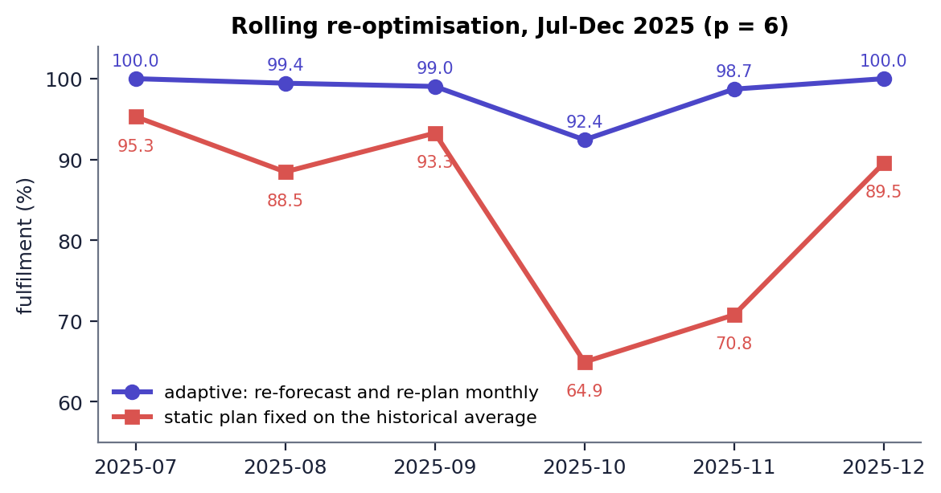
Fig. 8.10: Fulfilment of the adaptive and the static plan by month
Adaptive re-planning achieves 98.3% average fulfilment against 83.7% for the static plan (+14.6 points), an average delivery time of 8.93 h against 9.98 h, and an average cost of INR 51.4 M against INR 54.0 M (-4.9%). The gap is widest in the October peak (92.4% against 64.9%), where the static plan is sized for ordinary demand. The only hub change is Kolkata-W being replaced by Kolkata in October. The static plan was fitted on the earlier average, so it is a deliberately simple control; a static plan with generous capacity or a plan re-trained monthly was not tested.

8.5 Scalability
The scalability benchmark splits every region into 1, 2 or 3 nearby demand points to build networks of 90, 180 and 270 nodes and times the exact MIP (with a time limit) against the matheuristic.
Table 8.7: Exact MIP against matheuristic by network size
Nodes | Binary variables | Matheuristic (s) | Exact MIP (s) | Exact status | Matheuristic gap
90 | 8,190 | 3.13 | 12.74 | Optimal | +0.00%
180 | 32,580 | 8.31 | 42.94 | Optimal | -0.05%
270 | 73,170 | 30.53 | 67.14 | Not Solved | +3.67%

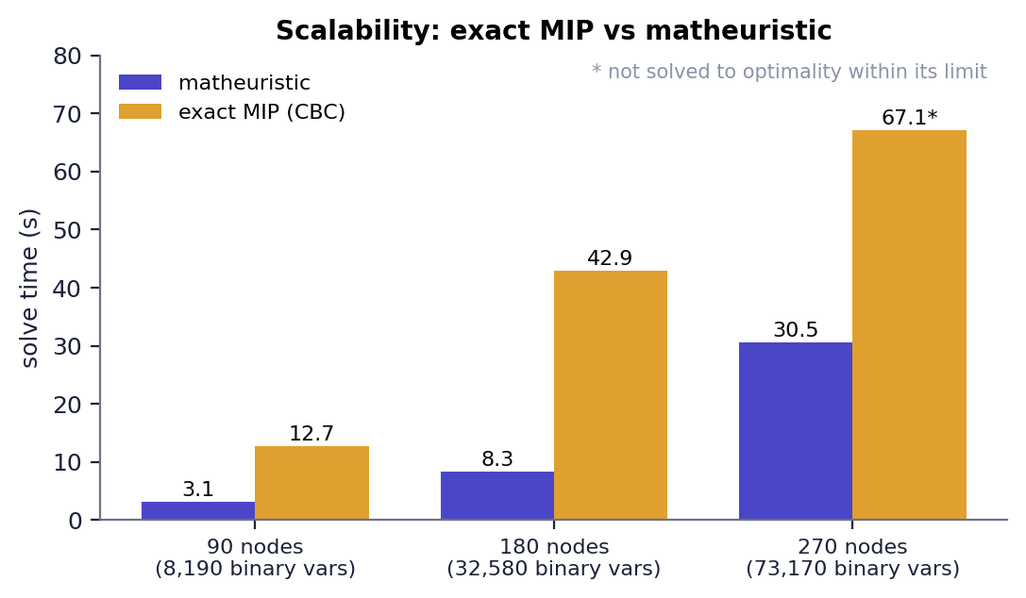
Fig. 8.11: Solve time of the exact MIP and the matheuristic
- At 90 and 180 nodes both methods find the same plan (gap 0.00% and -0.05%, i.e. the matheuristic was marginally better at 180 nodes because CBC stops within its default tolerance); the matheuristic is 4.1 and 5.2 times faster.
- At 270 nodes (73,170 binary variables) CBC did not finish within its limit (status 'Not Solved') and reported an incumbent of INR 53.43 M; the matheuristic returned INR 55.39 M in 30.5 s, 3.67% above the incumbent.
- The base paper reports networks of 50 to 500 nodes; this project measured three sizes up to 270 and makes no claim beyond them.

8.6 Output Screens
Every screen below is a capture of the running application (1440 x 900, Chrome) with the real data of this project; the planning screens were produced by operating the form. The comparison, scalability and rolling screens display the saved results in results/.
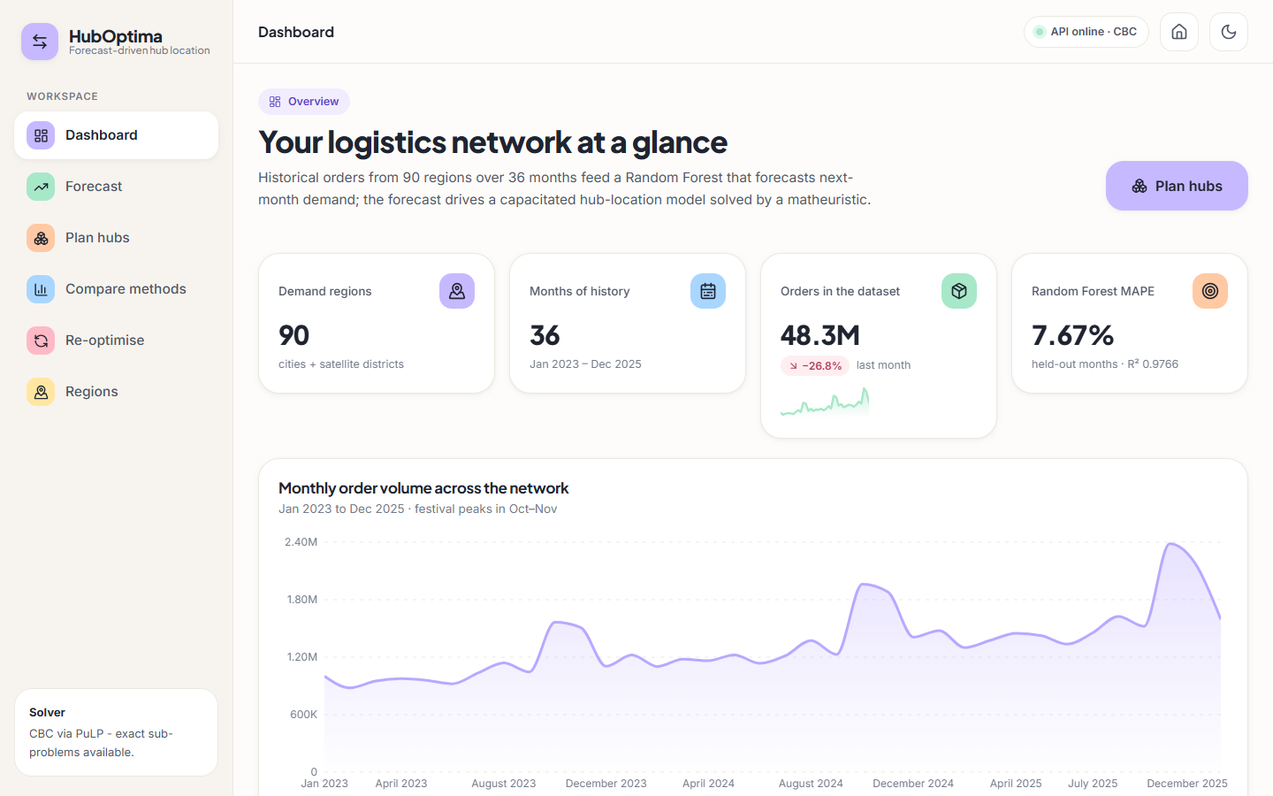
Fig. 8.12: Dashboard
Network overview: 90 regions, 36 months, 48.3 M orders in the dataset, Random Forest MAPE 7.67% (R-squared 0.9766) and the monthly order volume with the October-November festival peaks.
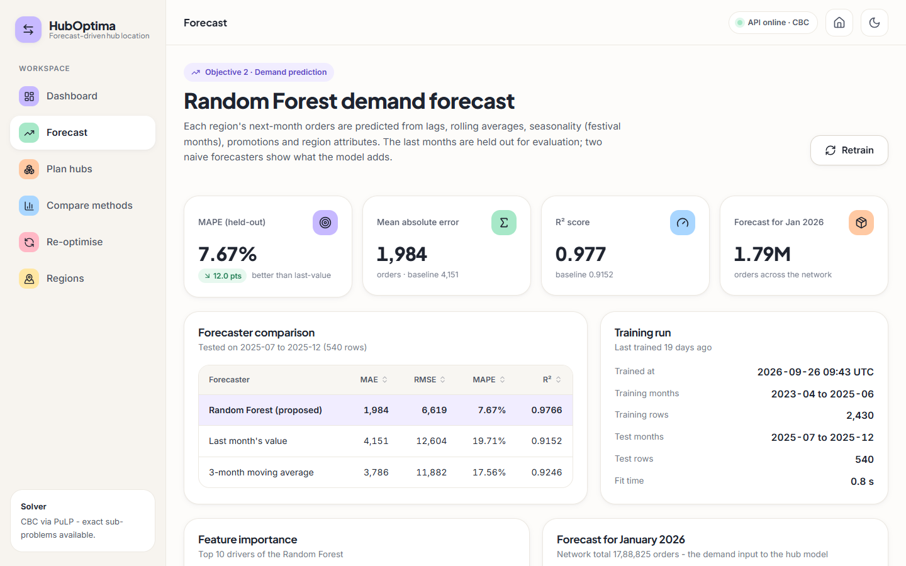
Fig. 8.13: Forecast page
Random Forest against the two naive forecasters on the 540 held-out region-months, with the training-run details.
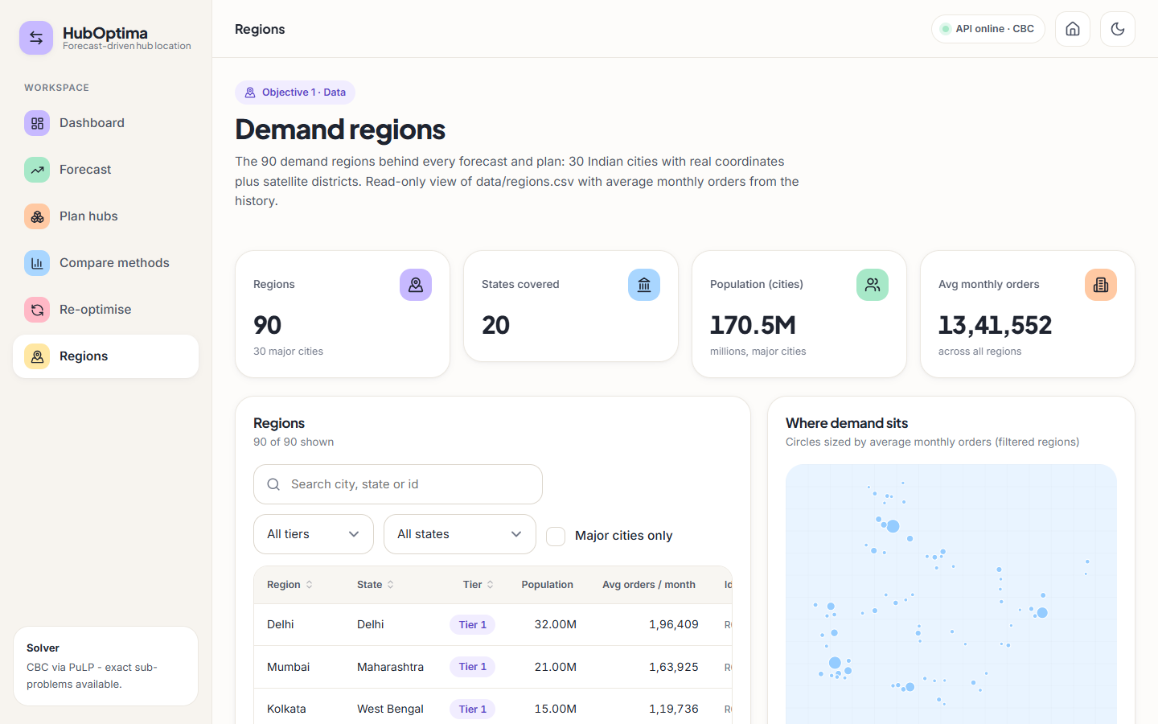
Fig. 8.14: Regions page
The 90 demand regions (30 cities and 60 satellite districts, 20 states) with search and filters, population, average monthly orders and a map of where demand sits.
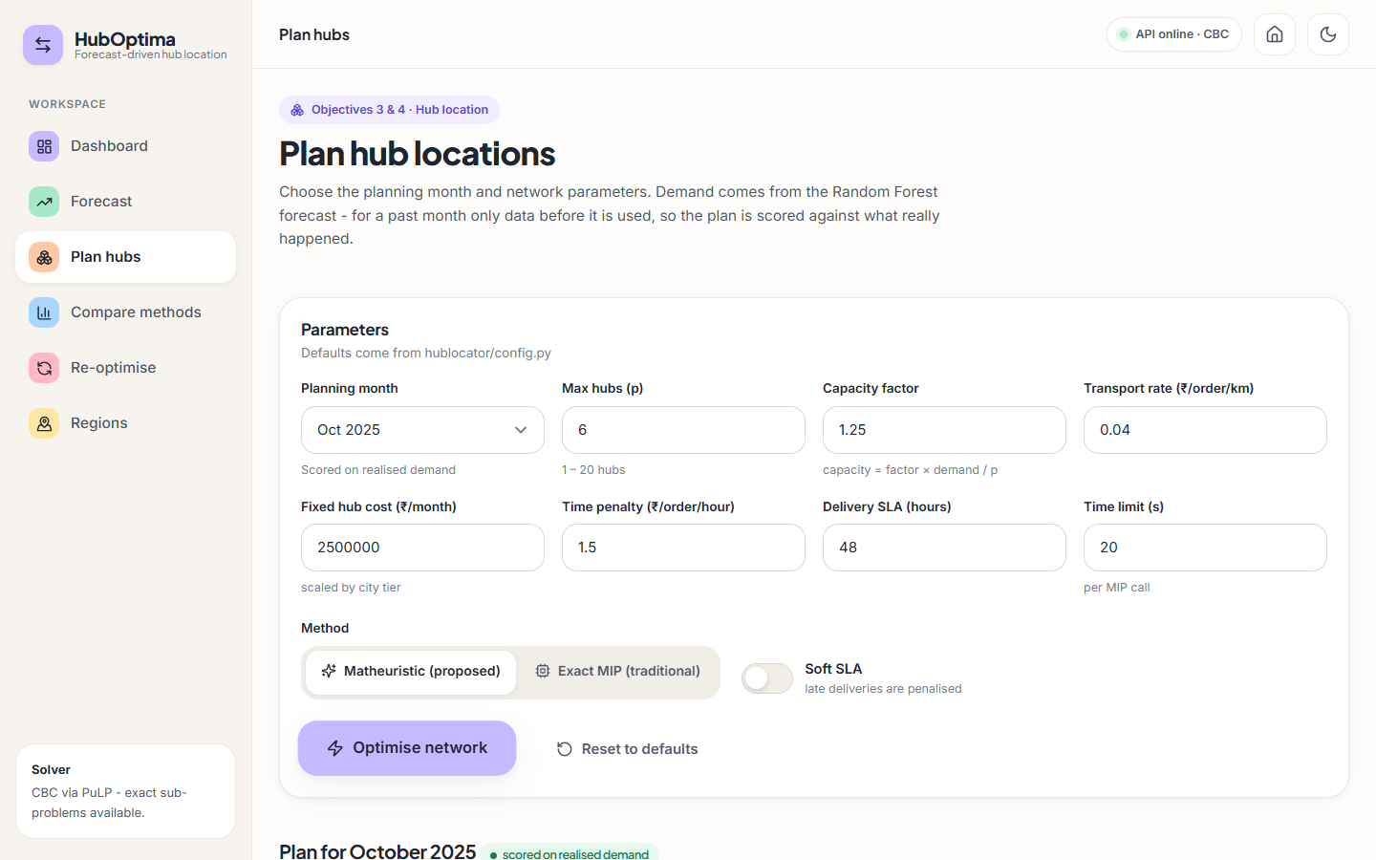
Fig. 8.15: Plan hubs: parameters
The planning form: month, maximum hubs p = 6, capacity factor 1.25, transport rate, fixed hub cost, time penalty, SLA, time limit, method and hard/soft SLA.
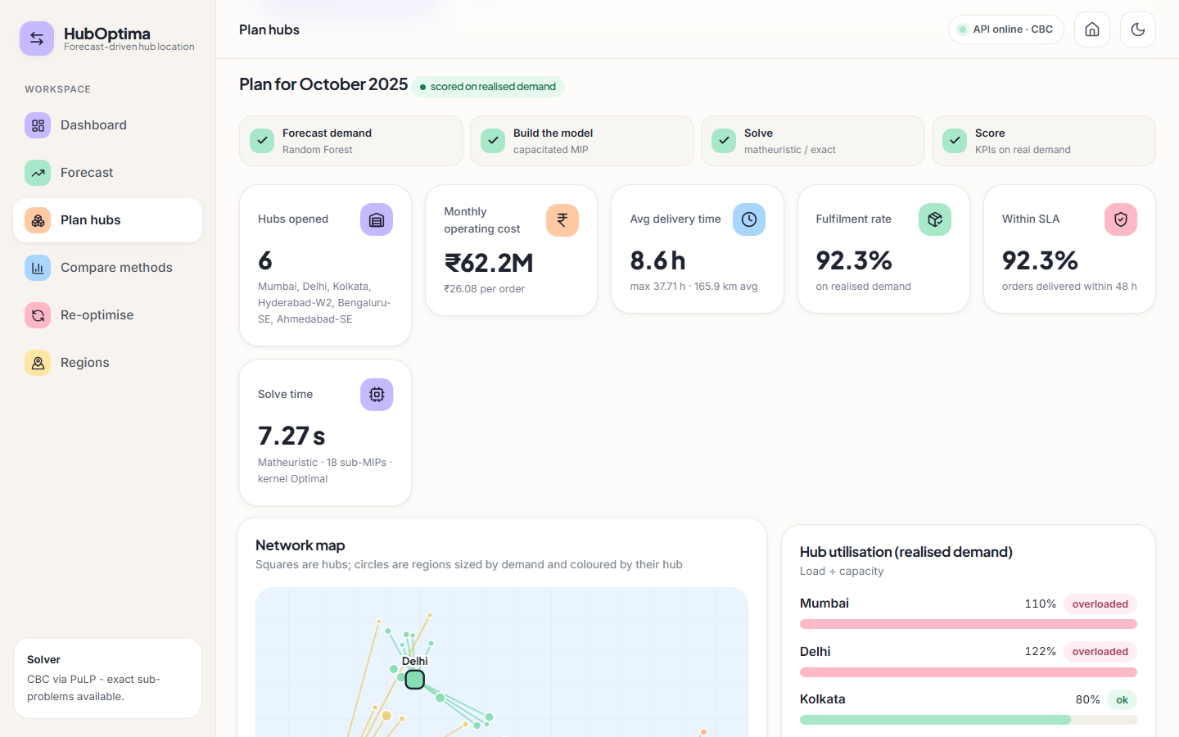
Fig. 8.16: Plan hubs: result KPIs
Oct 2025 plan from the matheuristic: 6 hubs, INR 62.2 M per month, 8.6 h average delivery, 92.3% fulfilment and 92.3% within the 48 h SLA on realised demand, solved in 9.23 s.
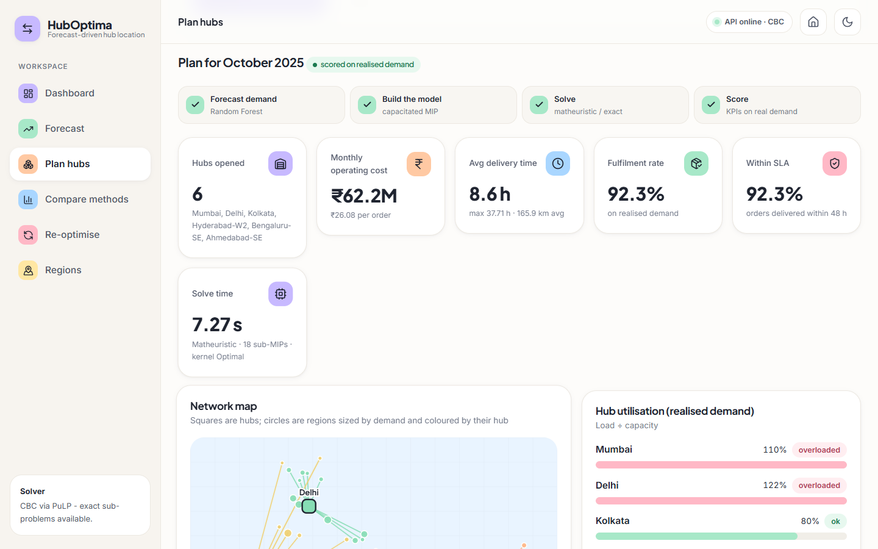
Fig. 8.17: Plan hubs: network map and cost split
Squares are hubs, circles are regions sized by demand and coloured by their hub; the cost split is INR 15.75 M fixed, 15.82 M transport and 30.59 M time penalty.
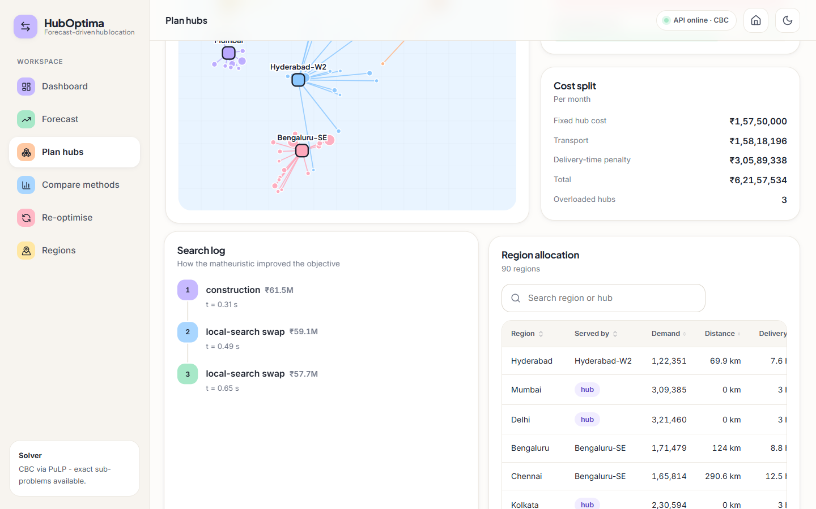
Fig. 8.18: Plan hubs: search log and allocation
How the matheuristic improved the objective: construction INR 61.5 M, then two local-search swaps to INR 57.7 M planned cost; below it the allocation of each region to its hub.
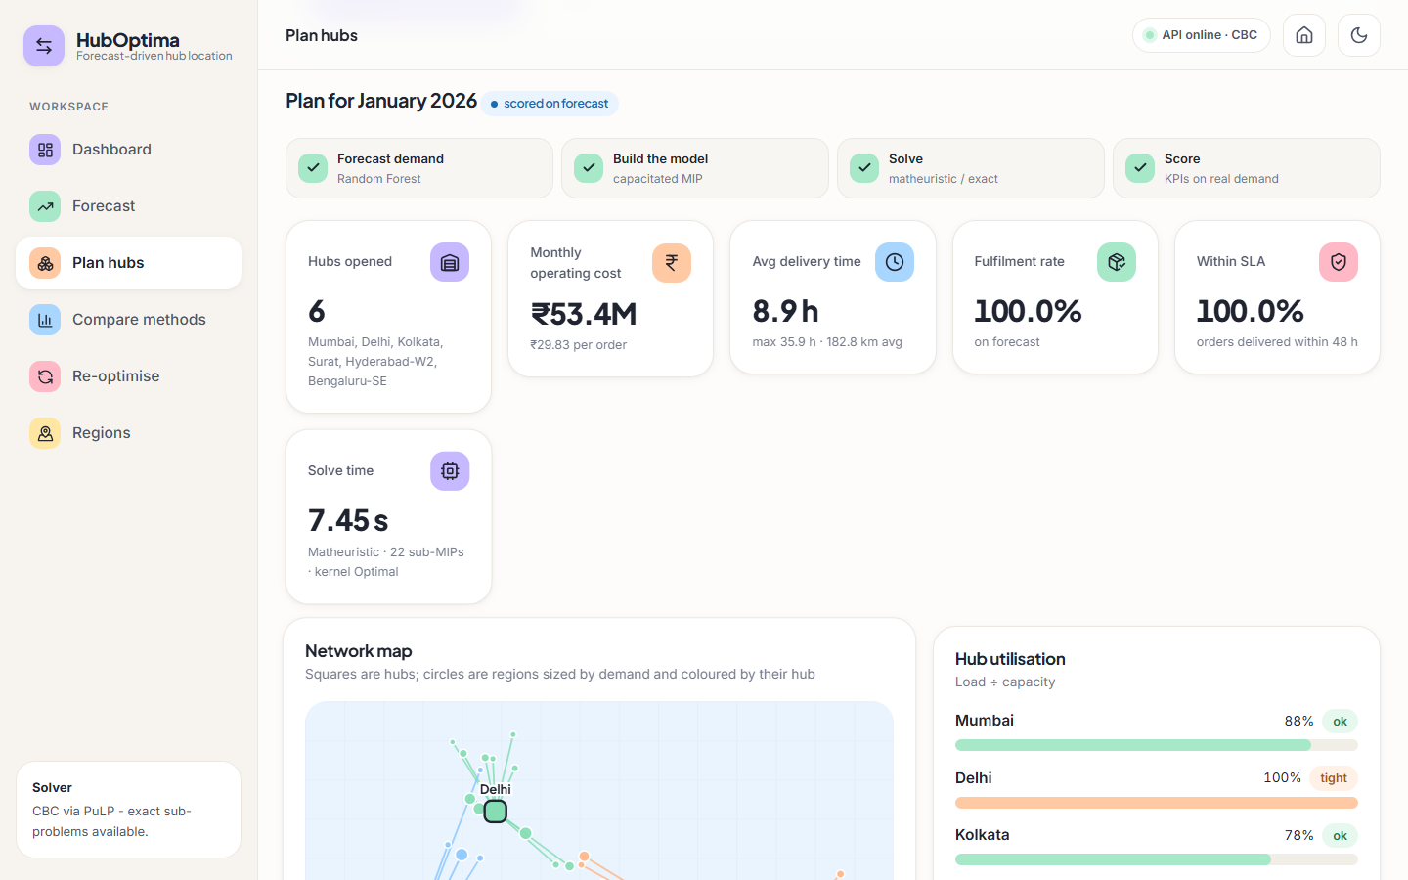
Fig. 8.19: Plan hubs: next month on the forecast
The January 2026 plan, scored on the forecast because that month has not happened yet.
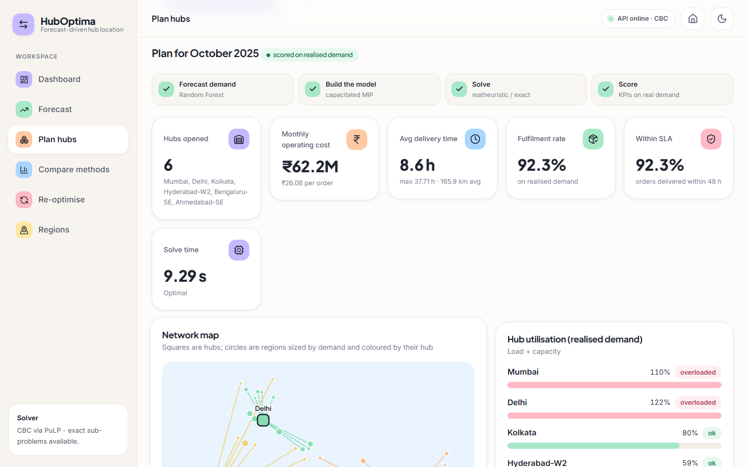
Fig. 8.20: Plan hubs: exact MIP
The same October 2025 plan solved by the traditional exact MIP: identical hubs and cost, status Optimal.

Fig. 8.21: Compare methods (full)
All six methods scored on the realised October 2025 demand, with operating-cost and fulfilment charts.
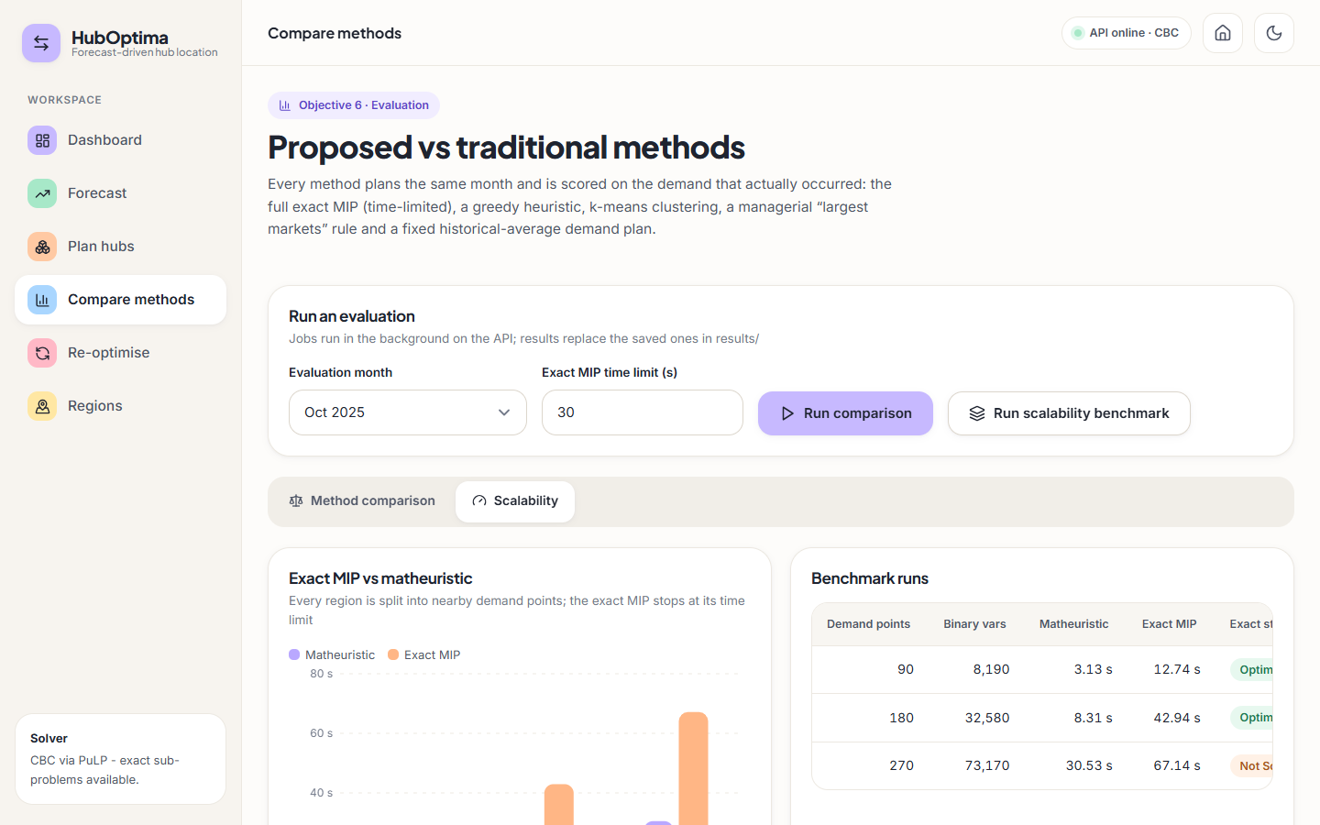
Fig. 8.22: Scalability benchmark
Exact MIP against the matheuristic at 90, 180 and 270 demand points.
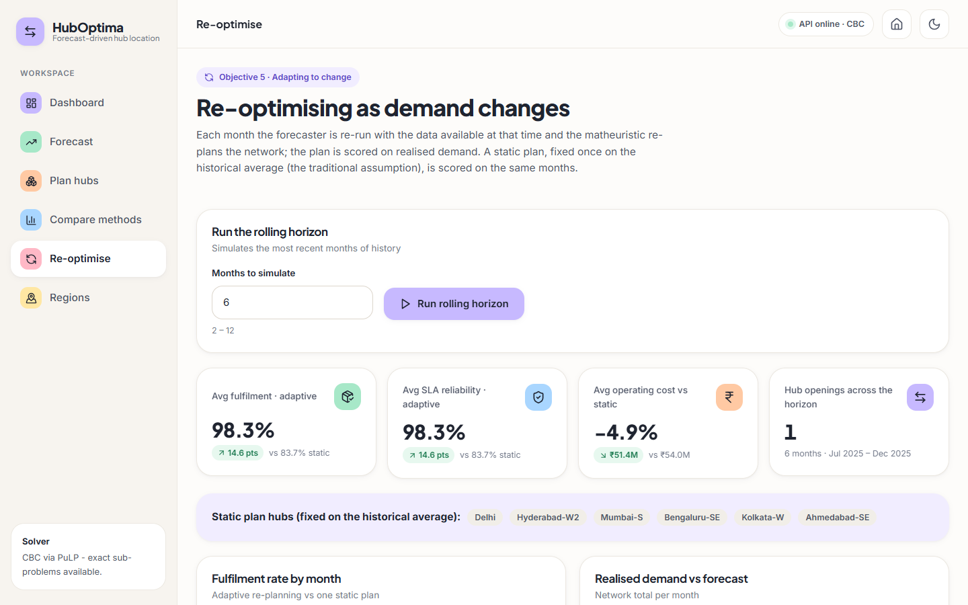
Fig. 8.23: Re-optimise page
Rolling-horizon summary: adaptive re-planning gives 98.3% fulfilment against 83.7% for a static plan.
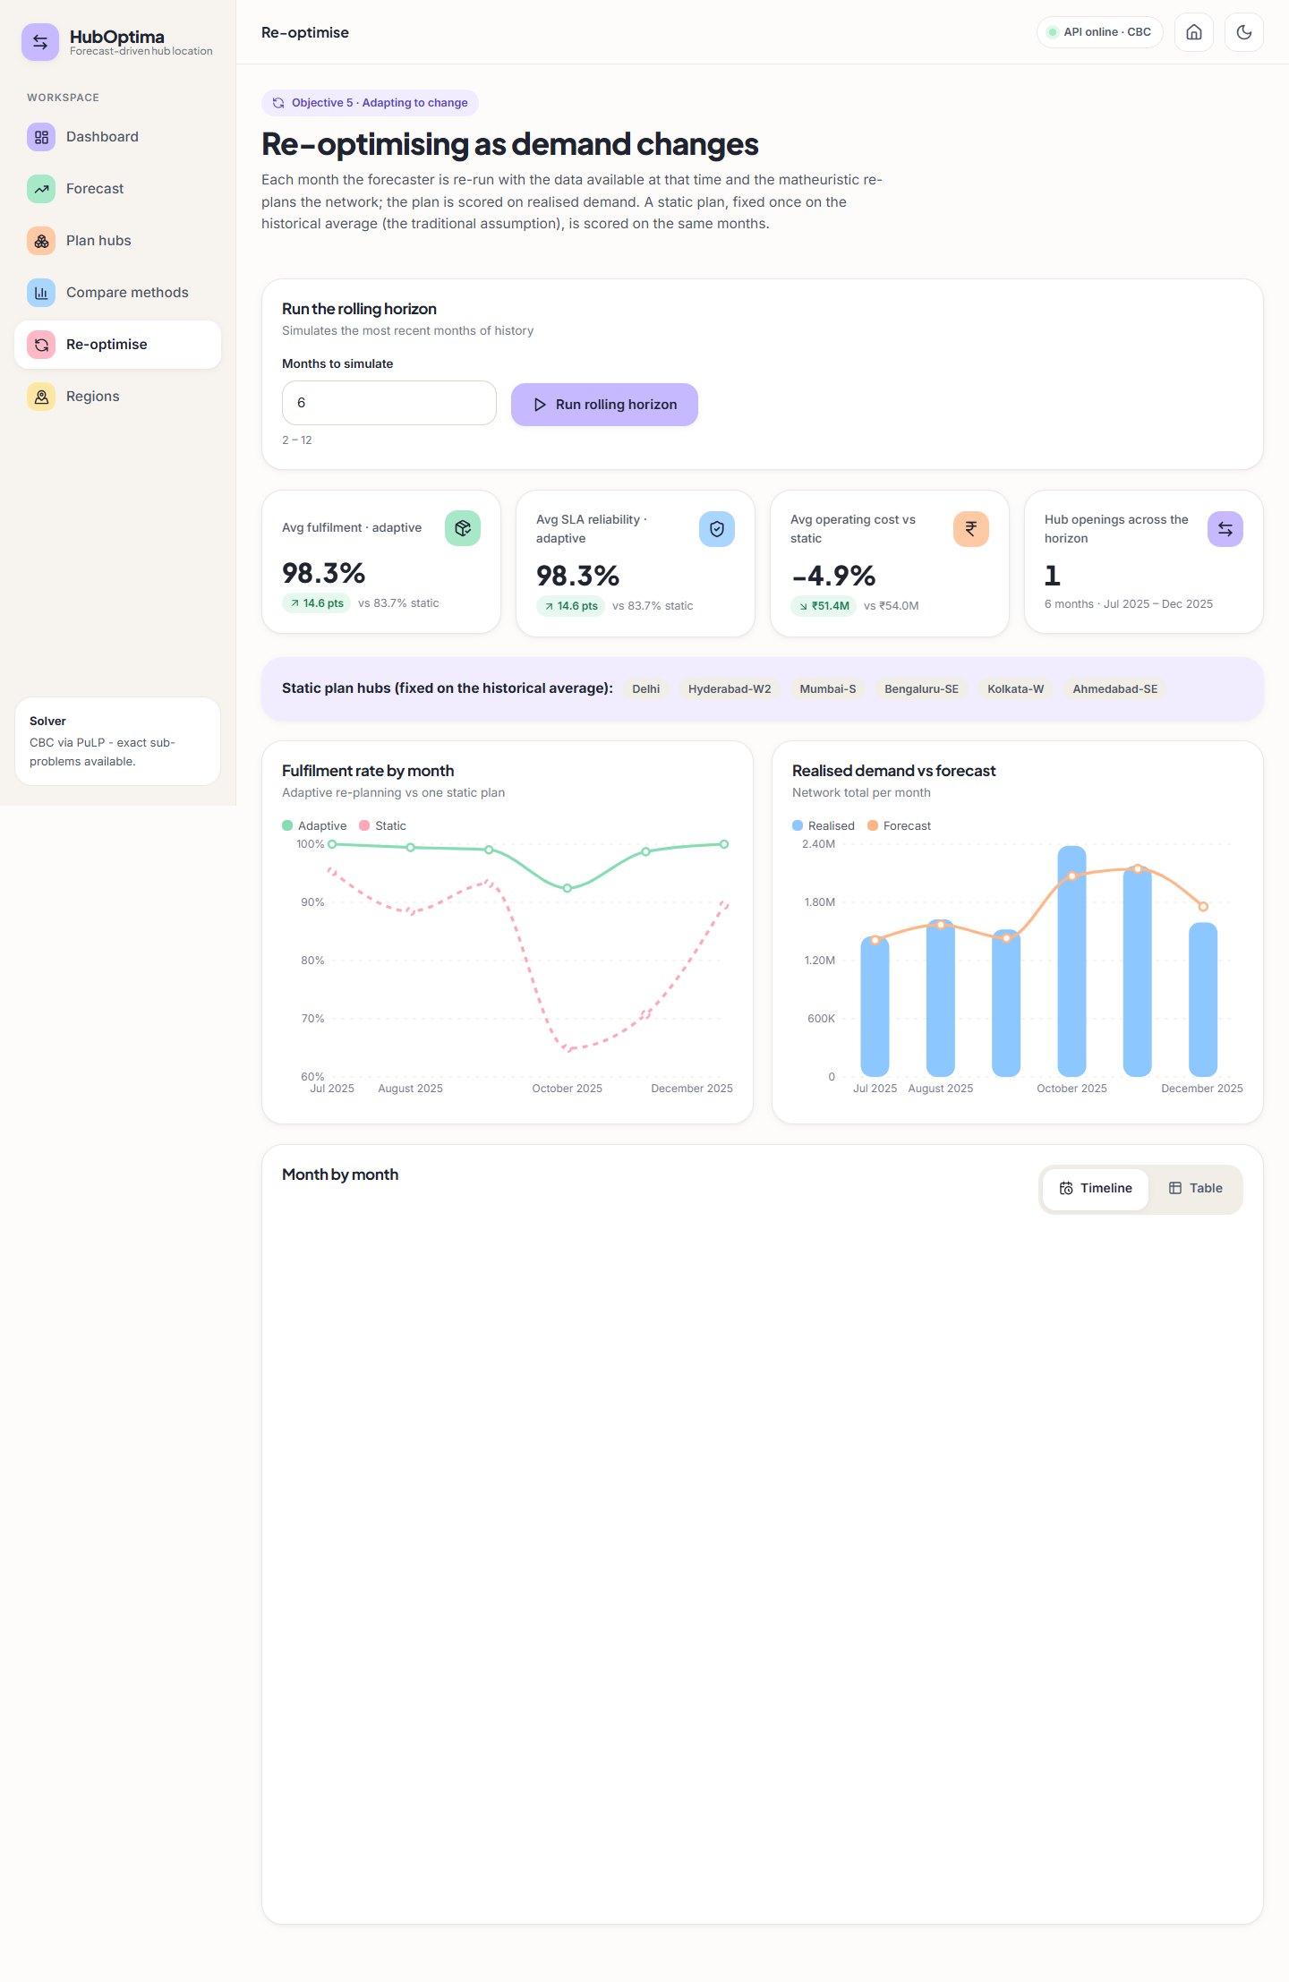
Fig. 8.24: Re-optimise page (full)
Month-by-month fulfilment, forecast against realised demand, hub changes and the monthly table.

8.7 Sample Inputs and Outputs
Planning request and result. Four hubs for December 2025 (the month is in the test range, so it is scored on realised demand):
Listing: sample input
{
"period": "2025-12",
"n_hubs": 4,
"method": "matheuristic"
}

Listing: sample output (trimmed)
{
"period": "2025-12",
"realized": true,
"sol": {
"status": "Matheuristic",
"hubs": [
1,
2,
5,
39
],
"objective": 54722309.15060887,
"seconds": 2.34,
"iterations": 1,
"subproblems_solved": 14,
"kernel_status": "Optimal"
},
"kpi": {
"n_hubs": 4,
"hub_cities": [
"Mumbai",
"Delhi",
"Kolkata",
"Bengaluru-N"
],
"total_cost": 50039855.0,
"fixed_cost": 12000000.0,
"transport_cost": 14358230.0,
"time_cost": 23681626.0,
"cost_per_order": 31.406,
"avg_delivery_hours": 9.91,
"max_delivery_hours": 27.07,
"avg_distance_km": 225.3,
"fulfilment_rate": 1.0,
"reliability_sla": 1.0,
"overloaded_hubs": 0,
"utilisation": {
"1": 0.892,
"2": 0.751,
"5": 0.431,
"39": 0.828
}
},
"kpi.assignment[0]": {
"region": "Hyderabad",
"region_id": "R001",
"hub": "Bengaluru-N",
"demand": 90287,
"distance_km": 546.7,
"hours": 18.1
},
"demand_used": "[90 values]"
}

Forecast. The next-month forecast (period 2026-01) totals 1,788,825 orders. The first two regions:
Listing: GET /api/forecast: first two regions
[
{
"region_id": "R001",
"period": "2026-01",
"forecast": 91030,
"city": "Hyderabad"
},
{
"region_id": "R002",
"period": "2026-01",
"forecast": 208611,
"city": "Mumbai"
}
]

Rejected input. POST /api/optimize {"n_hubs": 0} returns HTTP 422 and {"period": "1999-01"} returns HTTP 400 with 'Unknown planning month 1999-01.'.

8.8 Comparison with the Base Paper
The datasets and metric definitions differ, so the numbers below are not a head-to-head. The base paper [1] uses a proprietary dataset from a global transport company with thousands of customer locations; this project uses a synthetic dataset of 90 regions. The base paper's 'delivery-time compliance', 'fulfilment' and 'robustness' are defined on its own data; the 'fulfilment' and 'SLA reliability' of this project are simulated capacity-based measures. The table puts the two side by side and states what is and is not comparable.
Table 8.8: Base paper and this project, side by side
Indicator | Base paper [1] | This project | Comparable?
Delivery-time compliance | 92.3% average | SLA reliability (48 h) 92.3% in the Oct 2025 peak; 98.3% average with re-planning | No: different data and definition
Fulfilment rate | 97.6% average | 92.3% (Oct 2025 peak); 98.3% average over Jul-Dec 2025 with re-planning | No: simulated vs observed
Network robustness | 0.87 | Not implemented, not measured | -
Cost improvement | 15-20% against benchmarks | 3.6-16.1% lower than the heuristics and the managerial rule (greedy 11.5%, k-means 3.6%, largest 16.1%); 0% against the exact MIP | Qualitatively similar direction; different baselines
Improvement from adapting to demand | +7.8% delivery compliance, +9.4% fulfilment (abstract) | +14.6 points fulfilment against a static plan | Different comparison
Scalability | 50-500 nodes; near-optimal to 500 | 90-270 nodes; exact failed at 270; matheuristic +3.67% there | Smaller range tested
Forecast accuracy | 'X %' improvement (not stated) | MAPE 7.67%, R-squared 0.9766 vs naive 17.6-19.7% MAPE | Not reported by [1]

The qualitative agreement is that (i) forecasting demand before optimising helps, (ii) heuristic or managerial hub rules cost more than an optimised plan and (iii) adapting the network to changing demand improves service. This project does not reproduce the base paper's numbers and does not claim to.

8.9 Success and Failure Analysis
Table 8.9: Success cases
Success cases | Evidence
Forecast beats naive benchmarks by a wide margin | MAPE 7.67% vs 19.71% and 17.56%
Matheuristic reaches the optimum on 90 and 180 nodes | Gap 0.00% and -0.05%; same hubs as CBC at 90 nodes
Optimised plan is cheapest of six methods | Others cost 3.6% to 16.1% more
Re-planning protects service in the peak | 92.4% vs 64.9% fulfilment in October; 98.3% vs 83.7% average
Everything runs from one interface | 4 tests and 18 API checks pass; 22 screens captured

Table 8.10: Failure and weak cases
Failure or weak case | What happened | Cause (as far as known)
Peak under-forecast | Oct 2025 forecast 13.2% low; 3 of 6 hubs above capacity; fulfilment 92.3% | Volume above the training range; the optimiser trusts the forecast and has no safety margin
December over-forecast | 10.2% high | Probably the lag features still contain the October-November peak
Large errors for some regions | Pune, Ahmedabad and Chennai over-forecast by 39-40% in Dec 2025 | Not investigated; the post-peak drop is probably larger than the lags imply
No gain at 90 nodes | Same plan and similar time as the exact MIP | The instance is small enough for CBC
270 nodes | Matheuristic 3.67% above the exact incumbent | Probably the kernel of 24 candidates and the 70% time rule limit the search (not isolated by an experiment)
Distant service | Dehradun-N served 1,427 km away (37.7 h) | Only six hubs; cost model favours consolidation
Static control is simple | A stronger static plan was not tried | Comparison may overstate the benefit of re-planning

8.10 Limitations of the Results
- All results come from one synthetic dataset and one random seed; absolute rupee values, delivery hours and fulfilment are model outputs.
- Fulfilment and SLA reliability are simulated capacity measures, not observed deliveries.
- The comparison covers a single month (October 2025); the rolling horizon covers six months; the benchmark three sizes.
- The base paper's real-data results are not reproduced and its robustness measure is not implemented.
- No confidence intervals, repeated runs or statistical tests; solve times vary by several seconds from run to run.

8.11 Objectives Against Outcomes
Table 8.11: Objectives and outcomes
Objective | Outcome | Status
1 Collect and preprocess historical e-commerce logistics data | Synthetic 90-region, 36-month dataset generated and cleaned (duplicates, gaps); real data is not available | Met with synthetic data
2 Predict regional demand with a Random Forest | MAPE 7.67%, R-squared 0.9766 on held-out months; naive MAPE 17.6-19.7% | Met
3 Formulate hub location with cost, time and capacity constraints | Capacitated single-allocation MIP with fixed, transport and time cost, capacity, p, optional hard SLA | Met (single capacity level, no robustness)
4 Solve efficiently with a matheuristic | Optimal at 90 and 180 nodes, 4-5 times faster; 3.67% above the incumbent at 270 nodes | Met, with a stated gap at the largest size
5 Re-optimise as demand changes | Rolling horizon: 98.3% vs 83.7% fulfilment, one hub change | Met (model not retrained monthly)
6 Compare with traditional methods | Five baselines on the same instance; proposed is cheapest | Met on one month; base-paper numbers not reproduced

CHAPTER 9
CONCLUSION

9.1 Summary of the Work
This project implemented the predict-then-optimise framework of the base paper end to end. A Random Forest forecasts regional demand from lag, rolling, calendar and region features; the forecast feeds a capacitated single-allocation hub-location model; a matheuristic that combines greedy construction, a screened and MIP-priced local search and a kernel search solves it; the plan is scored on the demand that actually occurred; and the cycle is repeated month by month. A FastAPI service and a React application make the pipeline usable from a browser, and a command line and 22 captured screens document it.
The work was carried out on a synthetic dataset of 90 regions and 36 months, because no real order history was available. Every number reported is read from the project's own saved models and results, and the report states where the evidence is weaker than the base paper's.

9.2 Objectives Achieved
Table 9.1: Objectives achieved
Objective | Outcome
1 Data collection and preprocessing | Synthetic dataset with cleaning, de-duplication and gap filling (real data not available)
2 Random Forest demand prediction | MAPE 7.67%, R-squared 0.9766; naive forecasters 17.6-19.7% MAPE
3 Optimisation model | Capacitated MIP with cost, delivery-time and capacity constraints and an optional hard SLA
4 Matheuristic | Same plan as the exact MIP at 90 nodes; 4-5 times faster at 90-180 nodes; 3.67% above the exact incumbent at 270 nodes
5 Re-optimisation | 98.3% against 83.7% simulated fulfilment for a static plan
6 Comparison | Proposed plan cheapest of six methods on October 2025; others cost 3.6% to 16.1% more

9.3 Key Findings
1. Forecasting before optimising pays. Planning on the historical average instead of a forecast cost 8.1% more and served 66.0% of the October 2025 orders, against 92.3%.
2. The matheuristic is exact where exactness can be checked. It found the optimum at 90 and 180 nodes. Its advantage is speed at 180 nodes and above; at 90 nodes there was no practical gain.
3. Re-planning protects service in the peak. In October the adaptive plan kept 92.4% fulfilment against 64.9% for the static plan.
4. Forecast error shows up as overload. A 13.2% under-forecast of the peak left three of six hubs above capacity; the optimiser has no safety margin, which is the main weakness found.
5. Simple rules are costly. The largest-markets rule costs 16.1% more than the optimised plan and breaches the 48 h service level for some regions.
Fig. 9.1: Operating cost by method (October 2025)

9.4 Practical Applications
- Monthly review of a regional e-commerce hub network: forecast, plan and see which hubs would be overloaded.
- What-if analysis: change the number of hubs, capacity or service level and see the effect in seconds.
- Teaching: a compact, readable implementation of forecasting plus mixed-integer optimisation plus heuristic search.
- A benchmark harness for comparing a new hub-location heuristic with an exact solver and simple rules.

9.5 Known Limitations
- Synthetic data; no calibration to a real carrier; fulfilment and reliability are simulated.
- No robustness analysis; the plan is not hedged against forecast error.
- Single capacity level, single allocation, no routing or hub-to-hub economies of scale.
- One hold-out split, no cross-validation or tuning; the model is not retrained monthly in the simulation.
- At 270 nodes the matheuristic is 3.67% above the exact incumbent; networks beyond 270 nodes were not tested.
- No authentication, database or multi-user support; no user acceptance study; no frontend unit tests.

CHAPTER 10
FUTURE SCOPE

10.1 Improvements
- Robust plans. Add a safety margin or a scenario-based objective so that a forecast error of 10-15% does not overload the biggest hubs (the base paper's robust direction and [5]).
- Real data. Replace the synthetic files with a real order history (same schema) and re-run the pipeline; calibrate cost parameters with a carrier.
- Forecast quality. Cross-validated tuning, gradient boosting or LSTM benchmarks, prediction intervals, and a fix for the inability of forests to extrapolate beyond past peaks (for example by forecasting growth ratios).
- Solver. Add Variable Neighbourhood Search as in the base paper, tune the kernel size and time rules, and test on 500 nodes.
- Retraining. Retrain the forecaster every month inside the rolling horizon and compare with the fixed model.

10.2 Additional Features
- Multiple capacity levels per hub and capacity expansion over time.
- Split allocation (a region served by two hubs) and hub-to-hub transport with economies of scale.
- Explainability: a per-region forecast explanation and a map of why a hub was chosen (as proposed in the base paper's future work).
- Scenario manager: save, name and compare several plans side by side; export plans to Excel or PDF.
- Sustainability objectives such as emissions per parcel.

10.3 Scalability and Deployment
- Move results from files to a database with versioning so several users can plan at once.
- Add sign-in, roles and rate limiting; put the API behind a reverse proxy; containerise the stack.
- Run long jobs in a worker queue instead of threads so that jobs survive a restart and can run in parallel.
- Use a faster commercial or open-source solver for networks above a few hundred nodes, and parallelise the sub-problem pricing.
- Stream new orders from the warehouse system so that the forecast is refreshed without manual file replacement.

10.4 Further Research
- Compare the matheuristic with VNS-based and learning-based solvers on public hub-location benchmarks.
- Learn the matheuristic's parameters (screening tolerance, kernel size) from the instance, as the base paper suggests for the Random Forest.
- Study how forecast accuracy translates into plan quality: a sensitivity analysis of cost and overload against forecast error.
- Integrate demand uncertainty learned from data into a two-stage robust model.
- Evaluate with a logistics partner on real parcel data, including delivery-time compliance measured in the field.

REFERENCES
[1] K. Danach, A. Rammal, I. Moukadem, H. Harb, and A. Nasser, "Advanced optimization in e-commerce logistics: Combining matheuristics with random forests for hub location efficiency," IEEE Access, vol. 13, pp. 55915-55926, 2025, doi: 10.1109/ACCESS.2025.3550560.
[2] L. Zheng, G. Xu, and W. Chen, "Using improved particle swarm optimization algorithm for location problem of drone logistics hub," Computers, Materials & Continua, vol. 78, no. 1, pp. 935-957, 2024, doi: 10.32604/cmc.2023.046006.
[3] L. Yang, J. Zheng, J. Wang, and X. Hu, "The maximal detour liner shipping hub location problem: Improving the applicability of the p-hub center problem," Transportation Research Part E: Logistics and Transportation Review, vol. 179, Art. no. 103330, Nov. 2023, doi: 10.1016/j.tre.2023.103330.
[4] M. Dehghan Chenary, A. Ferdowsi, and R. F. Hartl, "A Pareto-based clustering approach for solving a bi-objective mobile hub location problem with congestion," Logistics, vol. 8, no. 4, Art. no. 130, Dec. 2024, doi: 10.3390/logistics8040130.
[5] H. Zhang, J.-C. Wang, and Y. Gao, "Two-stage adaptive robust hub location problem under demand uncertainty," Naval Research Logistics, Dec. 2025, doi: 10.1002/nav.70043.
[6] M. E. O'Kelly, "The location of interacting hub facilities," Transportation Science, vol. 20, no. 2, pp. 92-106, 1986.
[7] J. F. Campbell, A. T. Ernst, and M. Krishnamoorthy, "Hub location problems," in Facility Location: Applications and Theory. Berlin, Germany: Springer, 2002, pp. 373-407.
[8] A. T. Ernst and M. Krishnamoorthy, "Efficient algorithms for the uncapacitated single allocation p-hub median problem," Location Science, vol. 4, no. 3, pp. 139-154, Oct. 1996.
[9] K. Danach, S. Gelareh, and R. Neamatian Monemi, "The capacitated single-allocation p-hub location routing problem: A Lagrangian relaxation and a hyper-heuristic approach," EURO Journal on Transportation and Logistics, vol. 8, no. 5, pp. 597-631, Dec. 2019.
[10] M. Kahalimoghadam, R. G. Thompson, and A. Rajabifard, "Determining the number and location of micro-consolidation centres as a solution to growing e-commerce demand," Journal of Transport Geography, vol. 117, Art. no. 103875, May 2024.
[11] L. Breiman, "Random forests," Machine Learning, vol. 45, no. 1, pp. 5-32, Oct. 2001.
[12] V. Maniezzo, M. A. Boschetti, and T. Stuetzle, Matheuristics: Algorithms and Implementations. Cham, Switzerland: Springer, 2021.
[13] F. Pedregosa et al., "Scikit-learn: Machine learning in Python," Journal of Machine Learning Research, vol. 12, pp. 2825-2830, 2011.
[14] S. Mitchell, M. O'Sullivan, and I. Dunning, "PuLP: A linear programming toolkit for Python," Dept. of Engineering Science, University of Auckland, 2011.
[15] J. Forrest and R. Lougee-Heimer, "CBC user guide," in Emerging Theory, Methods, and Applications, INFORMS TutORials in Operations Research, 2005, pp. 257-277.
[16] P. Hansen and N. Mladenovic, "Variable neighborhood search: Principles and applications," European Journal of Operational Research, vol. 130, no. 3, pp. 449-467, May 2001.
[17] E. Angelelli, R. Mansini, and M. G. Speranza, "Kernel search: A general heuristic for the multi-dimensional knapsack problem," Computers & Operations Research, vol. 37, no. 11, pp. 2017-2026, Nov. 2010.
[18] S. P. Lloyd, "Least squares quantization in PCM," IEEE Transactions on Information Theory, vol. 28, no. 2, pp. 129-137, Mar. 1982.
[19] R. J. Hyndman and G. Athanasopoulos, Forecasting: Principles and Practice, 3rd ed. Melbourne, Australia: OTexts, 2021.
[20] R. W. Sinnott, "Virtues of the haversine," Sky and Telescope, vol. 68, no. 2, p. 159, 1984.
[21] S. Ramirez, "FastAPI documentation." [Online]. Available: https://fastapi.tiangolo.com
[22] Meta Platforms, "React documentation." [Online]. Available: https://react.dev

APPENDIX A
IMPORTANT CODE
The listings are extracted verbatim from the source files by the document builder, so they match the delivered code.

A.1 Hub-location model: instance and exact MIP
Listing: hublocator/model.py - Instance and objective
@dataclass
class Instance:
regions: pd.DataFrame
demand: np.ndarray # forecast (or fixed) demand per region, used to plan
dist: np.ndarray # km, n x n
params: dict = field(default_factory=dict)

def __post_init__(self):
p = {**config.DEFAULTS, **self.params}
self.params = p
n = len(self.regions)
self.n = n
self.time = self.dist / p["truck_speed_kmph"] + p["hub_handling_hours"] # hours
np.fill_diagonal(self.time, p["hub_handling_hours"] * 0.5) # local delivery
self.unit_cost = p["transport_rate"] * self.dist + p["time_penalty"] * self.time
tier_mult = self.regions["tier"].map({1: 1.35, 2: 1.0, 3: 0.75}).fillna(1.0).to_numpy()
self.fixed_cost = p["fixed_cost_per_hub"] * tier_mult
total = float(self.demand.sum())
self.capacity = np.full(n, p["capacity_factor"] * total / p["n_hubs"])
self.p = int(p["n_hubs"])

@classmethod
def from_forecast(cls, regions: pd.DataFrame, forecast: pd.Series | np.ndarray, **params):
return cls(regions, np.asarray(forecast, dtype=float), distance_matrix(regions), params)

# ------------------------------------------------------------------ #
def objective(self, hubs: list[int], assign: np.ndarray, demand: np.ndarray | None = None) -> float:
d = self.demand if demand is None else demand
idx = np.arange(self.n)
return float(self.fixed_cost[hubs].sum() + (self.unit_cost[idx, assign] * d).sum())

A.2 Matheuristic
Listing: hublocator/matheuristic.py - bound, price, construct
def _bound(inst: Instance, hubs: list[int]) -> float:
"""Cheap estimate of a hub set's cost (capacity-aware greedy allocation)."""
a = assign_greedy(inst, hubs)
return inst.objective(hubs, a)

def _price(inst: Instance, hubs: list[int], cache: dict, time_limit: float):
key = tuple(sorted(hubs))
if key in cache:
return cache[key]
assign, status = assign_exact(inst, list(key), time_limit)
if assign is None: # infeasible (capacity / SLA) -> huge cost
cache[key] = (None, float("inf"))
return cache[key]
obj = inst.objective(list(key), assign)
cache[key] = (assign, obj)
return cache[key]

def construct(inst: Instance) -> list[int]:
"""Greedy weighted k-medoids: repeatedly open the hub that most reduces cost."""
hubs: list[int] = []
remaining = set(range(inst.n))
while len(hubs) < inst.p:
best, best_cost = None, float("inf")
for j in remaining:
trial = hubs + [j]
cost = (inst.unit_cost[:, trial] * inst.demand[:, None]).min(axis=1).sum() + inst.fixed_cost[trial].sum()
if cost < best_cost:
best, best_cost = j, cost
hubs.append(best)
remaining.remove(best)
# medoid refinement on the un-capacitated problem
for _ in range(10):
changed = False
for k, h in enumerate(hubs):
members = np.where(np.argmin(inst.unit_cost[:, hubs], axis=1) == k)[0]
if len(members) == 0:
continue
costs = [(inst.unit_cost[members, m] * inst.demand[members]).sum() + inst.fixed_cost[m] for m in members]
new = int(members[int(np.argmin(costs))])
if new != h and new not in hubs:
hubs[k] = new
changed = True
if not changed:
break
return hubs

Listing: hublocator/matheuristic.py - construction and local search
def solve_matheuristic(inst: Instance, time_limit: float | None = None, kernel_size: int = 24,
sub_time_limit: float = 5, verbose: bool = False, log: list | None = None,
screen_tol: float = 0.06) -> dict:
t0 = time.time()
time_limit = time_limit or inst.params["time_limit"]
cache: dict = {}
log = log if log is not None else []

hubs = construct(inst)
assign, obj = _price(inst, hubs, cache, sub_time_limit)
if assign is None: # construction infeasible - open more hubs greedily until feasible
for j in np.argsort(-inst.demand):
if len(hubs) >= inst.p:
break
if j not in hubs:
hubs.append(int(j))
assign, obj = _price(inst, hubs, cache, sub_time_limit)
if assign is not None:
break
log.append({"phase": "construction", "hubs": sorted(hubs), "objective": obj, "t": round(time.time() - t0, 2)})
if verbose:
print(f" construction: {obj:,.0f} hubs={[inst.regions.city[h] for h in hubs]}")

# ---- phase 2: MIP-priced local search --------------------------------
improved = True
iters = 0
while improved and time.time() - t0 < time_limit * 0.7:
improved = False
iters += 1
# rank closed candidates by attractiveness (weighted demand near them)
closed = [j for j in range(inst.n) if j not in hubs]
attractiveness = {j: (inst.demand * np.exp(-inst.dist[:, j] / 400)).sum() for j in closed}
closed.sort(key=lambda j: -attractiveness[j])
top = closed[: max(12, inst.n // 4)]
moves = [("swap", h, j) for h in hubs for j in top]
if len(hubs) > 1:
moves += [("drop", h, None) for h in hubs]
if len(hubs) < inst.p:
moves += [("add", None, j) for j in top]
# screen every move with the cheap greedy bound, price the promising ones exactly
scored = []
for kind, h, j in moves:
trial = [x for x in hubs if x != h] + ([j] if j is not None else [])
scored.append((_bound(inst, trial), kind, h, j, trial))
scored.sort(key=lambda t: t[0])
for b, kind, h, j, trial in scored:
if time.time() - t0 > time_limit * 0.7:
break
if b > obj * (1 + screen_tol):
break # greedy bound too poor to be worth a MIP
a, o = _price(inst, trial, cache, sub_time_limit)
if o < obj - 1e-6:
hubs, assign, obj, improved = trial, a, o, True
log.append({"phase": f"local-search {kind}", "hubs": sorted(hubs), "objective": o,
"t": round(time.time() - t0, 2)})
if verbose:
print(f" {kind:<5} -> {o:,.0f} hubs={[inst.regions.city[x] for x in hubs]}")
break # first improvement

Listing: hublocator/matheuristic.py - kernel search and result
# ---- phase 3: kernel search (restricted exact MIP) --------------------
kernel_status = "skipped"
if HAS_PULP:
visited = sorted(cache.items(), key=lambda kv: kv[1][1])
kernel = set(hubs)
for h in hubs: # geographic neighbours of open hubs
kernel.update(int(j) for j in np.argsort(inst.dist[h])[1:3])
for key, _ in visited:
kernel.update(key)
if len(kernel) >= kernel_size:
break
# also admit the most attractive closed candidates not yet examined
attractiveness = np.array([(inst.demand * np.exp(-inst.dist[:, j] / 400)).sum() for j in range(inst.n)])
for j in np.argsort(-attractiveness):
if len(kernel) >= kernel_size:
break
kernel.add(int(j))
remaining = max(2.0, time_limit - (time.time() - t0))
res = solve_exact(inst, time_limit=remaining, candidates=sorted(kernel))
kernel_status = res["status"]
if res.get("assign") is not None and res["objective"] < obj - 1e-6:
hubs, assign, obj = res["hubs"], res["assign"], res["objective"]
log.append({"phase": "kernel-search", "hubs": sorted(hubs), "objective": obj,
"t": round(time.time() - t0, 2)})
if verbose:
print(f" kernel -> {obj:,.0f} hubs={[inst.regions.city[x] for x in hubs]}")

if assign is None:
assign = assign_greedy(inst, hubs)
obj = inst.objective(hubs, assign)
return {"status": "Matheuristic", "hubs": sorted(int(h) for h in hubs), "assign": assign,
"objective": obj, "seconds": round(time.time() - t0, 2), "iterations": iters,
"subproblems_solved": len(cache), "kernel_status": kernel_status, "log": log}

A.3 Forecasting
Listing: hublocator/forecast.py - train_forecaster
def train_forecaster(regions: pd.DataFrame, demand: pd.DataFrame, test_months: int = 6,
verbose: bool = True) -> dict:
df = build_features(regions, demand)
periods = sorted(df["period"].unique())
cutoff = periods[-test_months]
train, test = df[df.period < cutoff], df[df.period >= cutoff]

t0 = time.time()
rf = RandomForestRegressor(n_estimators=400, max_depth=None, min_samples_leaf=2,
max_features=0.6, n_jobs=-1, random_state=config.RANDOM_STATE)
rf.fit(train[FEATURES], train["orders"])
pred = rf.predict(test[FEATURES])

results = {
"trained_at": datetime.now(timezone.utc).isoformat(timespec="seconds"),
"train_rows": int(len(train)), "test_rows": int(len(test)),
"train_periods": f"{periods[0]} to {periods[-test_months-1]}",
"test_periods": f"{cutoff} to {periods[-1]}",
"train_seconds": round(time.time() - t0, 1),
"random_forest": _metrics(test["orders"], pred),
"baseline_last_value": _metrics(test["orders"], test["lag_1"]),
"baseline_moving_avg_3": _metrics(test["orders"], test["roll_mean_3"]),
"feature_importance": sorted(
[{"feature": f, "importance": round(float(v), 4)} for f, v in zip(FEATURES, rf.feature_importances_)],
key=lambda x: -x["importance"]),
}
# per-region detail for the last test month (used by the web UI)
last = test[test.period == periods[-1]].copy()
last["predicted"] = rf.predict(last[FEATURES]).round(0)
results["last_period"] = periods[-1]
results["last_period_detail"] = [
{"region_id": r.region_id, "actual": int(r.orders), "predicted": int(r.predicted),
"error_pct": round(abs(r.orders - r.predicted) / max(r.orders, 1) * 100, 1)}
for r in last.itertuples()]

config.MODEL_DIR.mkdir(parents=True, exist_ok=True)
joblib.dump({"model": rf, "features": FEATURES}, config.FORECAST_MODEL)
config.FORECAST_METRICS.write_text(json.dumps(results, indent=2))
if verbose:
rfm, b1, b2 = results["random_forest"], results["baseline_last_value"], results["baseline_moving_avg_3"]
print(f"Random Forest MAE {rfm['mae']:>9} RMSE {rfm['rmse']:>9} MAPE {rfm['mape']:>6}% R2 {rfm['r2']}")
print(f"Last value MAE {b1['mae']:>9} RMSE {b1['rmse']:>9} MAPE {b1['mape']:>6}% R2 {b1['r2']}")
print(f"Moving avg (3) MAE {b2['mae']:>9} RMSE {b2['rmse']:>9} MAPE {b2['mape']:>6}% R2 {b2['r2']}")
return results

A.4 Evaluation
Listing: hublocator/model.py - evaluate_solution
def evaluate_solution(inst: Instance, hubs: list[int], assign: np.ndarray,
realized: np.ndarray | None = None) -> dict:
"""Compute delivery time, fulfilment, reliability and cost for a configuration.

`realized` is the demand that actually materialised (defaults to the
planning demand). Capacity is exceeded when realised demand > planned.
"""
d = inst.demand if realized is None else np.asarray(realized, float)
idx = np.arange(inst.n)
t = inst.time[idx, assign]
dist = inst.dist[idx, assign]
total = d.sum()

load = np.zeros(inst.n)
np.add.at(load, assign, d)
served = np.minimum(load, inst.capacity) # orders each hub can process
fulfil_by_hub = np.where(load > 0, served / np.maximum(load, 1e-9), 1.0)
fulfilment = float((fulfil_by_hub[assign] * d).sum() / total)

on_time = (t <= inst.params["sla_hours"]).astype(float)
reliability = float((on_time * fulfil_by_hub[assign] * d).sum() / total)

transport = float((inst.params["transport_rate"] * dist * d).sum())
time_cost = float((inst.params["time_penalty"] * t * d).sum())
fixed = float(inst.fixed_cost[hubs].sum())
utilisation = {int(h): round(float(load[h] / inst.capacity[h]), 3) for h in hubs}

return {
"n_hubs": len(hubs),
"hubs": [int(h) for h in hubs],
"hub_cities": [inst.regions.city[h] for h in hubs],
"total_cost": round(fixed + transport + time_cost, 0),
"fixed_cost": round(fixed, 0),
"transport_cost": round(transport, 0),
"time_cost": round(time_cost, 0),
"cost_per_order": round((fixed + transport + time_cost) / total, 3),
"avg_delivery_hours": round(float((t * d).sum() / total), 2),
"max_delivery_hours": round(float(t.max()), 2),
"avg_distance_km": round(float((dist * d).sum() / total), 1),
"fulfilment_rate": round(fulfilment, 4),
"reliability_sla": round(reliability, 4),
"overloaded_hubs": int((load[hubs] > inst.capacity[hubs] + 1e-6).sum()),
"utilisation": utilisation,
"assignment": [{"region": inst.regions.city[i], "region_id": inst.regions.region_id[i],
"hub": inst.regions.city[assign[i]], "demand": int(d[i]),
"distance_km": round(float(dist[i]), 1), "hours": round(float(t[i]), 1)}
for i in range(inst.n)],
}

A.5 API endpoint for planning
Listing: backend/main.py - /api/optimize
class OptimizeBody(BaseModel):
period: str | None = None
method: str = Field("matheuristic", pattern="^(matheuristic|exact)$")
n_hubs: int = Field(config.DEFAULTS["n_hubs"], ge=1, le=20)
capacity_factor: float = Field(config.DEFAULTS["capacity_factor"], ge=1)
transport_rate: float = Field(config.DEFAULTS["transport_rate"], ge=0)
fixed_cost_per_hub: float = Field(config.DEFAULTS["fixed_cost_per_hub"], ge=0)
time_penalty: float = Field(config.DEFAULTS["time_penalty"], ge=0)
truck_speed_kmph: float = Field(config.DEFAULTS["truck_speed_kmph"], gt=0)
hub_handling_hours: float = Field(config.DEFAULTS["hub_handling_hours"], ge=0)
sla_hours: float = Field(config.DEFAULTS["sla_hours"], gt=0)
sla_hard: bool = config.DEFAULTS["sla_hard"]
time_limit: int = Field(config.DEFAULTS["time_limit"], ge=2, le=300)

@app.post("/api/optimize")
def api_optimize(body: OptimizeBody):
f = body.model_dump()
f["period"] = f["period"] or next_period
if f["period"] != next_period and f["period"] not in periods_hist[3:]:
return ok({"error": f"Unknown planning month {f['period']}."}, 400)
try:
fc, real, _ = demand_vectors(f["period"])
inst = Instance.from_forecast(regions, fc, **{k: f[k] for k in config.DEFAULTS})
sol = solve_exact(inst, time_limit=f["time_limit"]) if (f["method"] == "exact" and HAS_PULP) \
else solve_matheuristic(inst)
if sol.get("assign") is None or not np.isfinite(sol.get("objective", 0)):
return ok({"error": "No feasible solution (try more hubs, a larger capacity factor or a soft SLA)."})
kpi = evaluate_solution(inst, sol["hubs"], sol["assign"], real)
except Exception as exc: # noqa: BLE001
return ok({"error": str(exc)}, 400)
sol_public = {k: v for k, v in sol.items() if k != "assign"}
sol_public["hubs"] = [int(h) for h in sol["hubs"]]
return ok({"sol": sol_public, "kpi": kpi, "realized": real is not None, "period": f["period"],
"demand_used": (real if real is not None else fc).round(0)})

APPENDIX B
INSTALLATION AND USER GUIDE

B.1 Prerequisites
- Windows 10 or 11 (other systems work with the manual commands).
- Python 3.10 or later and Node.js 18 or later on the PATH.
- About 1 GB of free disk space and a modern browser.

B.2 One-click start (Windows)
1. Open the folder 8.ProjectCode.
2. Double-click run.bat. It installs any missing Python and npm packages, starts the API window (port 8104), waits for /api/health, starts the web window (port 5104) and opens http://localhost:5104.
3. To stop, close the two windows. If a port is already in use the script says so and exits.
4. Interactive API documentation is at http://localhost:8104/docs.

B.3 Using the application
Table B.1: User guide
To do this | Go to | Then
See what the data and the model look like | Dashboard, Forecast, Regions | Read the tiles and charts; search the regions
Plan hubs | Plan hubs | Pick a month (the first entry is the next month), adjust parameters if wished, choose Matheuristic or Exact MIP, click Optimise network; read the KPIs, map, utilisation, search log and allocation table
Compare methods | Compare methods | Pick a month and click Run comparison; wait for the job to finish (the page polls); switch to the Scalability tab for the benchmark
See the effect of re-planning | Re-optimise | Choose the number of months and click Run rolling horizon
Retrain the forecaster | Forecast | Click Retrain and confirm; a new model and metrics replace the saved ones
Use the dark theme | Top bar | Click the moon icon; the choice is remembered

B.4 Command line
Listing: commands
python run.py data --seed 7 # regenerate the synthetic history
python run.py forecast # train the Random Forest
python run.py optimize --period 2025-10 --hubs 6 # plan hubs (add --exact for the exact MIP)
python run.py compare --period 2025-10 # proposed vs traditional methods
python run.py rolling --months 6 # month-by-month re-optimisation
python run.py benchmark --factors 1 2 3 # scalability benchmark
python run.py all # data -> forecast -> compare -> rolling
python run.py serve # classic Flask interface on port 5000

B.5 Tests
Listing: test commands
python tests.py # 4 tests
python scripts/smoke_test.py # 18 API checks, in-process
python scripts/smoke_test.py --url http://127.0.0.1:8104 --frontend http://localhost:5104

B.6 Troubleshooting
Table B.2: Troubleshooting
Symptom | Cause and remedy
'Could not reach the HubOptima API' in the browser | The API window is closed or on another port; start run.bat again or check .env
Port already in use | HubOptima may already be running; close the old windows or change the port in .env
Comparison or rolling page empty | No saved result; click the Run button on that page
'No feasible solution' | Use more hubs, a larger capacity factor or a soft SLA
Plans take longer than expected | Lower the MIP time limit or choose the matheuristic; CBC time varies with the processor load

APPENDIX C
ADDITIONAL SCREENS
These are the screens that are not part of the main results chapter. All were captured from the running application with the project's data.

Fig. C.1: Landing page
The product landing page: the headline, a preview of the planned network (INR 62.2 M per month) and the key claims (90 regions, Random Forest MAPE 7.67%, +14.6 points of fulfilment against a static plan).
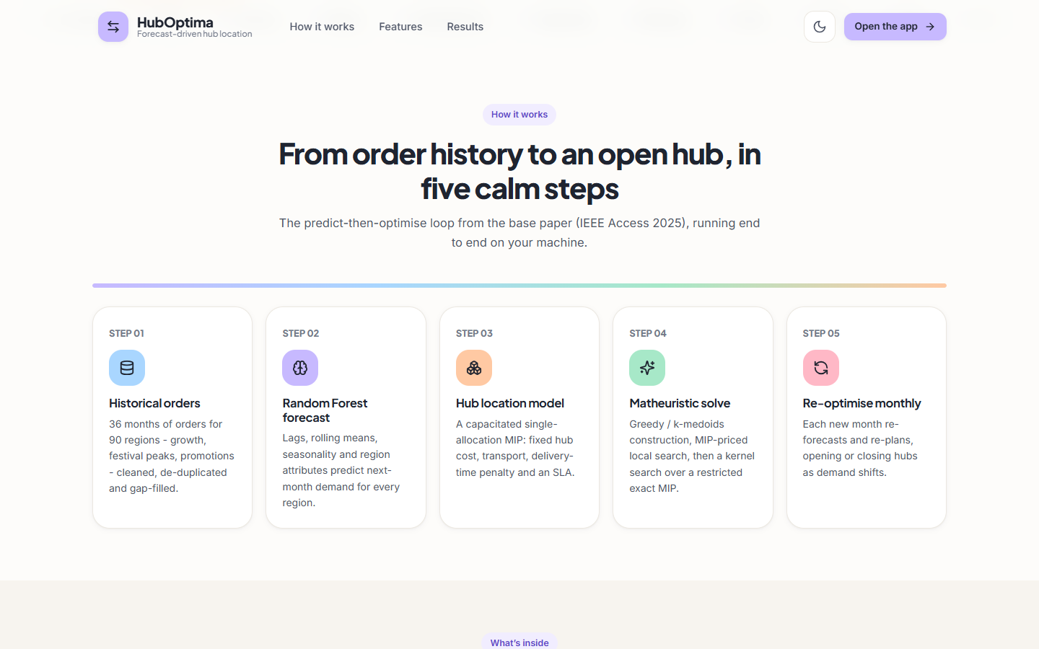
Fig. C.2: Landing page: the pipeline
The landing section that explains the pipeline in five steps: historical orders, Random Forest forecast, hub-location model, matheuristic solve and monthly re-optimisation.
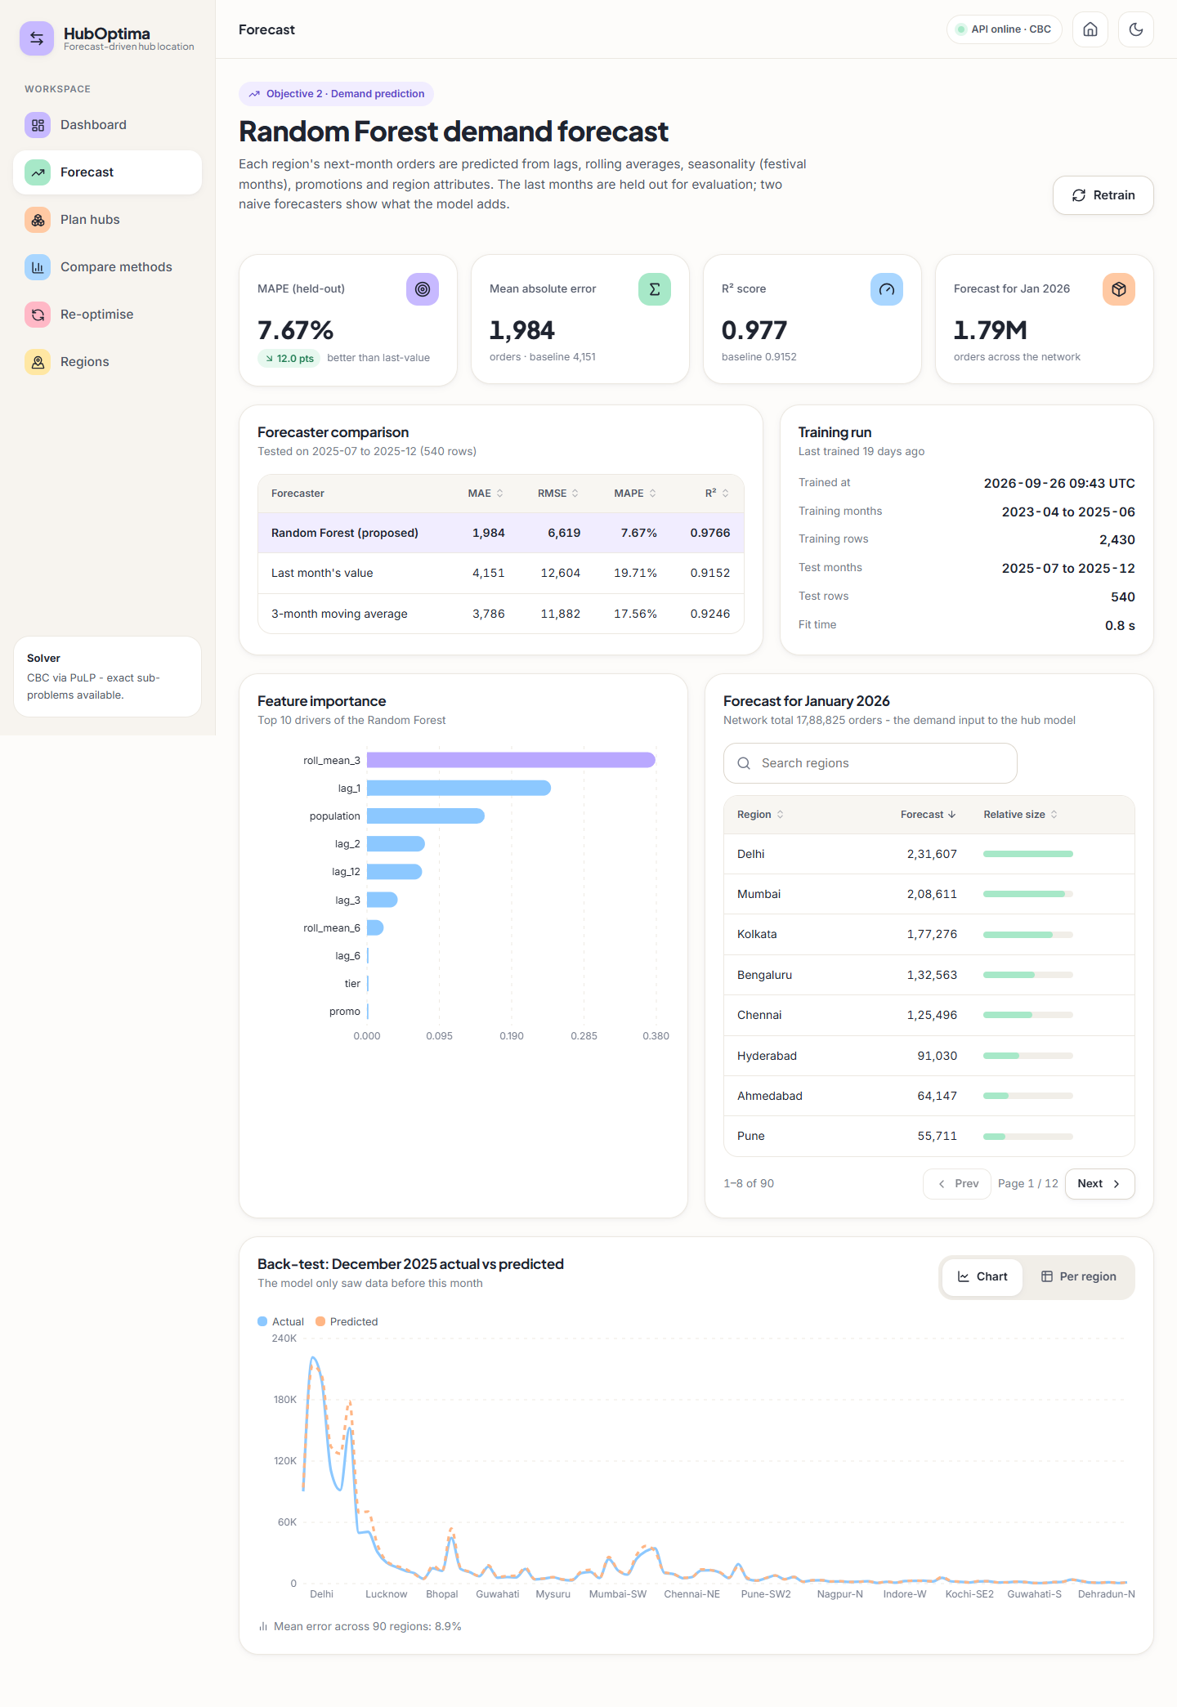
Fig. C.3: Forecast page (full)
The whole forecast page: accuracy tiles, forecaster comparison, feature importance, the January 2026 forecast per region (1,788,825 orders in total) and the December 2025 back-test (mean error 8.9% across 90 regions).
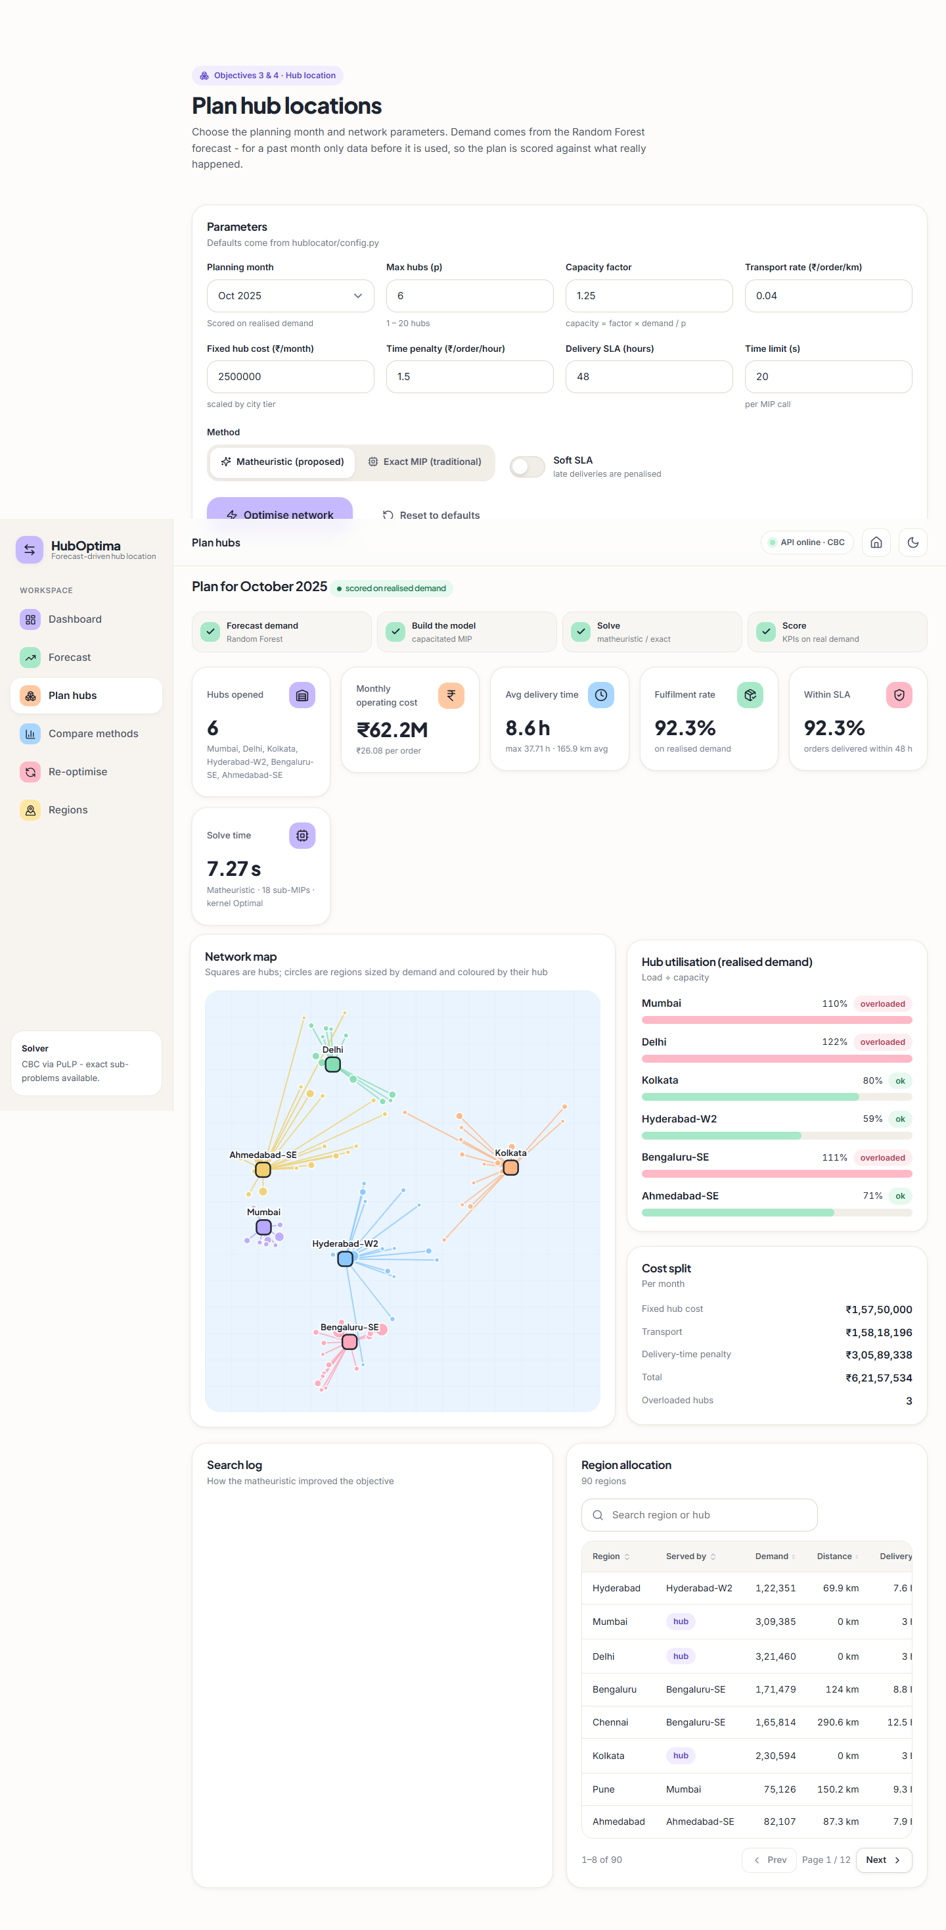
Fig. C.4: Plan hubs: complete result
The full result page: KPI tiles, network map, hub utilisation, cost split, search log and the region allocation table.
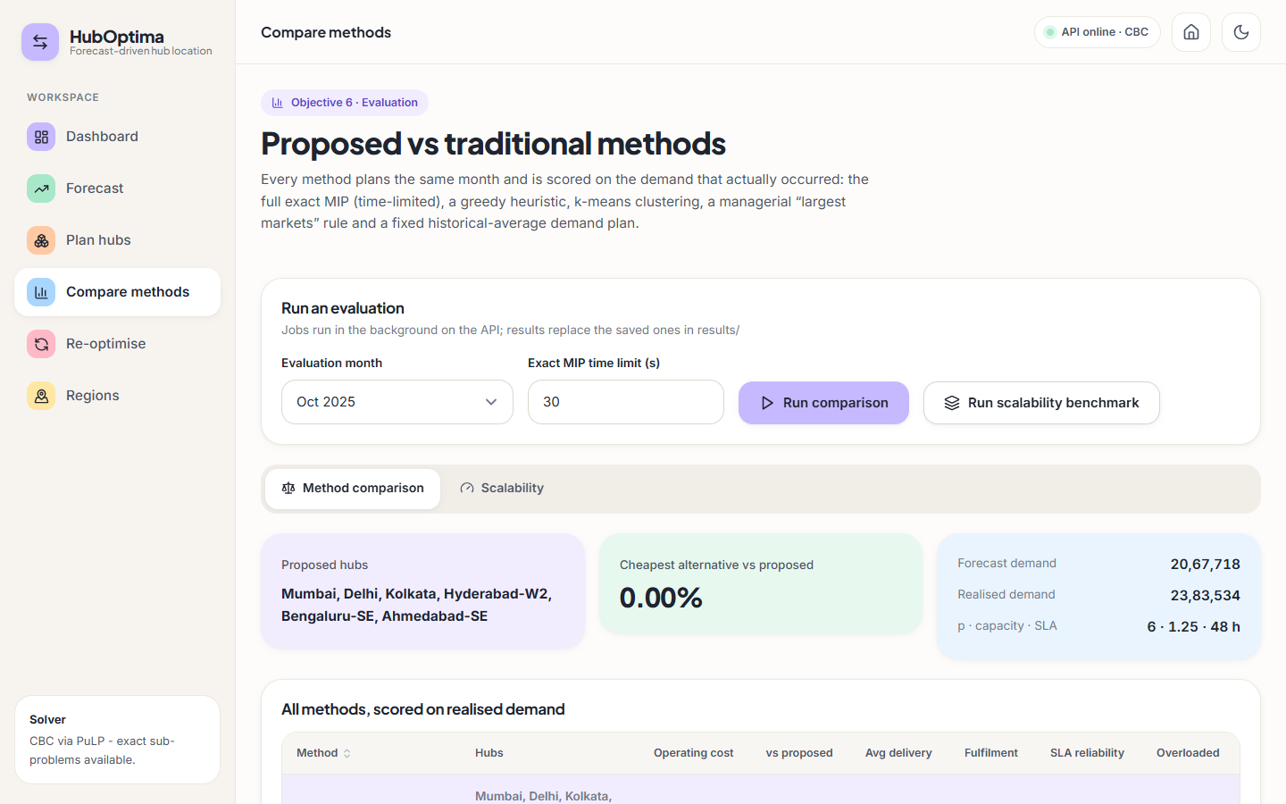
Fig. C.5: Compare methods
Proposed method against the traditional methods: the proposed hubs and the headline comparison.

Fig. C.6: Scalability benchmark (full)
The scalability charts and the table of benchmark runs.

Fig. C.7: Dashboard in dark mode
The same dashboard in the dark theme, which follows the operating-system setting until the user chooses.

Fig. C.8: Not-found page
A friendly page for routes that do not exist.

